
Sri Lanka Institute of Information Technology
SE4040 – Enterprise Application Development

Smart Solar Microgrid Trading System
Client–Server Application (Web, Mobile and Web Service)
Assignment Report
Group ID - 34
Registration number | Name
IT22207272 | Fonseka G N V S
IT22228062 | Jayasinghe I A S A
IT22049872 | Navod W D C
IT22246332 | Hettiarachchi H A S L

Table of Contents
1 Introduction 8
1.1 Background 8
1.2 Purpose and Scope 8
1.3 User Roles 9
1.4 Structure of this Report 9
2 Requirements Coverage 10
3 System Architecture 11
3.1 High-Level Architecture Diagram 11
3.2 Technology Stack 11
3.3 Applying the FAT Service Pattern 12
3.4 Request Lifecycle 14
3.5 Uniform Response Envelope 14
4 Use Case Diagrams 15
4.1 Web Application 15
4.2 Android Application 16
4.3 Actor Summary 17
5 Data Flow Diagrams 18
5.1 Level 0 — Context Diagram 18
5.2 Level 1 Diagram 18
6 Database Design 20
6.1 Choice of Database 20
6.2 Collection Relationships 20
6.3 Users Collection 21
6.4 SolarStationInfo Collection 22
6.5 EnergyBookingSlots Collection 23
6.6 EnergyReservation Collection 23
6.7 Indexes 24
6.8 Design Decisions 24
6.9 Sample Data 25
6.10 Android Local Database (SQLite) 25
7 Business Rules 27
7.1 Rule Catalogue 27
7.2 Key Rule Implementations 27
7.3 Rule Ordering 28
7.4 Reservation Life Cycle 29
8 Web Service (C# Web API) 30
8.1 Project Structure 30
8.2 Authentication and Authorisation 30
8.3 Endpoint Summary 31
8.4 QR Code Issue and Verification 32
8.5 Booking Workflow 34
8.6 Server-Side Distance Calculation 35
8.7 Concurrency 35
9 Web Application 36
9.1 Structure 36
9.2 Error Handling 36
9.3 Routes and Role-Based Access 37
10 Android Application 38
10.1 Compliance with the "Pure Native" Constraint 38
10.2 Networking 38
10.3 Screens 39
11 User Interface Screenshots 40
11.1 Web Application 40
11.2 Android Application 48
12 Testing and Verification 52
12.1 API Verification Suite 52
12.2 Defects Found and Fixed 53
12.3 Build Verification 53
13 Deployment 54
13.1 Prerequisites 54
13.2 Hosting the API on IIS 54
13.3 Running Locally 54
13.4 Demonstration Accounts 55
14 Git Repository and Demonstration Video 56
15 Individual Contributions 57
15.1 Declared Use of AI Tools 57
16 Challenges and Lessons Learned 59
17 Conclusion 60
18 References 61
Appendix A — Source Code 63
A.1 Web API (C#) 63
A.1.1 Program.cs 63
A.1.2 web.config 67
A.1.3 MongoDbContext.cs 68
A.1.4 User.cs 70
A.1.5 SolarStationInfo.cs 72
A.1.6 EnergyBookingSlot.cs 74
A.1.7 EnergyReservation.cs 75
A.1.8 ServiceResult.cs 77
A.1.9 ErrorCodes.cs 79
A.1.10 PasswordHasher.cs 80
A.1.11 JwtTokenService.cs 82
A.1.12 MethodOverrideMiddleware.cs 83
A.1.13 AuthService.cs 84
A.1.14 ReservationService.cs 90
A.1.15 ReservationsController.cs 113
A.2 Web Application (React + TypeScript) 120
A.2.1 App.tsx 120
A.2.2 client.ts 121
A.2.3 services.ts 124
A.2.4 AuthContext.tsx 129
A.2.5 ProtectedRoute.tsx 131
A.3 Android Application (Java) 132
A.3.1 ApiClient.java 132
A.3.2 DatabaseHelper.java 137
A.3.3 SessionManager.java 140
A.3.4 LoginActivity.java 143
A.3.5 ScannerActivity.java 147
A.3.6 VerifyResultActivity.java 151

List of Figures
Figure 1: High-level architecture diagram 11
Figure 2: Use case diagram — web application (Backoffice Officer and Grid Operator) 15
Figure 3: Use case diagram — Android application (Solar Prosumer and Grid Operator) 16
Figure 4: Data flow diagram — Level 0 (context diagram) 18
Figure 5: Data flow diagram — Level 1 19
Figure 6: Database design — collections, key fields and references 20
Figure 7: Reservation life cycle (state diagram) 29
Figure 8: Sequence diagram — QR verification and transfer completion 33
Figure 9: Sequence diagram — booking creation and rule evaluation 34
Figure 10: Home (index) page — public landing page describing the workflow, the three roles and the demo accounts 40
Figure 11: Login — a single sign-in for every role, accepting a NIC, username or e-mail, with role-based redirect 41
Figure 12: Backoffice dashboard — live counters, pending-activation banner, reservation mix chart and upcoming bookings 41
Figure 13: Reservations — search, status, node and date filters; approve, reject and cancel actions driven by server flags 42
Figure 14: Reservation detail — booking and prosumer details, audit trail and the server-generated QR code 42
Figure 15: Microgrid nodes — capacity, battery bays, opening hours and the R4 warning for nodes with future bookings 43
Figure 16: Booking slots — per node and date, with bulk generation, add, edit, block and delete 43
Figure 17: Prosumers — the NIC-keyed prosumer register with status filtering and account actions 44
Figure 18: Pending activations — the Backoffice queue of self-registered accounts (R6) and deactivation requests 44
Figure 19: Web users — Backoffice-only administration of Backoffice and Grid Operator accounts (R10) 45
Figure 20: Station map — every microgrid node plotted from its stored GPS coordinates (Leaflet) 45
Figure 21: Profile — edit own details and change password 46
Figure 22: Grid Operator dashboard — counters scoped to the operator's assigned node (STN-001) 46
Figure 23: Role enforcement — a prosumer signed in to the web portal sees reduced navigation and the API refuses the staff-only list 47
Figure 24: Responsive layout — the home page at 390 px phone width, shown in three consecutive segments 47
Figure 25: Android — Splash screen 48
Figure 26: Android — Login 48
Figure 27: Android — Register with NIC 48
Figure 28: Android — Prosumer Home — main opening screen 49
Figure 29: Android — New booking — node selected 49
Figure 30: Android — New booking — slots listed 49
Figure 31: Android — Booking summary 49
Figure 32: Android — My bookings — Current tab 49
Figure 33: Android — My bookings — History tab 49
Figure 34: Android — Booking detail with QR code 50
Figure 35: Android — Edit booking 50
Figure 36: Android — Nearby nodes on Google Maps 50
Figure 37: Android — Station detail 50
Figure 38: Android — Profile and deactivation request 50
Figure 39: Android — Grid Operator home 50
Figure 40: Android — QR scanner 51
Figure 41: Android — Verification result and finalise transfer 51
Figure 42: Android — Operator node bookings 51

List of Tables
Table 1: Deployable parts of the system 8
Table 2: User roles and their responsibilities 9
Table 3: Requirements traceability 10
Table 4: Technology stack 11
Table 5: Actors, key use cases and governing business rules 17
Table 6: Level 1 processes 18
Table 7: Users collection — "User's detail" 21
Table 8: SolarStationInfo collection — microgrid nodes 22
Table 9: EnergyBookingSlots collection 23
Table 10: EnergyReservation collection 23
Table 11: MongoDB indexes 24
Table 12: Seeded microgrid nodes (SolarStationInfo) 25
Table 13: Android SQLite tables 26
Table 14: Business rules enforced by the Web API 27
Table 15: Role-based access enforced by the API 31
Table 16: REST endpoints by controller 31
Table 17: Web application routes 37
Table 18: Native Android technology choices 38
Table 19: Android activities 39
Table 20: API verification results 52
Table 21: Defects found during testing and their fixes 53
Table 22: Build verification 53
Table 23: Prerequisites 54
Table 24: Seeded demonstration accounts 55
Table 25: Individual contributions 57
Table 26: AI tool disclosure 58

1 Introduction

1.1 Background
Households and small businesses with rooftop solar arrays — prosumers — often generate more energy than they consume during the day and need more than they generate at night. A neighbourhood microgrid lets them trade that surplus: energy is dropped into, or drawn from, battery bays at shared microgrid nodes. Doing this fairly needs scheduling (who uses which bay, when), verification on site (is this really the booked prosumer?) and an audit trail of the energy that actually moved.
The Smart Solar Microgrid Trading System provides exactly that. A prosumer reserves a time slot at a node, either to charge from the grid or to drop surplus energy into it. When a booking is approved the system issues a secure QR code; at the node a grid operator scans that code, the server verifies it, and the operator records how many kilowatt-hours were transferred. A back office team registers the nodes, publishes their schedules and administers every account.

1.2 Purpose and Scope
The system was built for SE4040 Assignment 1 as an end-to-end client–server application [1]. It consists of three deployable parts that communicate only through a RESTful web service, as summarised in Table 1.
Table 1: Deployable parts of the system
Part | Technology | Users
Central Web API (web service) | ASP.NET Core 8 (C#) hosted on Windows IIS, MongoDB (NoSQL) | — (serves both clients)
Web application | React 18, TypeScript, Vite, Tailwind CSS 3 | Backoffice officers, Grid operators
Mobile application | Pure native Android (Java) with a local SQLite database | Solar prosumers, Grid operators

The defining architectural constraint is the FAT service pattern: every business rule, validation and calculation lives in the central API, and both clients are limited to user-interface work. Section 3 explains how this constraint was enforced rather than merely asserted.

1.3 User Roles
Table 2: User roles and their responsibilities
Role | Client(s) | Responsibilities
Backoffice Officer | Web | Registers microgrid nodes and maintains their schedules; creates web users; manages prosumer profiles; is the only role allowed to activate or reactivate an account; approves or rejects bookings.
Grid Operator | Web and Android | Keeps battery bay availability current at the assigned node; publishes booking slots; monitors, approves and cancels bookings; in the field, scans the prosumer's QR code, verifies it against the server and finalises the energy transfer.
Solar Prosumer | Android | Registers with the National Identity Card (NIC) number as primary key; edits the profile or requests deactivation; reserves, modifies and cancels energy slots; views the booking QR code, history, pending bookings and nearby nodes.

1.4 Structure of this Report
Section 2 maps each requirement of the specification to its implementation. Sections 3 to 5 present the architecture, use case and data flow diagrams, and Section 6 the database design. Sections 7 to 10 describe the business rules, the web service and the two clients. Section 11 contains screenshots of every user interface, Sections 12 and 13 cover testing and deployment, and Sections 14 to 18 give the Git repository, individual contributions, challenges, conclusions and references. The source code is reproduced as text in Appendix A.

2 Requirements Coverage
Table 3 traces every requirement in the assignment specification [1] to the part of the system that implements it and to the evidence presented later in this report.
Table 3: Requirements traceability
Requirement | Implementation | Evidence
Web — User management: Backoffice and Grid Operator roles; only Backoffice can administer | UsersPage, role-filtered navigation, ProtectedRoute; /users endpoints restricted to Backoffice (R10) | §9.3, Fig. 19, 23
Web — Prosumer management: NIC as primary key; create, update, deactivate; only Backoffice reactivates | ProsumersPage, PendingActivationsPage; /prosumers/{nic}; rules R5, R6, R7 | §7, Fig. 17–18
Web — Microgrid node management: GPS location, kWh capacity, battery slots; schedules; deactivation blocked by active bookings | StationsPage, MapPage; /stations incl. /schedule, /availability, /deactivate; rule R4 | §7.2, Fig. 15, 20
Web — Reservation management: create, update, cancel; within 7 days; 12 hours' notice | ReservationsPage, ReservationDetailPage, SlotsPage; rules R1, R2, R3 in ReservationService | §7, Fig. 13, 14, 16
Web — UI built with React / Tailwind CSS, responsive | React 18 + Tailwind CSS 3; sidebar layout collapses on small screens | §9, Fig. 10, 24
Mobile — Pure native Android with SQLite, no frameworks | Java, XML layouts, HttpURLConnection, org.json, SQLiteOpenHelper | §10.1, §6.10
Mobile — Prosumer account control: register with NIC, edit profile, request deactivation | RegisterActivity, ProfileActivity; /auth/register, /prosumers/{nic}/request-deactivation | §10.3, Fig. 27, 38
Mobile — Reservation & QR dispatch: reserve, modify, cancel; secure QR once approved | NewBookingActivity, EditBookingActivity, BookingDetailActivity, BookingSummaryActivity; server-rendered QR | §8.4, Fig. 29–31, 34–35
Mobile — Dashboard & maps: active/pending counts, nearby nodes on Google Maps, history, pending, search | ProsumerHomeActivity, MyBookingsActivity (tabs + search), StationsMapActivity, StationDetailActivity | §10.3, Fig. 28, 32–33, 36–37
Mobile — Operator mode: log in, scan QR, verify with server, finalise transfer | OperatorHomeActivity, ScannerActivity (ZXing), VerifyResultActivity; /verify-qr, /complete; rule R9 | §8.4, Fig. 39–42
Web service — FAT service: all business logic in the central API | Thin controllers; Services/Implementations/*; server-computed canModify, canCancel, isBookable, distanceKm | §3.3
Web service — C# Web API on IIS with NoSQL | ASP.NET Core 8, web.config for the ASP.NET Core Module, MongoDB.Driver 2.28, four collections | §6, §13.2
Client constraints: REST only; local persistence only where specified | Web: axios only; Android: HttpURLConnection; SQLite used as a session store and cache, never the source of truth | §3.3, §6.10

3 System Architecture

3.1 High-Level Architecture Diagram
The system is a three-tier client–server application (Figure 1). The presentation tier contains two user interfaces, the application tier contains the single ASP.NET Core Web API, and the data tier contains the MongoDB database. Data always flows client → API → database; there is no path from a client to MongoDB.
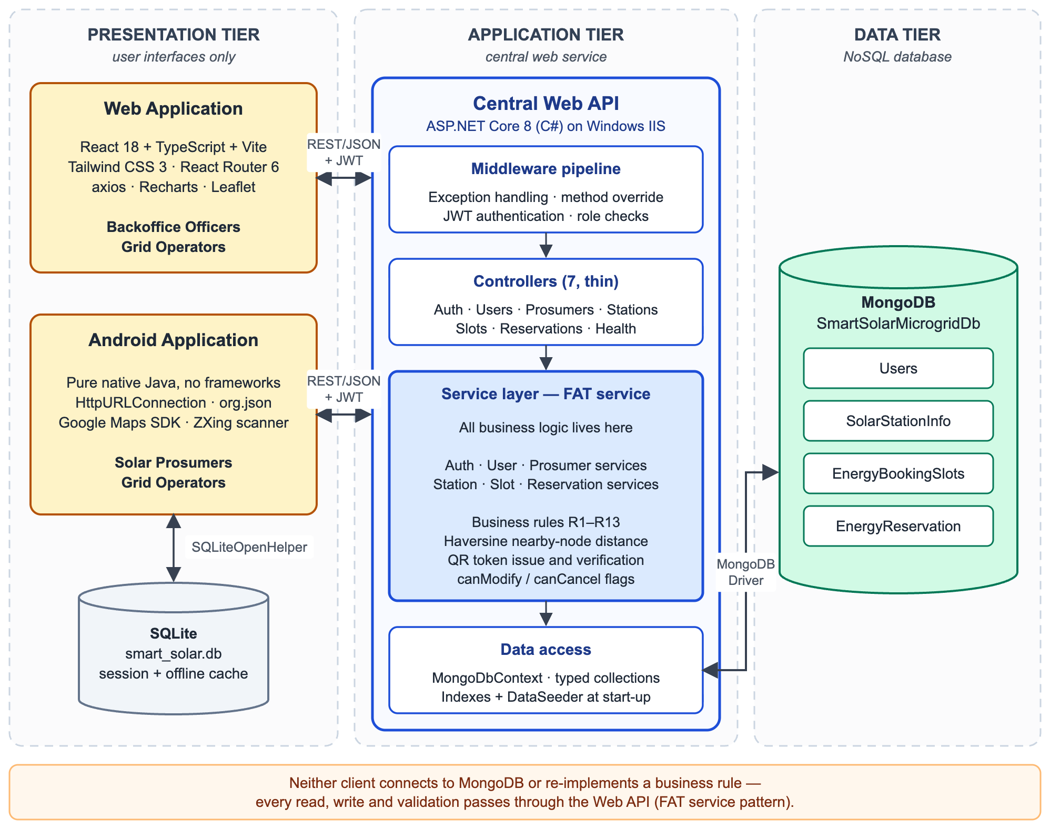
Figure 1: High-level architecture diagram

3.2 Technology Stack
Table 4: Technology stack
Layer | Component | Choice | Reason
Web service | Framework | ASP.NET Core 8 (LTS) | Long-term support; first-class IIS hosting through the ASP.NET Core Module
 | Database driver | MongoDB.Driver 2.28 | Official driver with typed collections and LINQ filters
 | Authentication | JWT bearer, HMAC-SHA256 | Stateless tokens used identically by both clients
 | Password hashing | PBKDF2-SHA256, 100 000 iterations | Salted, slow hash recommended by Microsoft and OWASP [4], [25]
 | QR generation | QRCoder 1.6 (PngByteQRCode) | Produces PNG bytes with no System.Drawing dependency
 | API documentation | Swashbuckle (Swagger UI) | Lets a marker exercise every secured endpoint
Web client | UI | React 18 + TypeScript, Vite | Component model and compile-time checking of every API contract
 | Styling | Tailwind CSS 3 | Utility classes give a consistent, responsive design system
 | HTTP / routing | axios, React Router 6 | One interceptor handles every error; protected routes per role
 | Charts / maps | Recharts, Leaflet + OpenStreetMap | Leaflet needs no billing-enabled API key on the web
Android client | Language / UI | Java, XML layouts | Pure native, no cross-platform framework
 | Networking / JSON | HttpURLConnection, org.json | Platform classes only — no Retrofit, OkHttp or Gson
 | Persistence | SQLite via SQLiteOpenHelper | Required by the specification; no Room or ORM
 | Maps / QR | Google Maps SDK, ZXing Android Embedded | Required by the specification for maps and scanning
Data | Database | MongoDB 6+ | NoSQL document store; nested schedules map naturally to sub-documents

3.3 Applying the FAT Service Pattern
The FAT service constraint is easy to state and easy to violate by accident — the natural instinct when writing a Cancel button is to compare the time locally and hide the button. Four measures make the constraint hold in this code base.
1. Controllers cannot hold logic. Every controller action binds a DTO, calls exactly one service method and maps the returned ServiceResult to an HTTP status. No controller contains a conditional over domain data. The mapping is one shared helper:
private ActionResult<ApiResponse<T>> Respond<T>(ServiceResult<T> result)
{
// Translates the service layer outcome into the matching HTTP status code and envelope.
var body = result.IsSuccess
? ApiResponse<T>.Ok(result.Value, result.Message)
: ApiResponse<T>.Fail(result.Message, result.ErrorCode, result.Errors);

return result.Status switch
{
ResultStatus.Success => Ok(body),
ResultStatus.Created => StatusCode(StatusCodes.Status201Created, body),
ResultStatus.ValidationError => BadRequest(body),
ResultStatus.NotFound => NotFound(body),
ResultStatus.Conflict => Conflict(body),
ResultStatus.Forbidden => StatusCode(StatusCodes.Status403Forbidden, body),
ResultStatus.Unauthorized => Unauthorized(body),
_ => StatusCode(StatusCodes.Status500InternalServerError, body),
};
}

ServiceResult carries no ASP.NET types, so the service layer has no dependency on the web framework at all.
2. Clients receive answers, not the inputs to a rule. Instead of sending a start time and trusting each client to apply the 12-hour notice rule, the API evaluates the rule per record and returns the verdict as two booleans (DomainMapper.ToDto):
// Hours of notice remaining drives both the modify and the cancel verdicts.
var hoursUntilStart = (reservation.ReservationStartUtc - utcNow).TotalHours;
var isChangeableState = reservation.Status is ReservationStatus.Pending or ReservationStatus.Approved;
var hasNotice = hoursUntilStart >= noticeHours;

return new ReservationDto
{
…
CanModify = isChangeableState && hasNotice,
CanCancel = isChangeableState && hasNotice,
…
};

The React client simply writes disabled={!reservation.canCancel} and the Android client btnCancel.setEnabled(reservation.canCancel()). Neither computes an hour difference. Slot availability (isBookable) and node distance (distanceKm) follow the same pattern.
3. Attempting the action anyway is still rejected. A disabled button is a courtesy, not a control. Every rule is re-checked on the write path, so a crafted request or a stale screen is refused with a stable error code.
4. Neither client can reach the database. Neither client project references a MongoDB driver. The web application's only network dependency is axios, and the Android application uses the platform's own HttpURLConnection.

3.4 Request Lifecycle
Every request passes through the same pipeline, configured in Program.cs:
- The client sends an HTTPS request with Authorization: Bearer <JWT>.
- ExceptionHandlingMiddleware wraps the pipeline so any unhandled exception still returns the JSON envelope.
- MethodOverrideMiddleware converts POST + X-HTTP-Method-Override: PATCH into a real PATCH (needed by some Android HTTP stacks).
- UseRouting(), then JWT authentication validates the token signature and lifetime (clock skew is zero).
- Authorisation checks [Authorize(Roles = …)] on the action; model validation runs on the bound DTO.
- The controller calls one service method, which applies the business rules and returns a ServiceResult.
- The service reads and writes MongoDB through the typed collections of MongoDbContext.
- The ServiceResult is wrapped in the ApiResponse envelope and returned with the matching status code.

3.5 Uniform Response Envelope
Every endpoint, successful or not, returns the same JSON shape, so each client needs exactly one deserialiser and one error handler:
{
"success": true,
"message": "Reservation created successfully. It is pending approval.",
"data": { ... },
"errorCode": null,
"errors": null,
"timestamp": "2026-09-05T15:33:32.374Z"
}

On failure errorCode carries a stable, machine-readable identifier such as RES_CANCEL_12H. The clients branch on that code, never on the English message, so wording can change without breaking either client.

4 Use Case Diagrams
The use cases are split by client so that each diagram stays readable. The Grid Operator is the only actor that appears on both, because operators work at a desk (web) and in the field (Android).

4.1 Web Application
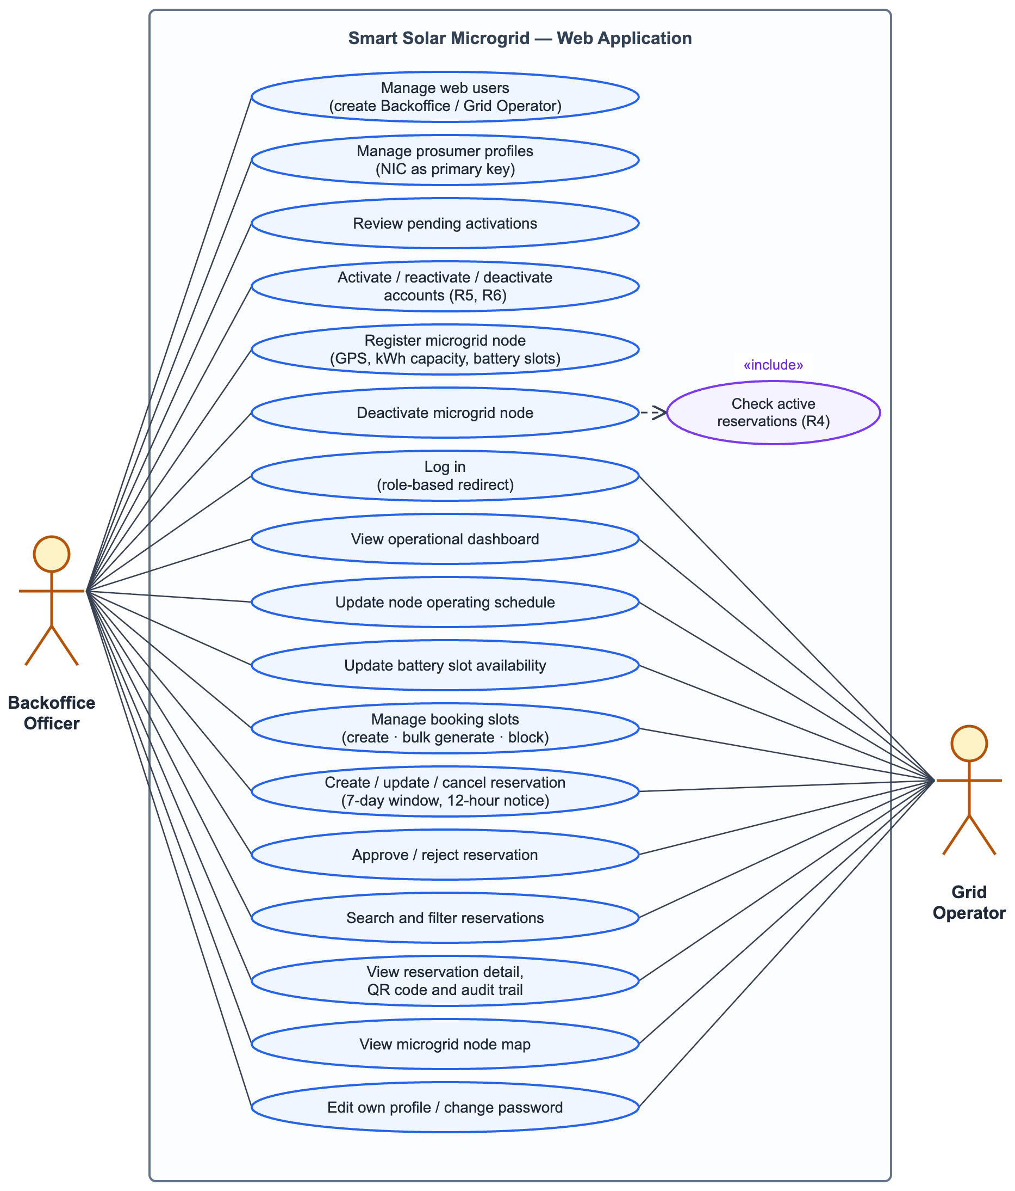
Figure 2: Use case diagram — web application (Backoffice Officer and Grid Operator)

4.2 Android Application
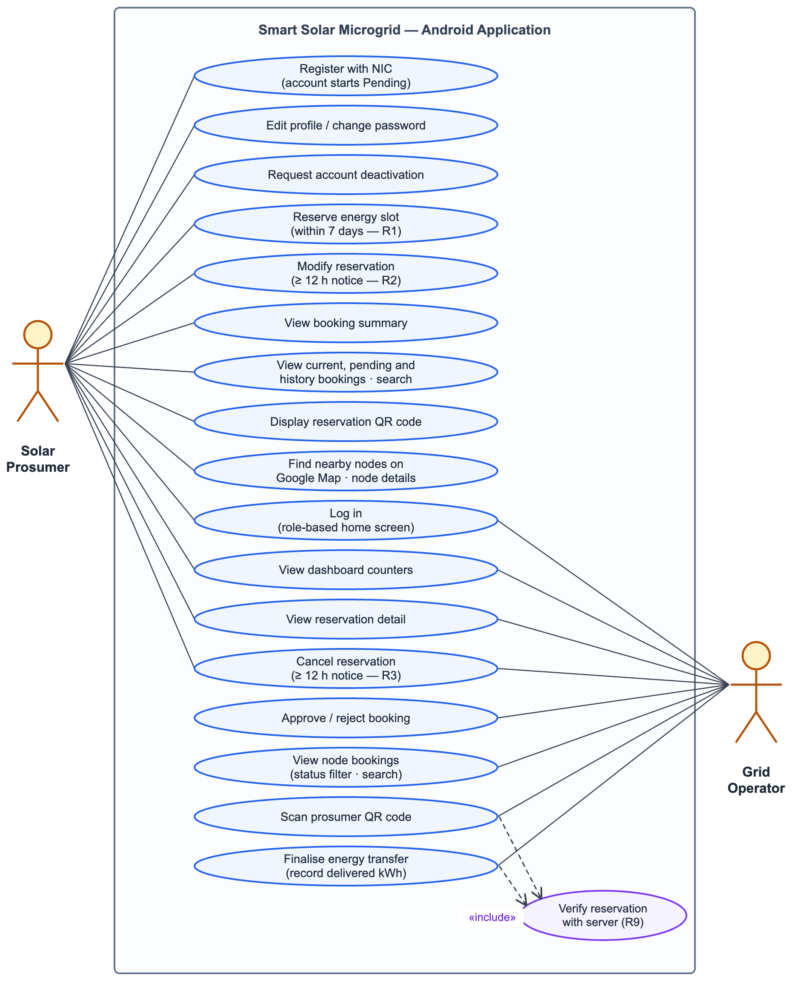
Figure 3: Use case diagram — Android application (Solar Prosumer and Grid Operator)

4.3 Actor Summary
Table 5: Actors, key use cases and governing business rules
Actor | Key use cases | Governing rules
Backoffice Officer | Manage web users and prosumers; review the pending-activation queue; activate or reactivate accounts; register, schedule and deactivate nodes; manage slots; approve, reject and cancel bookings. | R4, R5, R6, R7, R10
Grid Operator | Update node schedule and battery availability; manage slots; approve, reject and cancel bookings; scan the prosumer QR code, verify it with the server and finalise the transfer. | R2, R3, R8, R9
Solar Prosumer | Register with NIC; edit profile; request deactivation; reserve, modify and cancel energy slots; view the booking summary, QR code, history, pending bookings and nearby nodes. | R1, R2, R3, R6, R11, R12, R13

5 Data Flow Diagrams

5.1 Level 0 — Context Diagram
The context diagram (Figure 4) treats the whole system as a single process and shows the data exchanged with the three external entities.
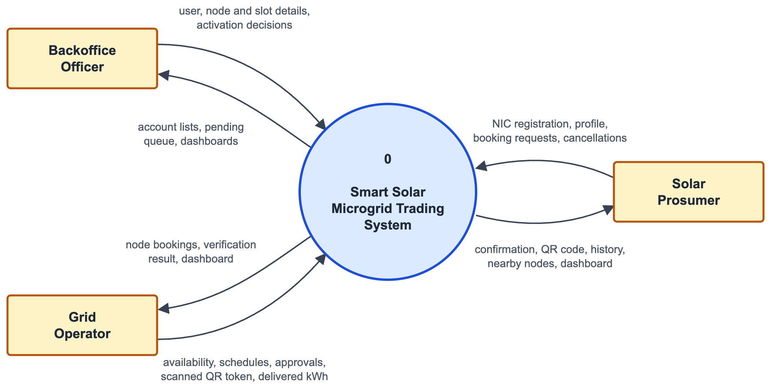
Figure 4: Data flow diagram — Level 0 (context diagram)

5.2 Level 1 Diagram
The Level 1 diagram (Figure 5, on the following landscape page) decomposes the system into six processes. The four data stores map one-to-one onto the four MongoDB collections. Table 6 summarises each process.
Table 6: Level 1 processes
Process | Description | Stores used
1.0 Authenticate & Manage Accounts | Login for all roles; prosumer self-registration (Pending); web user and prosumer administration; activation, deactivation and deactivation requests. | D1
2.0 Manage Microgrid Nodes | Create and update nodes, schedules and battery availability; distance-ranked nearby-node search; deactivation guarded by R4. | D2, D4 (read)
3.0 Publish Booking Slots | Create, bulk-generate, update, block and delete slots, honouring each node's weekly opening days. | D3, D2 (read)
4.0 Process Reservations | Create, update, cancel, approve and reject bookings under rules R1–R3, R5, R6, R8, R12, R13; maintains the slot booked count. | D4, D3, D1/D2 (read)
5.0 Verify QR & Finalise Transfer | Resolve a scanned token, validate it (R9), record the delivered kWh and clear the token. | D4
6.0 Generate Dashboards | Pending and approved-future counts, completed transfers, energy delivered, active nodes and pending activations. | D4, D1, D2 (read)

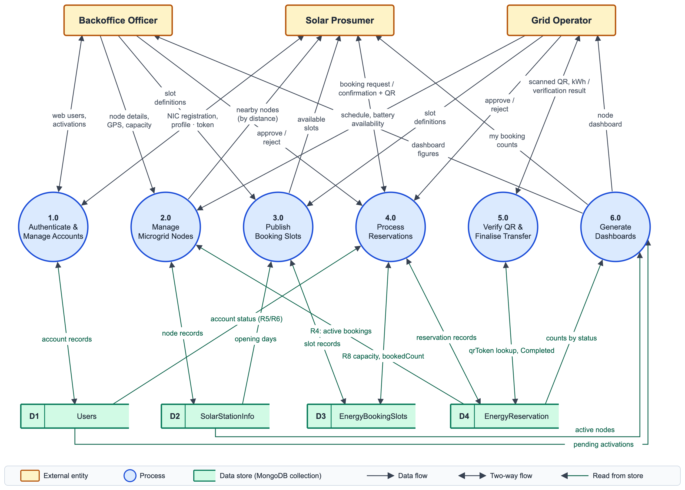
Figure 5: Data flow diagram — Level 1

6 Database Design

6.1 Choice of Database
MongoDB was used as required by the specification. It suits this domain: a node's weekly schedule is naturally a nested array of seven day-records, and storing it as a sub-document avoids the join a relational design would need. The database is named SmartSolarMicrogridDb and contains exactly the four collections named in the marking scheme — Users, SolarStationInfo, EnergyBookingSlots and EnergyReservation. Indexes are created by MongoDbContext.EnsureIndexesAsync() when the API starts, so no manual set-up is needed.

6.2 Collection Relationships
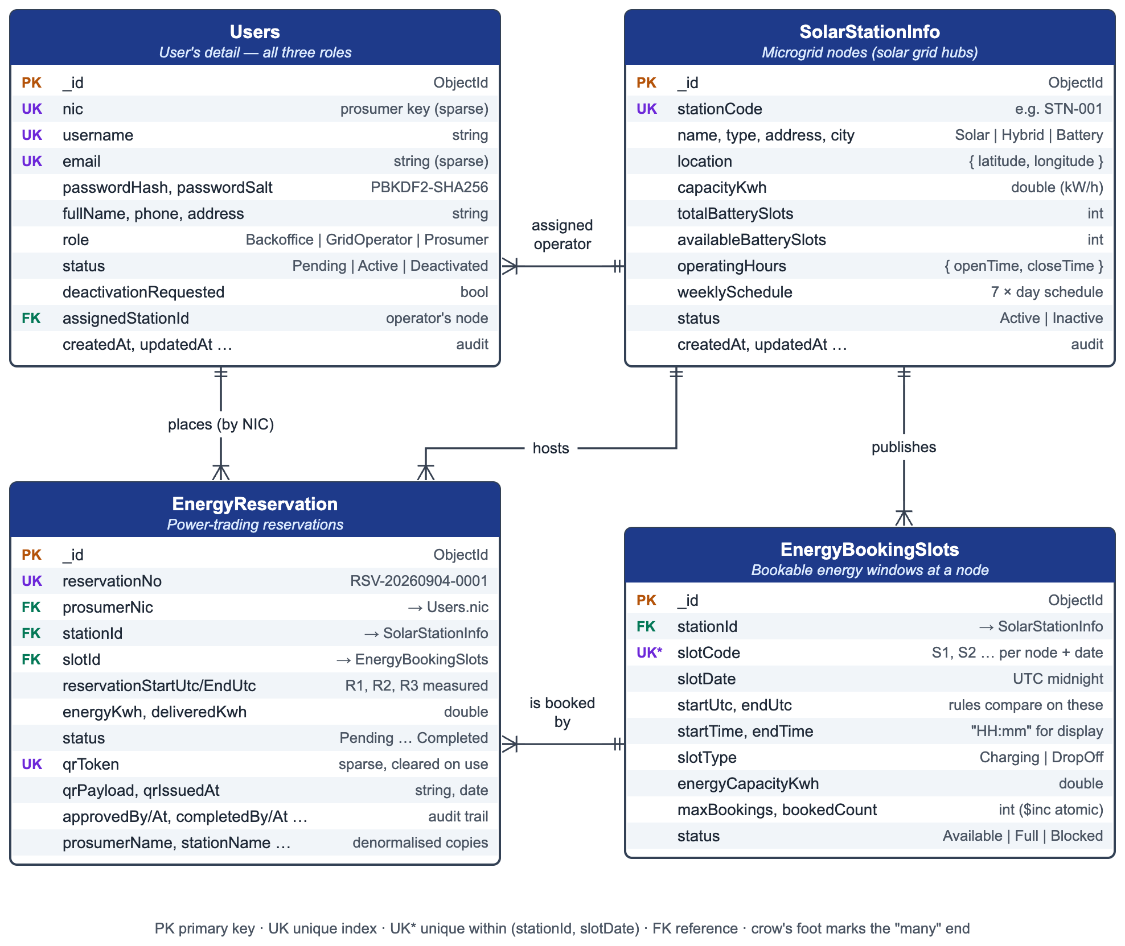
Figure 6: Database design — collections, key fields and references

6.3 Users Collection
Table 7: Users collection — "User's detail"
Field | Type | Notes
_id | ObjectId | MongoDB identifier
nic | string | null | Prosumer primary key. Unique, sparse index; null for staff accounts
username | string | Unique. For prosumers the NIC is copied here so all roles log in the same way
email | string | Unique, sparse
passwordHash | string | PBKDF2-SHA256, 100 000 iterations, base64
passwordSalt | string | 16 random bytes per account, base64
fullName, phone, address | string | Profile details
role | string | Backoffice | GridOperator | Prosumer
status | string | Pending | Active | Deactivated
deactivationRequested | bool | Raised by the prosumer from the mobile app
deactivationRequestedAt, deactivationReason | date, string | When and why deactivation was requested
assignedStationId, assignedStationCode | string | Grid operator's home node (code denormalised for display)
lastLoginAt | date | Set on each successful login
createdAt, updatedAt, createdBy, updatedBy | date, string | Audit fields

6.4 SolarStationInfo Collection
Table 8: SolarStationInfo collection — microgrid nodes
Field | Type | Notes
_id | ObjectId
stationCode | string | Unique, e.g. STN-001
name, address, city | string
type | string | Solar | Hybrid | Battery
location | object | { latitude, longitude } — GPS location
capacityKwh | double | Capacity specification (kW/h)
totalBatterySlots | int | Battery storage slots installed
availableBatterySlots | int | Kept current by the grid operator
operatingHours | object | { openTime, closeTime } as "HH:mm"
weeklySchedule | array | 7 × { dayOfWeek, isOpen, openTime, closeTime } — schedule updates
contactNumber | string
status | string | Active | Inactive
createdAt, updatedAt, createdBy, updatedBy | date, string | Audit fields

6.5 EnergyBookingSlots Collection
Table 9: EnergyBookingSlots collection
Field | Type | Notes
_id | ObjectId
stationId | string (ref) | → SolarStationInfo._id
stationCode, stationName | string | Denormalised for list screens
slotCode | string | S1, S2 … unique within station + date
slotDate | date | UTC midnight of the slot's day
startTime, endTime | string | "08:00" — display only
startUtc, endUtc | date | Absolute instants; every rule compares on these
slotType | string | Charging | DropOff
energyCapacityKwh | double | Ceiling on a booking's energy
batterySlotNumber | int | Which physical battery bay
maxBookings, bookedCount | int | bookedCount is maintained atomically with $inc
status | string | Available | Full | Blocked
createdAt, updatedAt | date | Audit fields

6.6 EnergyReservation Collection
Table 10: EnergyReservation collection
Field | Type | Notes
_id | ObjectId
reservationNo | string | Unique, e.g. RSV-20260904-0001
prosumerNic | string (ref) | → Users.nic
prosumerName, prosumerPhone | string | Denormalised
stationId, stationCode, stationName | string | → SolarStationInfo (code and name denormalised)
slotId, slotCode | string | → EnergyBookingSlots
reservationStartUtc, reservationEndUtc | date | Rules R1, R2 and R3 measure on these
startTime, endTime, slotType | string | Display values copied from the slot
energyKwh | double | Requested energy
deliveredKwh | double | null | Captured by the operator on completion
status | string | Pending | Approved | Completed | Cancelled | Rejected
qrToken | string | null | 32 random bytes, URL-safe base64. Unique, sparse; cleared on cancel/complete
qrPayload, qrIssuedAt | string, date | Exact JSON encoded into the QR image, and when it was issued
approvedBy/At, completedBy/At, cancelledBy/At | string, date | Audit trail
cancelReason, rejectedReason, operatorNotes | string
createdAt, updatedAt, createdBy, updatedBy | date, string | Audit fields

6.7 Indexes
Table 11: MongoDB indexes
Collection | Index | Purpose
Users | nic (unique, sparse) | Enforces R7 for prosumers without colliding on staff accounts that have no NIC
Users | username (unique), email (unique, sparse) | Single-field login lookup
SolarStationInfo | stationCode (unique), status | Readable node codes; active-node filtering
EnergyBookingSlots | {stationId, slotDate, slotCode} (unique), startUtc | No duplicate slot codes per day; time-window queries
EnergyReservation | reservationNo (unique), qrToken (unique, sparse) | Human reference numbers; O(1) QR lookup
EnergyReservation | prosumerNic, stationId, status, reservationStartUtc | Booking history, node dashboards and rule R4

6.8 Design Decisions
Sparse unique index on NIC. A plain unique index on nic would reject a second staff account, because two documents with nic: null collide. Marking the index sparse excludes documents without the field, so uniqueness applies only to prosumers — exactly what the specification asks for.
Deliberate denormalisation. stationCode, stationName, prosumerName and prosumerPhone are copied onto each reservation when it is created. Rendering a page of twenty bookings would otherwise need twenty extra lookups; with the copies it is one query. The trade-off is that renaming a node must propagate, which StationService.UpdateAsync does explicitly with UpdateManyAsync.
Time handling. Every stored instant is UTC. Slot times are stored twice: as "HH:mm" strings for display and as absolute startUtc/endUtc values. Every business rule compares only the absolute values, and the service layer reads "now" from an injected IClock rather than DateTime.UtcNow, which makes each rule testable with a frozen clock.

6.9 Sample Data
On first start the DataSeeder populates the database so the system can be demonstrated immediately: six microgrid nodes at real coordinates, ten accounts, fourteen days of booking slots per node and about twenty-five reservations spread across every status. Table 12 lists the seeded nodes.
Table 12: Seeded microgrid nodes (SolarStationInfo)
Code | Name | Type | City | GPS (lat, lng) | kWh | Bays
STN-001 | Malabe Solar Hub | Solar | Malabe | 6.9061, 79.9696 | 250 | 12
STN-002 | Colombo Fort Grid Node | Hybrid | Colombo | 6.9344, 79.8428 | 400 | 20
STN-003 | Kaduwela Community Array | Solar | Kaduwela | 6.9331, 79.9850 | 180 | 10
STN-004 | Nugegoda Battery Bank | Battery | Nugegoda | 6.8649, 79.8997 | 320 | 16
STN-005 | Kandy Hill Microgrid | Hybrid | Kandy | 7.2906, 80.6337 | 210 | 12
STN-006 | Galle Coastal Node | Solar | Galle | 6.0535, 80.2210 | 150 | 8

A representative reservation document, as stored in the EnergyReservation collection:
{
"_id": ObjectId("66d9..."),
"reservationNo": "RSV-20260907-0007",
"prosumerNic": "200356701199", "prosumerName": "Ishara Gunawardena",
"stationId": "66d9...", "stationCode": "STN-001", "stationName": "Malabe Solar Hub",
"slotId": "66d9...", "slotCode": "S10", "slotType": "DropOff",
"reservationStartUtc": ISODate("2026-09-07T10:30:00Z"),
"reservationEndUtc": ISODate("2026-09-07T12:30:00Z"),
"startTime": "16:00", "endTime": "18:00",
"energyKwh": 14.0, "deliveredKwh": null,
"status": "Approved",
"qrToken": "<32 random bytes, URL-safe base64>",
"qrPayload": "{\"v\":1,\"t\":\"...\",\"r\":\"RSV-20260907-0007\",\"n\":\"200356701199\",\"s\":\"STN-001\",\"e\":\"...\"}",
"approvedBy": "admin", "approvedAt": ISODate("2026-09-04T15:07:00Z"),
"createdAt": ISODate("2026-09-04T14:07:00Z")
}

6.10 Android Local Database (SQLite)
The Android client keeps its own SQLite database, smart_solar.db, created directly through SQLiteOpenHelper. The specification asks for login details to persist in SQLite, so the session and JWT are stored in a table rather than in SharedPreferences. SQLite is a session store and offline cache, never the authority: every create, update, cancel, approve and complete goes straight to the API, and cached rows are only shown — with a visible "showing saved data" banner — when a list request fails for lack of connectivity.
Table 13: Android SQLite tables
Table | Key columns | Purpose
session | id (single row), user_id, nic, username, role, status, assigned_station_id, token, expires_at | The signed-in user and their JWT; the splash screen reads it to route by role
stations | id, station_code, name, latitude, longitude, capacity_kwh, available_battery_slots, status, cached_at | Cached nodes for the map and pickers
reservations | id, reservation_no, station_code, reservation_start_utc, energy_kwh, status, qr_token, can_modify, can_cancel | Cached bookings for the list screens (the server's rule verdicts are cached, not recomputed)
sync_log | id, entity, row_count, synced_at | Audit of what was cached and when

7 Business Rules

7.1 Rule Catalogue
All thirteen rules are implemented only in backend/SmartSolar.Api/Services/. Each failure returns a stable error code that both clients understand.
Table 14: Business rules enforced by the Web API
# | Rule | Error code | HTTP
R1 | A reservation must start in the future and within 7 days | RES_WINDOW_7_DAYS | 400
R2 | Updates need ≥ 12 hours notice and status Pending or Approved | RES_UPDATE_12H | 400
R3 | Cancellations need ≥ 12 hours notice | RES_CANCEL_12H | 400
R4 | A node cannot be deactivated while it holds future Pending/Approved bookings | STATION_HAS_ACTIVE_RES | 409
R5 | A Deactivated account cannot log in; only Backoffice may reactivate it | ACCOUNT_DEACTIVATED | 403
R6 | Self-registered prosumers start Pending and cannot log in until activated | ACCOUNT_PENDING | 403
R7 | NIC is unique across all accounts | NIC_ALREADY_EXISTS | 409
R8 | A slot must be Available, have capacity, be in the future and belong to an active node | SLOT_UNAVAILABLE | 409
R9 | A scanned QR must exist, be Approved and fall within ±2 h of its window | QR_INVALID / QR_NOT_APPROVED / QR_OUT_OF_WINDOW | 400
R10 | Only Backoffice may manage web users and activate accounts | FORBIDDEN | 403
R11 | A prosumer may only read or modify their own data | FORBIDDEN | 403
R12 | A node closed on that weekday cannot be booked | STATION_CLOSED | 400
R13 | A prosumer may not hold two active bookings on one slot | DUPLICATE_RESERVATION | 409

7.2 Key Rule Implementations
R1 — the 7-day window (ReservationService). Both bounds are checked against the injected clock:
// ***RULE R1*** - the booking must start in the future and no more than the configured window
// (7 days) from now. Both halves are checked together so the message can explain the whole rule.
if (slot.StartUtc <= now || slot.StartUtc > now.AddDays(WindowDays))
{
return ServiceResult<bool>.Invalid(
$"Reservations must be scheduled within the next {WindowDays} days and cannot be in the past.",
ErrorCodes.ReservationWindow);
}

The Android date picker also caps its maximum date at seven days, purely as a convenience; the comment in that code states that the API remains the authority.
R3 — the 12-hour cancellation notice (ReservationService.CancelAsync):
// ***RULE R3*** - the same 12 hour notice the update rule uses, so an operator is never left with
// a slot that empties minutes before the prosumer was due to arrive.
var hoursUntilStart = (reservation.ReservationStartUtc - now).TotalHours;
if (hoursUntilStart < NoticeHours)
{
_logger.LogInformation(
"R3 blocked a cancellation of {ReservationNo}: {Hours} hour(s) of notice remained.",
reservation.ReservationNo, Math.Round(hoursUntilStart, 2));

return ServiceResult<ReservationDto>.Invalid(
$"Reservations can only be cancelled at least {NoticeHours} hours before the scheduled start time.",
ErrorCodes.ReservationCancelNotice);
}

R4 — the node deactivation guard (StationService):
// ***RULE R4*** - a node holding Pending or Approved reservations that have not started yet cannot be
// switched off, because those prosumers are still expecting to trade energy there.
var activeReservations = await CountActiveReservationsAsync(existing.Id, ct);
if (activeReservations > 0)
{
_logger.LogWarning(
"R4 blocked deactivation of node {StationCode}: {Count} active reservation(s).",
existing.StationCode, activeReservations);

return ServiceResult<StationDto>.Conflict(
$"This microgrid node cannot be deactivated because it still has {activeReservations} " +
"active energy reservation(s). Cancel or complete them first.",
ErrorCodes.StationHasActiveReservations);
}

The same count populates StationDto.ActiveReservationCount, so the web UI can warn the officer before they click (visible on the node cards in Figure 15) while the guard itself stays on the server.

7.3 Rule Ordering
Rule order is itself a design decision. During testing, a duplicate booking returned SLOT_UNAVAILABLE instead of DUPLICATE_RESERVATION: a slot normally has maxBookings = 1, so the prosumer's own first booking had already filled it and the R8 capacity check fired before R13. The checks were reordered so R13 runs first, giving the truthful message "You already hold an active reservation for this slot" rather than the misleading "this slot is full".

7.4 Reservation Life Cycle
Figure 7 shows how the rules govern a reservation's status. Only Pending and Approved reservations can change; Completed, Cancelled and Rejected are final.
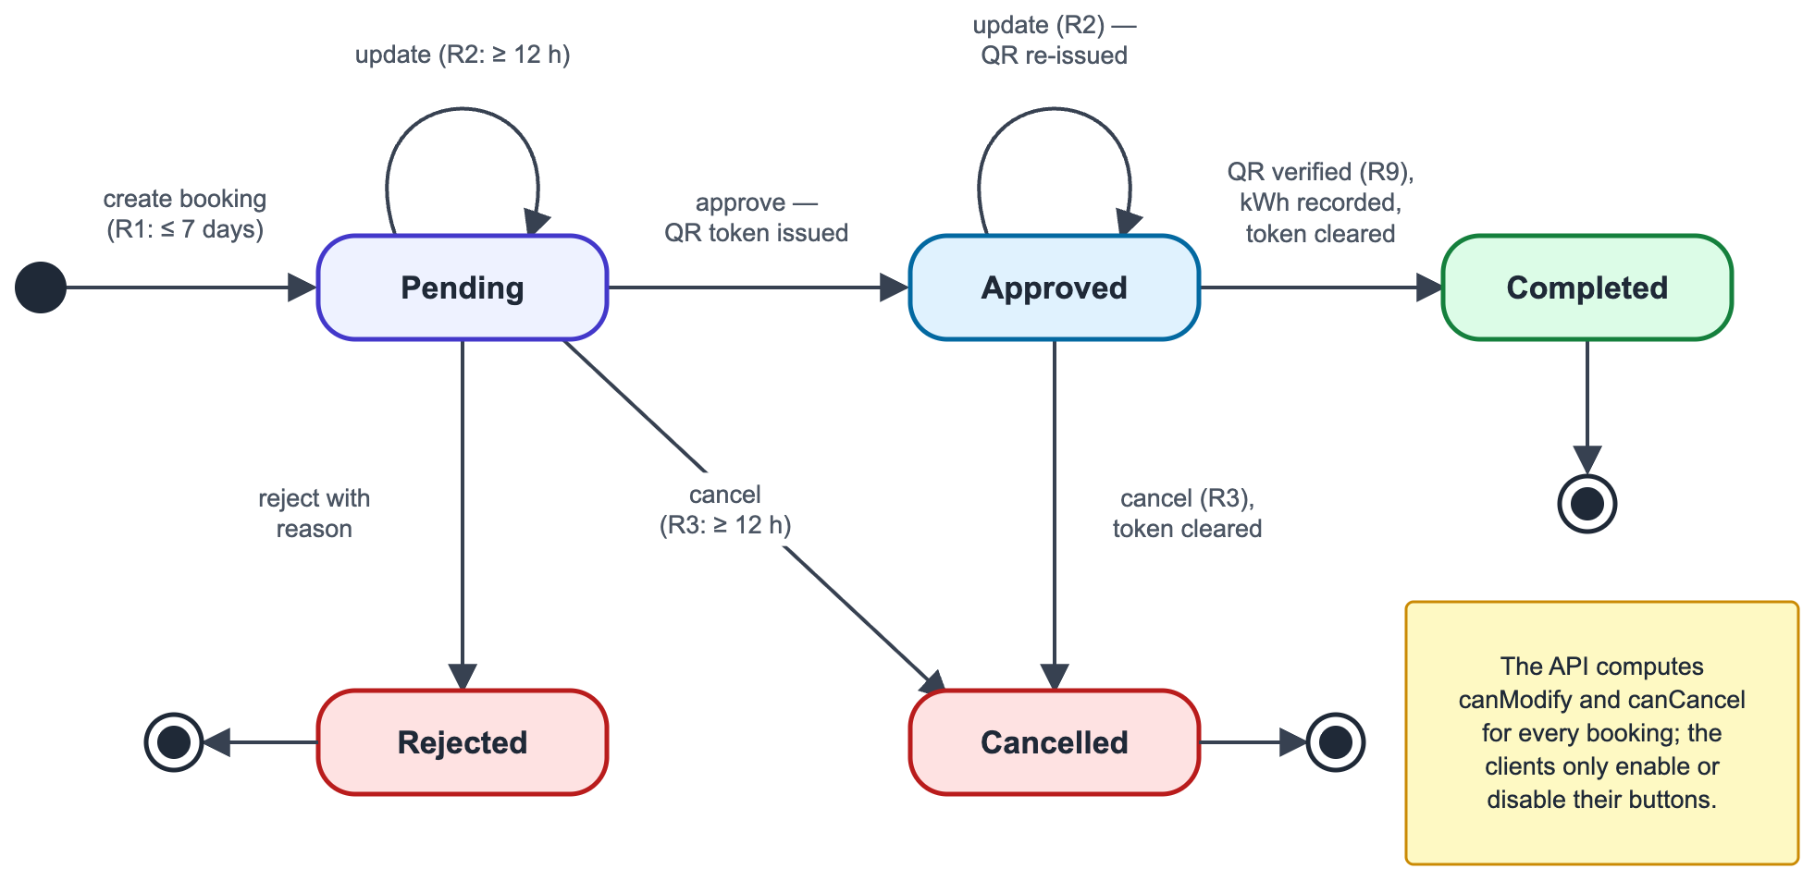
Figure 7: Reservation life cycle (state diagram)

8 Web Service (C# Web API)

8.1 Project Structure
SmartSolar.Api/
├── Controllers/ 7 thin controllers (Auth, Users, Prosumers, Stations, Slots, Reservations, Health)
├── Services/
│ ├── Interfaces/ IServices.cs — the whole service contract in one file
│ └── Implementations/
│ ├── AuthService.cs login, registration, password change
│ ├── UserService.cs Backoffice / Grid Operator accounts
│ ├── ProsumerService.cs prosumers keyed by NIC
│ ├── StationService.cs nodes, schedules, Haversine "nearby"
│ ├── SlotService.cs slots and bulk generation
│ ├── ReservationService.cs booking workflow and QR life cycle
│ ├── QrCodeGenerator.cs token creation and PNG rendering
│ └── DomainMapper.cs entity → DTO projections (canModify / canCancel)
├── Models/ the four MongoDB documents and enums
├── DTOs/ request / response contracts with validation attributes
├── Data/ MongoDbContext (collections + indexes), DataSeeder
├── Security/ PasswordHasher, JwtTokenService, CurrentUser
├── Middleware/ ExceptionHandlingMiddleware, MethodOverrideMiddleware
├── Common/ ApiResponse, ServiceResult, ErrorCodes, IClock, PagedResult
├── Program.cs composition root and HTTP pipeline
└── web.config IIS / ASP.NET Core Module configuration

Every .cs file begins with a comment header block (file, project, module, description, author, date) and every method begins with an inline comment, as the submission instructions require.

8.2 Authentication and Authorisation
Login accepts a NIC, a username or an e-mail address in one field. The lookup uses an anchored, case-insensitive regular expression built from escaped input, so regex metacharacters cannot be injected:
private static BsonRegularExpression CaseInsensitiveExact(string value)
{
// Regex.Escape neutralises metacharacters such as . * + ( ) so no pattern can be injected,
// and the ^...$ anchors keep the match to the whole field rather than a substring.
return new BsonRegularExpression("^" + Regex.Escape(value) + "$", "i");
}

"User not found" and "wrong password" return the same message, so the endpoint does not reveal which accounts exist. A successful login issues a JWT valid for eight hours carrying the user id, username, role, NIC and assigned node [24]. ClockSkew is zero, so an expired token is rejected immediately. Passwords are stored as salted PBKDF2-SHA256 hashes with 100 000 iterations [4], [25].
Table 15: Role-based access enforced by the API
Capability | Backoffice | Grid Operator | Prosumer
Create / modify web users | ✓
Activate or reactivate accounts | ✓
View prosumers | ✓ | ✓ | own profile only
Create / update / deactivate nodes | ✓
Update schedule and battery availability | ✓ | ✓
Create, generate, block slots | ✓ | ✓
Create / update / cancel reservations | ✓ | ✓ | own bookings only
Approve / reject reservations | ✓ | ✓
Verify QR and complete transfer | ✓ | ✓
View dashboard | all nodes | assigned node | own counts

8.3 Endpoint Summary
The API exposes 53 endpoints under the base path /api/v1, documented interactively through Swagger at /swagger. Full request and response shapes are specified in docs/API_CONTRACT.md.
Table 16: REST endpoints by controller
Controller | Count | Endpoints
AuthController | 4 | POST login · POST register · GET me · POST change-password
UsersController | 8 | list · get · create · update · activate · deactivate · reset-password · delete (Backoffice only)
ProsumersController | 9 | list · pending · get by NIC · create · update · activate · deactivate · request-deactivation · delete
StationsController | 10 | list · nearby · get · create · update · schedule · availability · activate · deactivate · delete
SlotsController | 8 | list · available · get · create · generate · update · block · delete
ReservationsController | 13 | list · my · history · dashboard · get · qr · create · update · cancel · approve · reject · verify-qr · complete
HealthController | 1 | health (reports database connectivity)

8.4 QR Code Issue and Verification
When a booking is approved the service generates a 32-byte random token and a compact JSON payload, which is rendered to a PNG by QRCoder on the server. The phone only displays the image; the operator's phone only scans it.
{"v":1,"t":"<token>","r":"RSV-20260907-0007","n":"200356701199","s":"STN-001","e":"2026-09-07T16:00:00Z"}

The critical security property is that the server trusts only the token. Every other field is re-read from MongoDB during verification, so a tampered payload claiming a different reservation number or NIC changes nothing. The scanner may post the bare token or the whole payload:
private async Task<ServiceResult<EnergyReservation>> ResolveApprovedByTokenAsync(
string rawToken, CancellationToken ct)
{
var token = (rawToken ?? string.Empty).Trim();

// A scanner may hand over the entire payload string instead of just the token, so a JSON looking
// input is parsed and its "t" member is taken.
//
// IMPORTANT: the server trusts ONLY the token. Every other fact about this booking - the prosumer,
// the node, the status, the times - is re-read from the database below. Nothing that was printed in
// the scanned payload is believed, because anybody can generate a QR image containing any text they
// like. The token is the sole credential; the database is the sole authority.
if (token.StartsWith("{", StringComparison.Ordinal))
{
try
{
using var document = JsonDocument.Parse(token);
if (document.RootElement.ValueKind == JsonValueKind.Object
&& document.RootElement.TryGetProperty("t", out var tokenElement)
&& tokenElement.ValueKind == JsonValueKind.String)
{
token = (tokenElement.GetString() ?? string.Empty).Trim();
}
}
catch (JsonException)
{
// Not valid JSON after all - fall back to treating the whole string as the token itself.
token = (rawToken ?? string.Empty).Trim();
}
}

On completion the token is cleared, so the same code cannot be scanned twice; if an approved booking is moved to another slot a fresh token is issued, so a screenshot of the old code cannot be replayed. Figure 8 shows the full sequence.
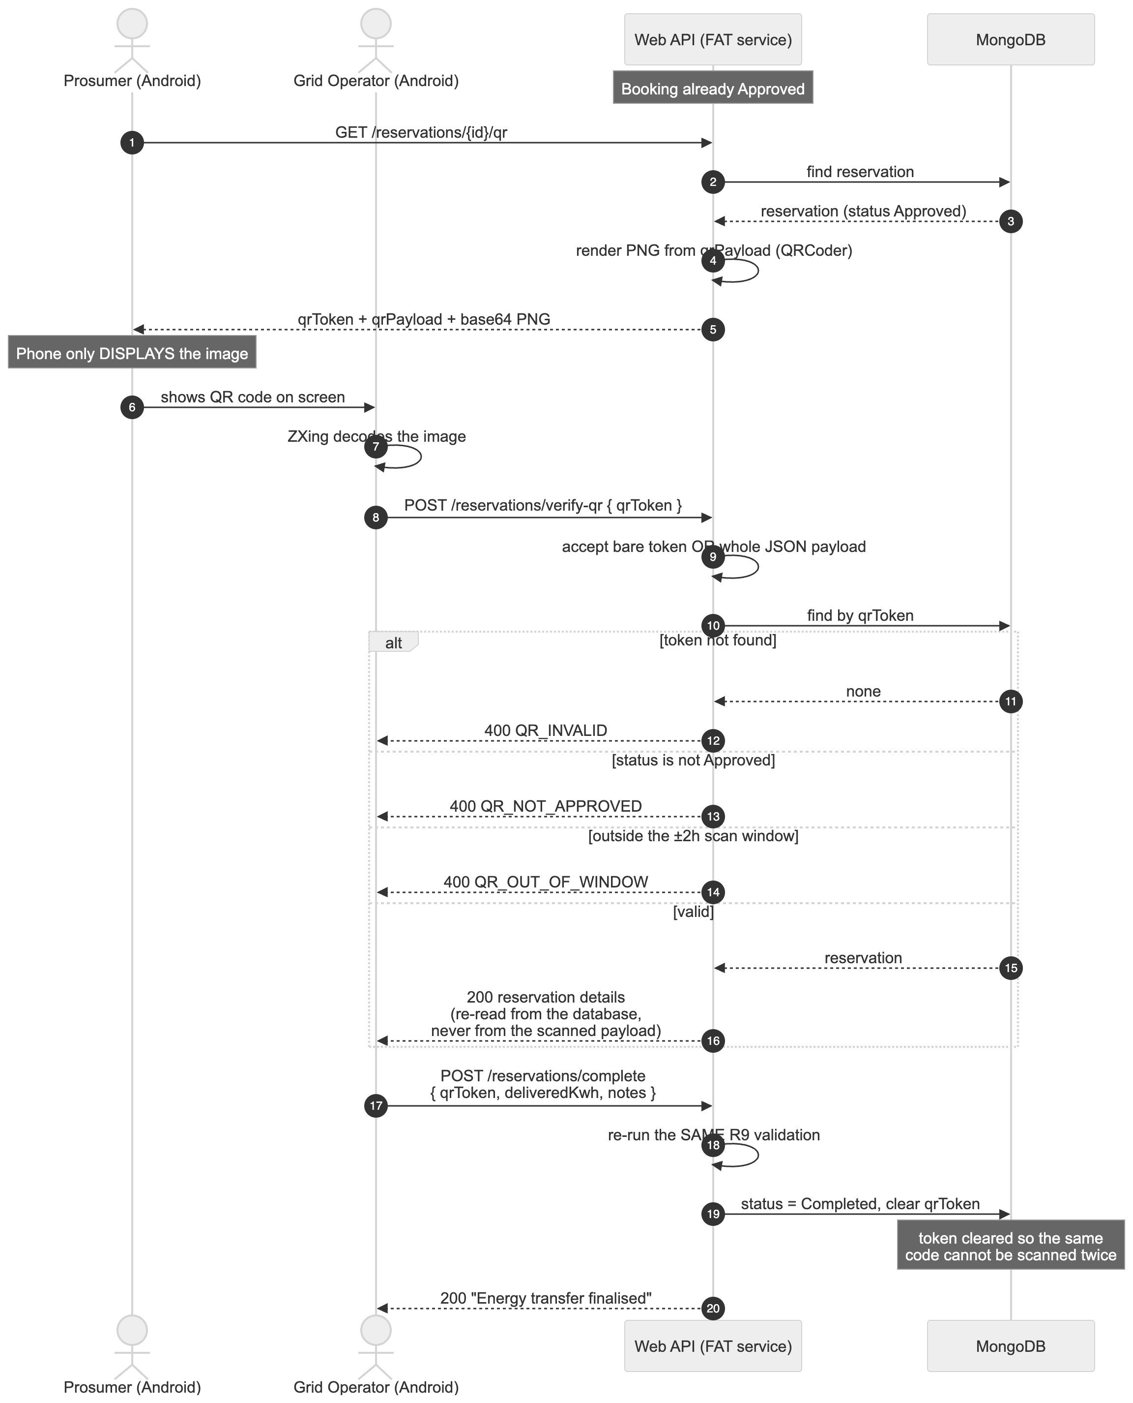
Figure 8: Sequence diagram — QR verification and transfer completion

8.5 Booking Workflow
Figure 9 shows where each rule fires when a booking is created. The client never sends the prosumer's NIC; the API takes it from the caller's token (R11).
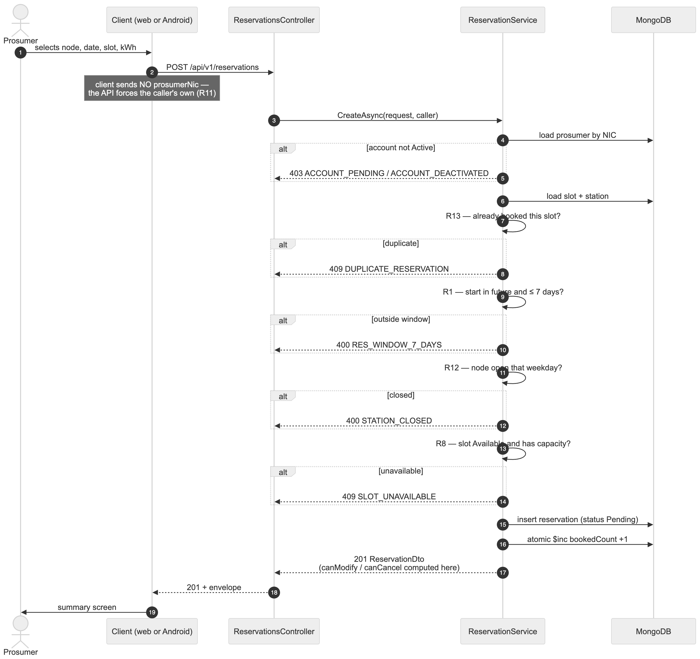
Figure 9: Sequence diagram — booking creation and rule evaluation

8.6 Server-Side Distance Calculation
The "nearby nodes" feature illustrates the FAT service rule well. Sending every node to the client and letting it compute distances is exactly what the constraint forbids, so the Haversine formula [23] runs in StationService and the clients receive a finished distanceKm:
private static double HaversineKm(double lat1, double lon1, double lat2, double lon2)
{
// Trigonometry in .NET works in radians, so every degree value is converted first.
var lat1Rad = DegreesToRadians(lat1);
var lat2Rad = DegreesToRadians(lat2);
var deltaLat = DegreesToRadians(lat2 - lat1);
var deltaLon = DegreesToRadians(lon2 - lon1);

var a = Math.Sin(deltaLat / 2) * Math.Sin(deltaLat / 2)
+ Math.Cos(lat1Rad) * Math.Cos(lat2Rad)
* Math.Sin(deltaLon / 2) * Math.Sin(deltaLon / 2);

var c = 2 * Math.Atan2(Math.Sqrt(a), Math.Sqrt(1 - a));

return EarthRadiusKm * c;
}

8.7 Concurrency
The slot's bookedCount is maintained with MongoDB's atomic $inc operator [9] rather than a read-modify-write, so two prosumers booking the last place at the same moment cannot both succeed:
// $inc is applied atomically by the MongoDB server itself, so two concurrent bookings can never both
// read a stale count and write the same new value - one increment cannot overwrite the other. Reading
// the count into C#, adding one and writing it back would lose a booking under exactly that race.
await _db.Slots.UpdateOneAsync(
idFilter,
Builders<EnergyBookingSlot>.Update
.Inc(s => s.BookedCount, delta)
.Set(s => s.UpdatedAt, now),
cancellationToken: ct);

9 Web Application

9.1 Structure
The web application is a React 18 single-page application written in TypeScript, built with Vite and styled with Tailwind CSS 3 [17], [18]. It is purely a user interface: it holds no business rules and talks to the API through a single axios instance.
web/src/
├── api/
│ ├── client.ts axios instance, JWT interceptor, ApiError, envelope unwrapper
│ └── services.ts one typed function per endpoint
├── components/
│ ├── ui.tsx Spinner, Modal, ConfirmDialog, Toast, StatCard, Pagination …
│ ├── Layout.tsx sidebar shell, role-filtered navigation, live API health indicator
│ └── ProtectedRoute.tsx
├── context/AuthContext.tsx session state and role helpers
├── pages/ 12 screens
├── types/index.ts TypeScript mirrors of every API DTO
└── utils/format.ts date and status-badge helpers

9.2 Error Handling
A single response interceptor turns every failure into a typed ApiError, so each screen has one thing to catch and can show the server's message or branch on its error code:
// Converts every failure into an ApiError so callers have one thing to catch.
http.interceptors.response.use(
(response) => response,
(error: AxiosError<ApiResponse<unknown>>) => {
// No response at all means DNS, CORS, a timeout or a stopped API.
if (!error.response) {
return Promise.reject(
new ApiError(
'Could not reach the Smart Solar service. Please confirm the API is running.',
0,
'NETWORK_ERROR',
),
);
}

const { status, data } = error.response;
return Promise.reject(
new ApiError(
data?.message ?? `The request failed with HTTP ${status}.`,
status,
data?.errorCode ?? null,
data?.errors ?? null,
),
);
},

9.3 Routes and Role-Based Access
Table 17: Web application routes
Route | Screen | Roles
/ | Public landing (index) page | anyone
/login | Sign in with role-based redirect | anyone
/dashboard | Live counters, status chart, upcoming bookings | all signed-in users
/reservations | Filterable list; approve, reject, cancel | Backoffice, Grid Operator
/reservations/:id | Detail, QR panel, audit trail | owner / staff
/stations | Node cards; edit, schedule, availability, activate | all (editing: Backoffice)
/slots | Slot table; create, bulk generate, block, delete | Backoffice, Grid Operator
/prosumers | Prosumer register keyed by NIC | Backoffice, Grid Operator
/prosumers/pending | Pending-activation queue | Backoffice
/users | Web user administration | Backoffice
/map | Leaflet map of all nodes | all signed-in users
/profile | Own profile and password change | all signed-in users

ProtectedRoute redirects a user whose role is not allowed, and Layout hides navigation entries the role cannot use. These are conveniences only: the API enforces the same boundary on every request, as Figure 23 shows for a prosumer who signs in to the web portal.
Why Leaflet rather than Google Maps on the web? The Google Maps JavaScript API requires a billing-enabled key, whereas Leaflet with OpenStreetMap tiles needs no key, so the map works on any machine — including a marker's. Google Maps is used on the Android client, where the specification requires it.

10 Android Application

10.1 Compliance with the "Pure Native" Constraint
Table 18: Native Android technology choices
Concern | Choice | Deliberately not used
Language | Java | Kotlin, Flutter, React Native, Xamarin
Views | XML layouts + findViewById | View binding, data binding, Jetpack Compose
Networking | java.net.HttpURLConnection | Retrofit, OkHttp, Volley
JSON | org.json (bundled with Android) | Gson, Jackson, Moshi
Persistence | SQLiteOpenHelper | Room or any ORM
Concurrency | ExecutorService + Handler | RxJava, Kotlin coroutines
Dependency injection | Plain constructors | Dagger, Hilt

The only third-party artefacts are AndroidX and Material components (Google's standard UI toolkit), play-services-maps and play-services-location for the map, and zxing-android-embedded for scanning — libraries, not application frameworks. The app targets API 35 with a minimum of API 24.

10.2 Networking
ApiClient wraps HttpURLConnection, runs each request on a fixed thread pool and posts the result back to the main looper so activities can update views directly:
/** Queues the request on the background pool and marshals the reply to the UI thread. */
private void enqueue(final String method, final String path, final JSONObject body,
final String token, final Callback callback) {
// A connectivity check up front turns a 20 second timeout into an instant message.
if (!isOnline()) {
MAIN_HANDLER.post(() -> callback.onResult(
ApiResult.networkFailure("No internet connection. Please check your network and try again.")));
return;
}

EXECUTOR.execute(() -> {
final ApiResult result = execute(method, path, body, token);
MAIN_HANDLER.post(() -> callback.onResult(result));
});
}

10.3 Screens
Table 19: Android activities
Activity | Purpose
SplashActivity | Reads the SQLite session and routes to the correct home screen by role
LoginActivity | Sign in with NIC or username; handles ACCOUNT_PENDING and ACCOUNT_DEACTIVATED distinctly
RegisterActivity | Prosumer self-registration with NIC as primary key
ProsumerHomeActivity | Dashboard: live counts, quick actions, upcoming bookings (main opening screen)
OperatorHomeActivity | Operator console scoped to the assigned node, with the QR scanner as primary action
NewBookingActivity | Node → date → slot → energy booking flow
MyBookingsActivity | Current, Pending and History tabs plus search
BookingDetailActivity | Detail and QR display; edit and cancel enabled from server flags; staff approve/reject
EditBookingActivity | Move to another slot or change the energy amount
BookingSummaryActivity | Summary page shown after every create, update and cancel
StationsMapActivity | Google Maps with nearby nodes ranked by the API
StationDetailActivity | Node details on marker selection
ScannerActivity | QR scanning with ZXing; manual token entry for emulators
VerifyResultActivity | Verified booking; records delivered kWh and finalises the transfer
OperatorBookingsActivity | Node bookings with status filter and debounced search
ProfileActivity | Edit profile, change password, request deactivation

11 User Interface Screenshots
The screenshots below were captured from the running system with the seeded demonstration data. Each screen is unique; together they cover every page of the web application and every activity of the Android application.

11.1 Web Application
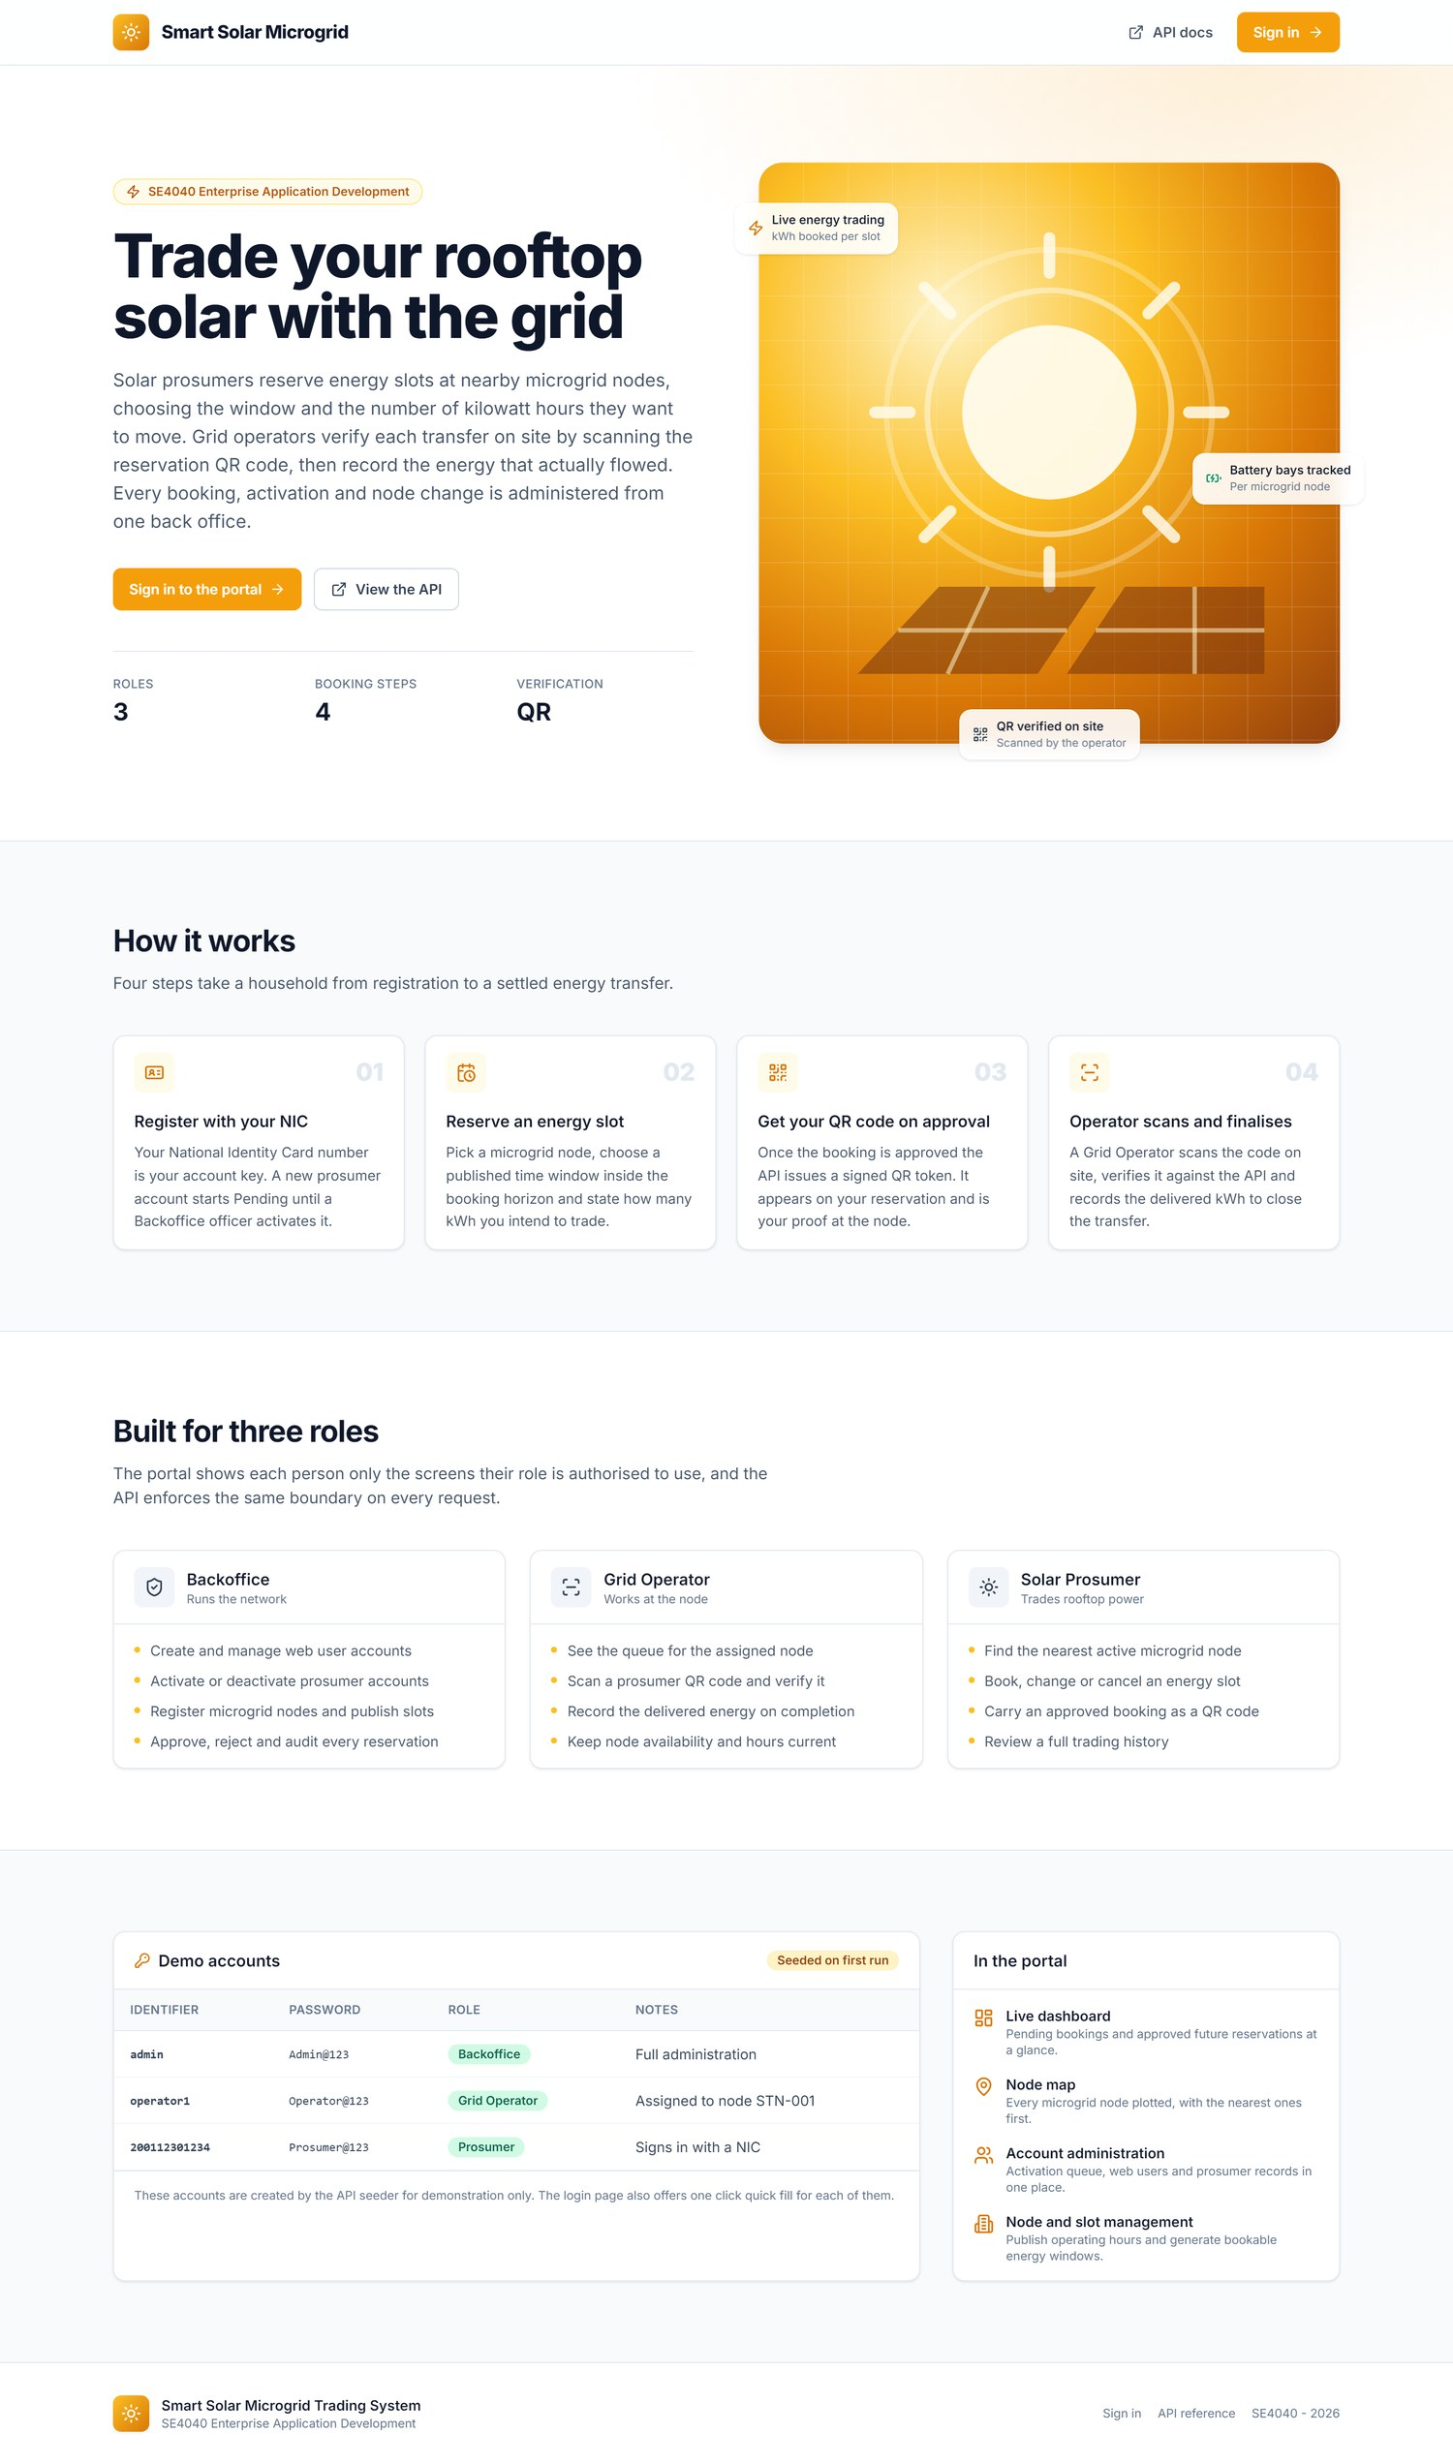
Figure 10: Home (index) page — public landing page describing the workflow, the three roles and the demo accounts
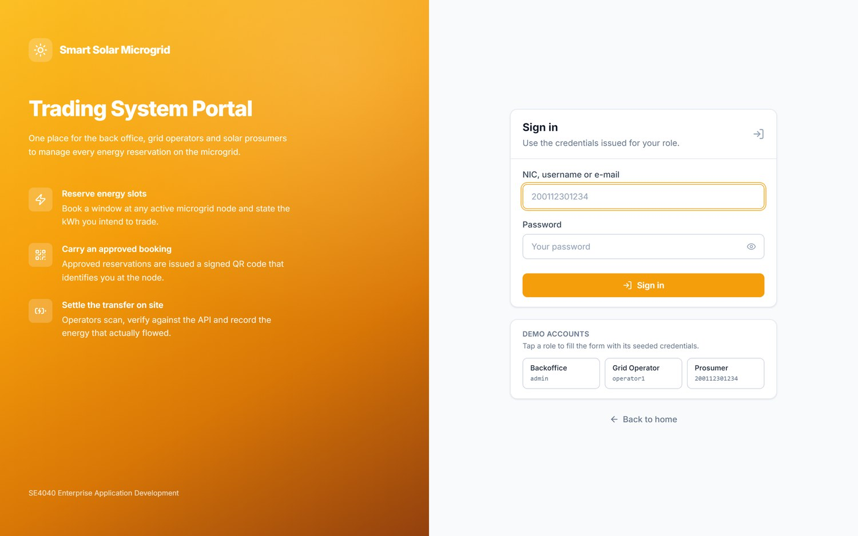
Figure 11: Login — a single sign-in for every role, accepting a NIC, username or e-mail, with role-based redirect
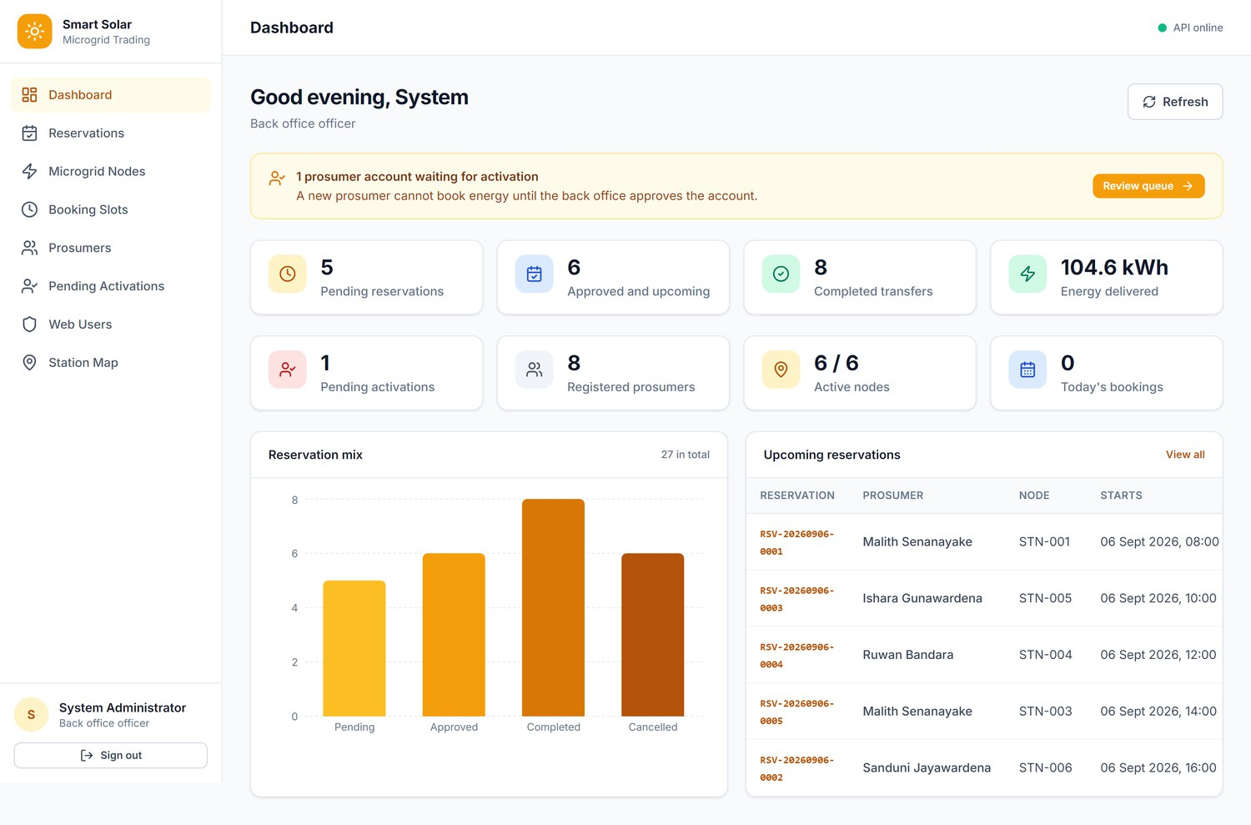
Figure 12: Backoffice dashboard — live counters, pending-activation banner, reservation mix chart and upcoming bookings
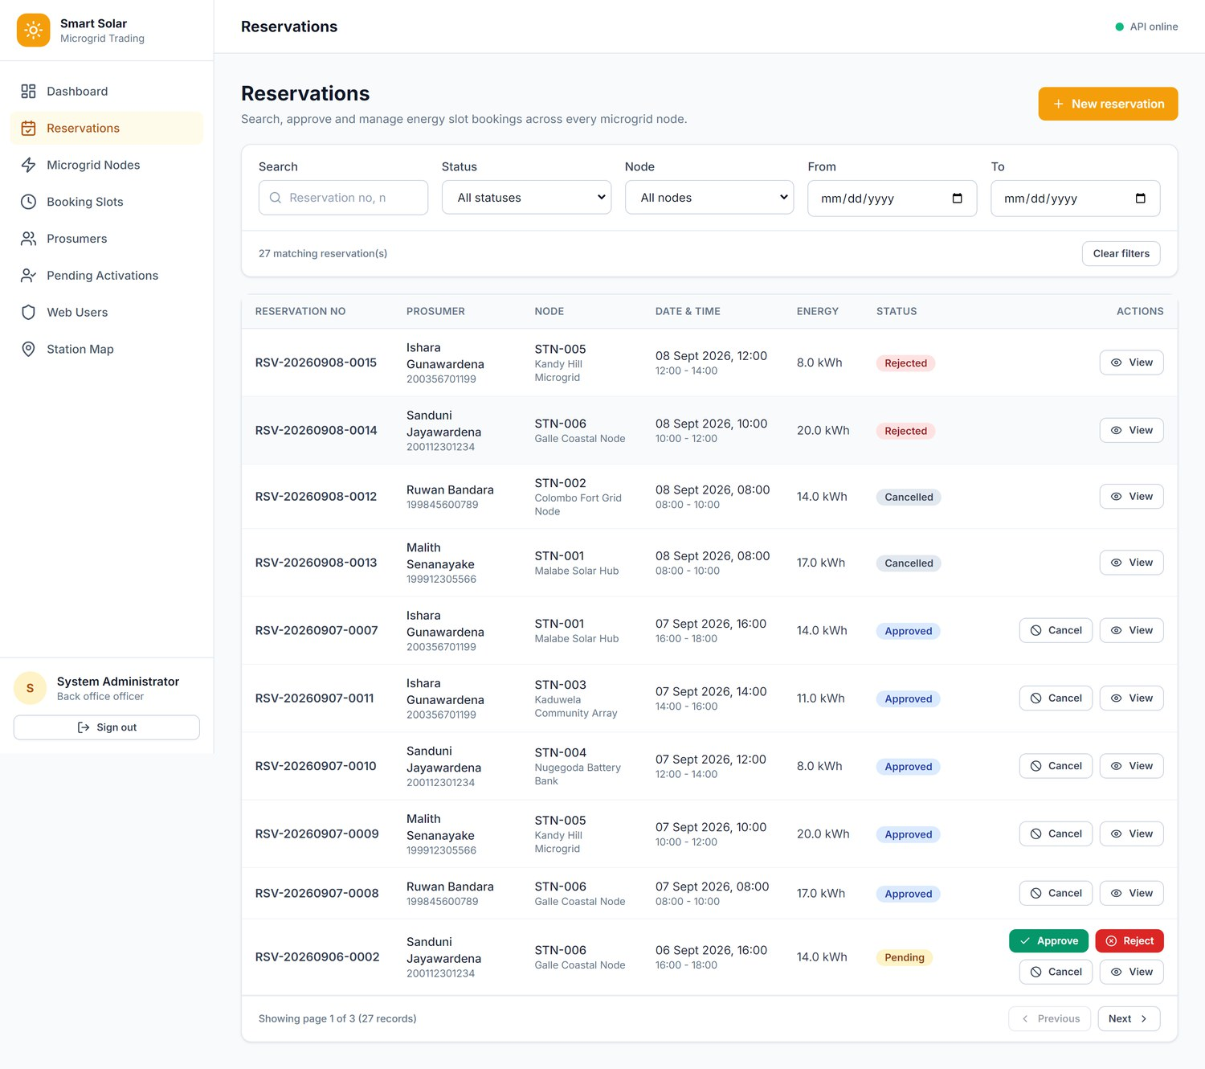
Figure 13: Reservations — search, status, node and date filters; approve, reject and cancel actions driven by server flags
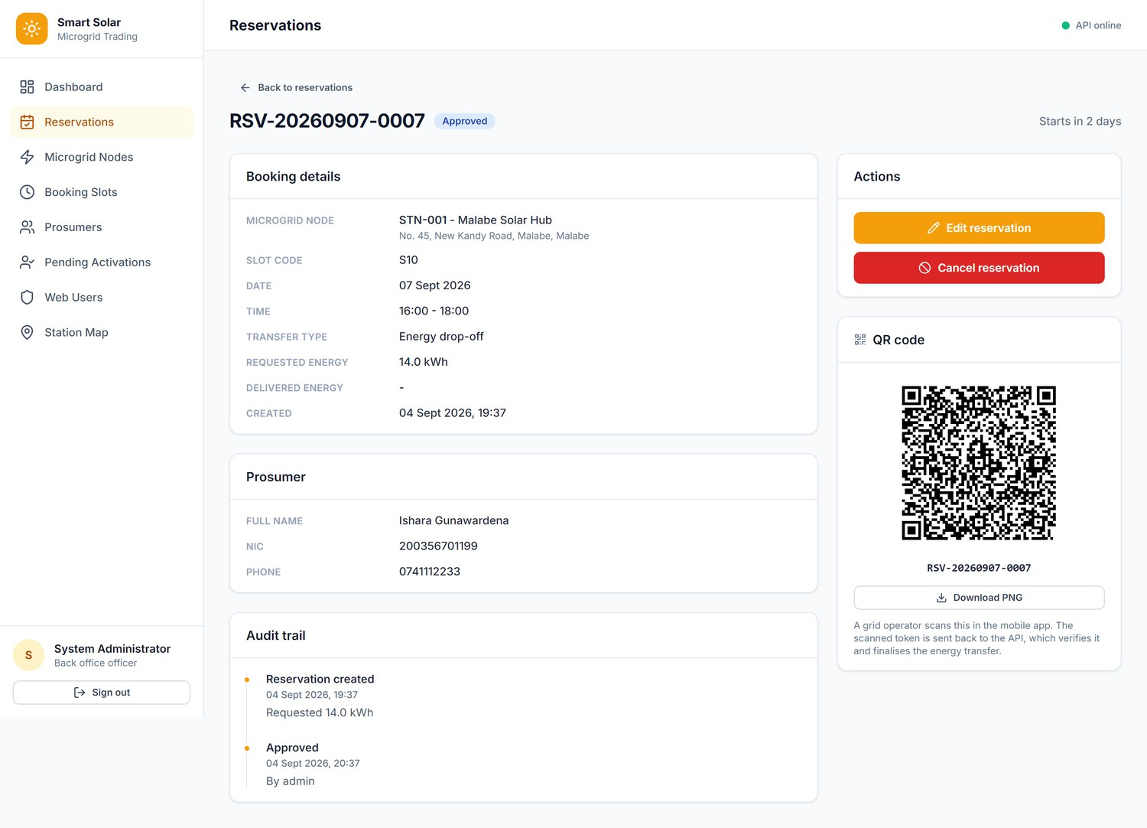
Figure 14: Reservation detail — booking and prosumer details, audit trail and the server-generated QR code
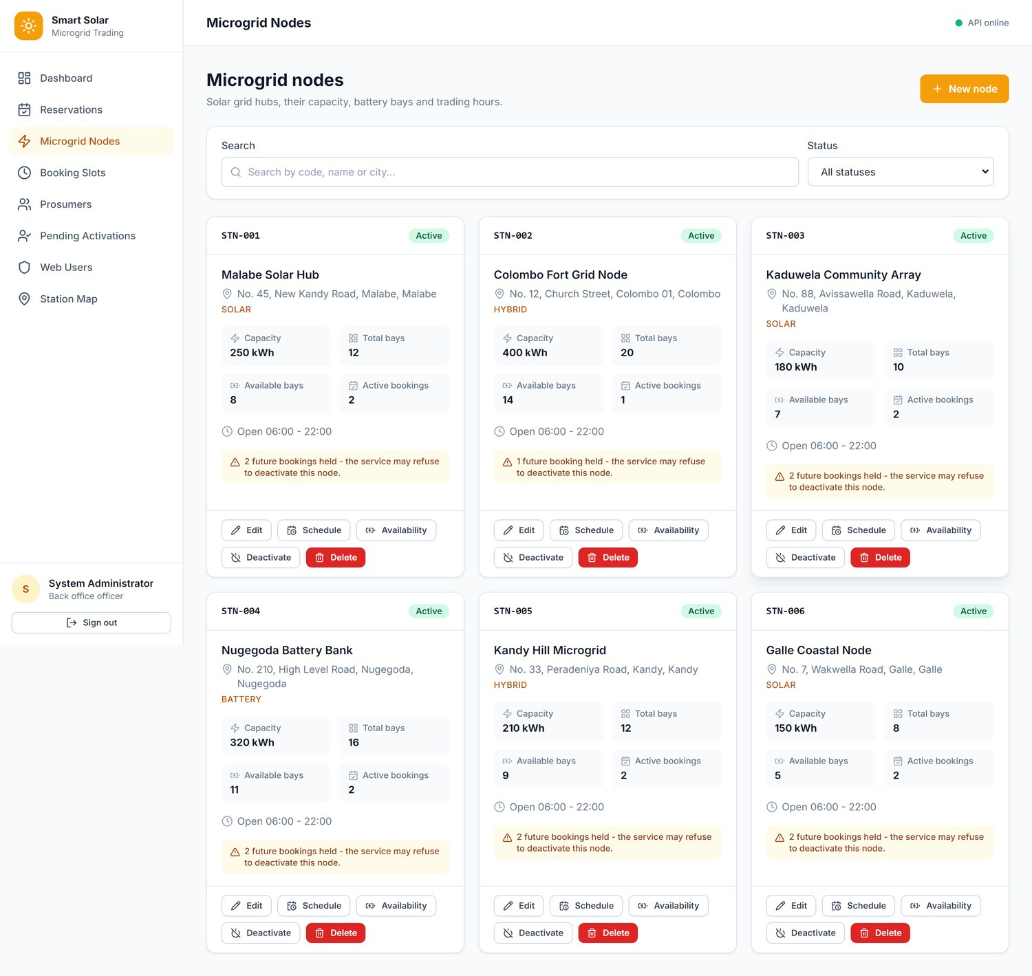
Figure 15: Microgrid nodes — capacity, battery bays, opening hours and the R4 warning for nodes with future bookings
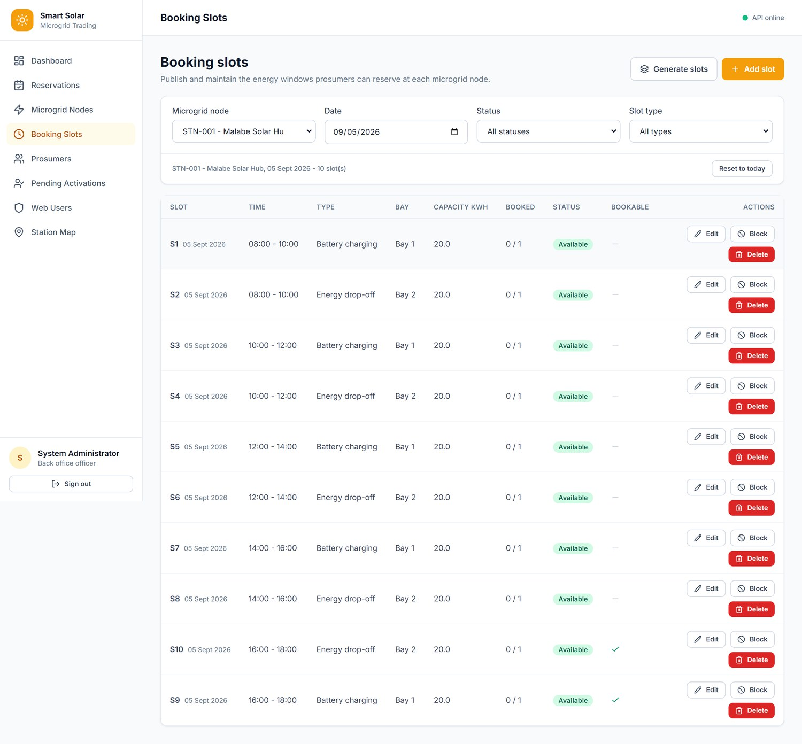
Figure 16: Booking slots — per node and date, with bulk generation, add, edit, block and delete
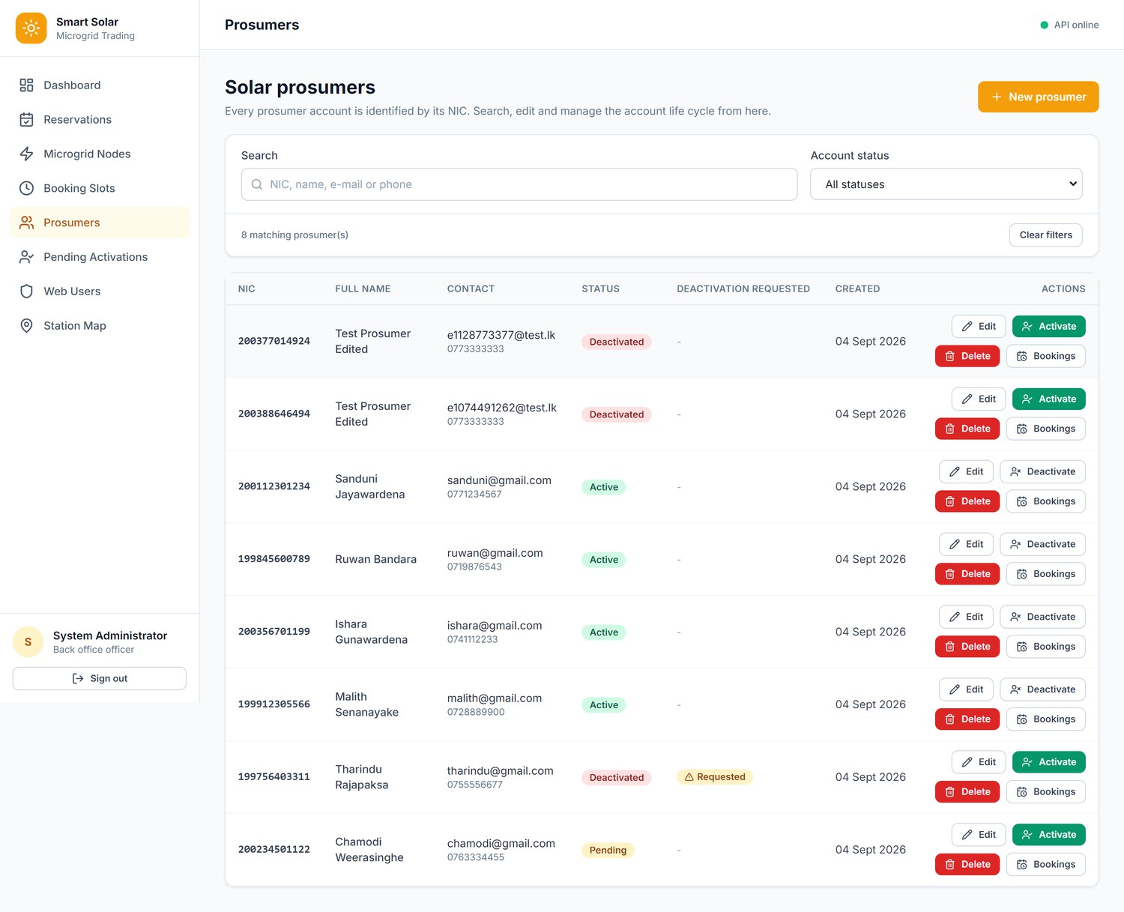
Figure 17: Prosumers — the NIC-keyed prosumer register with status filtering and account actions
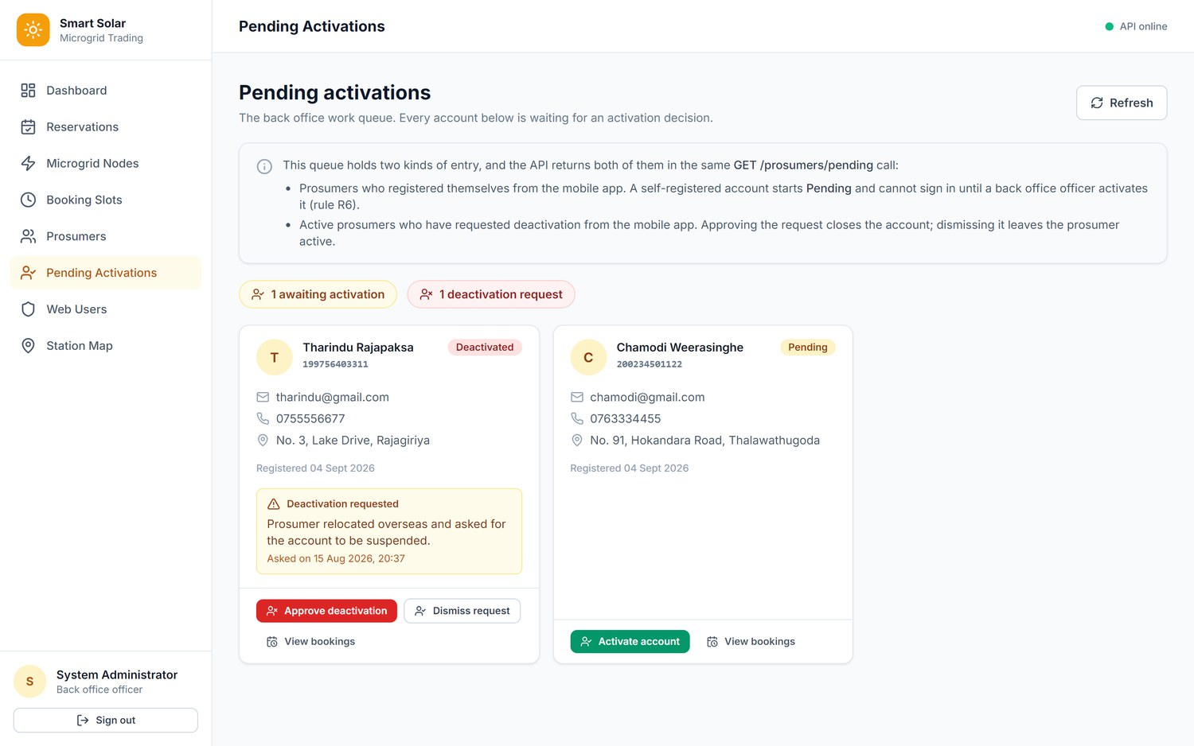
Figure 18: Pending activations — the Backoffice queue of self-registered accounts (R6) and deactivation requests
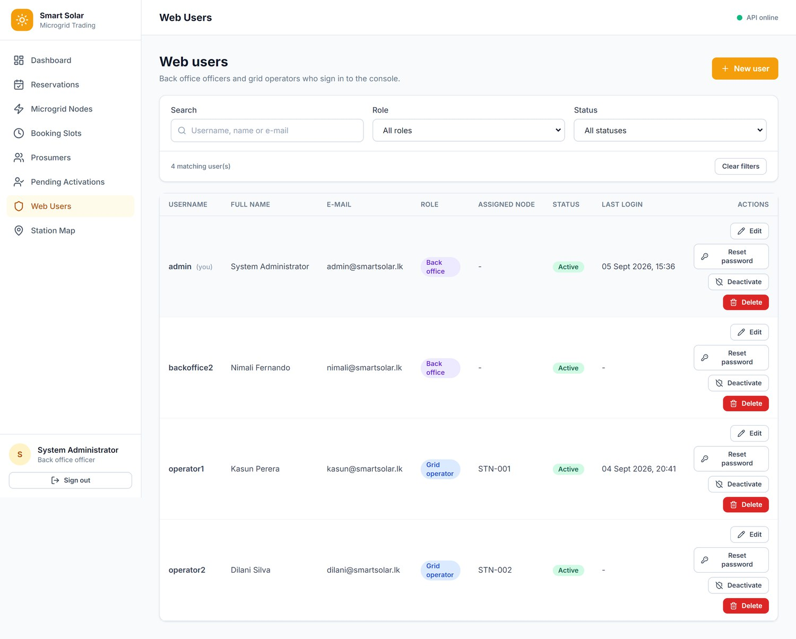
Figure 19: Web users — Backoffice-only administration of Backoffice and Grid Operator accounts (R10)
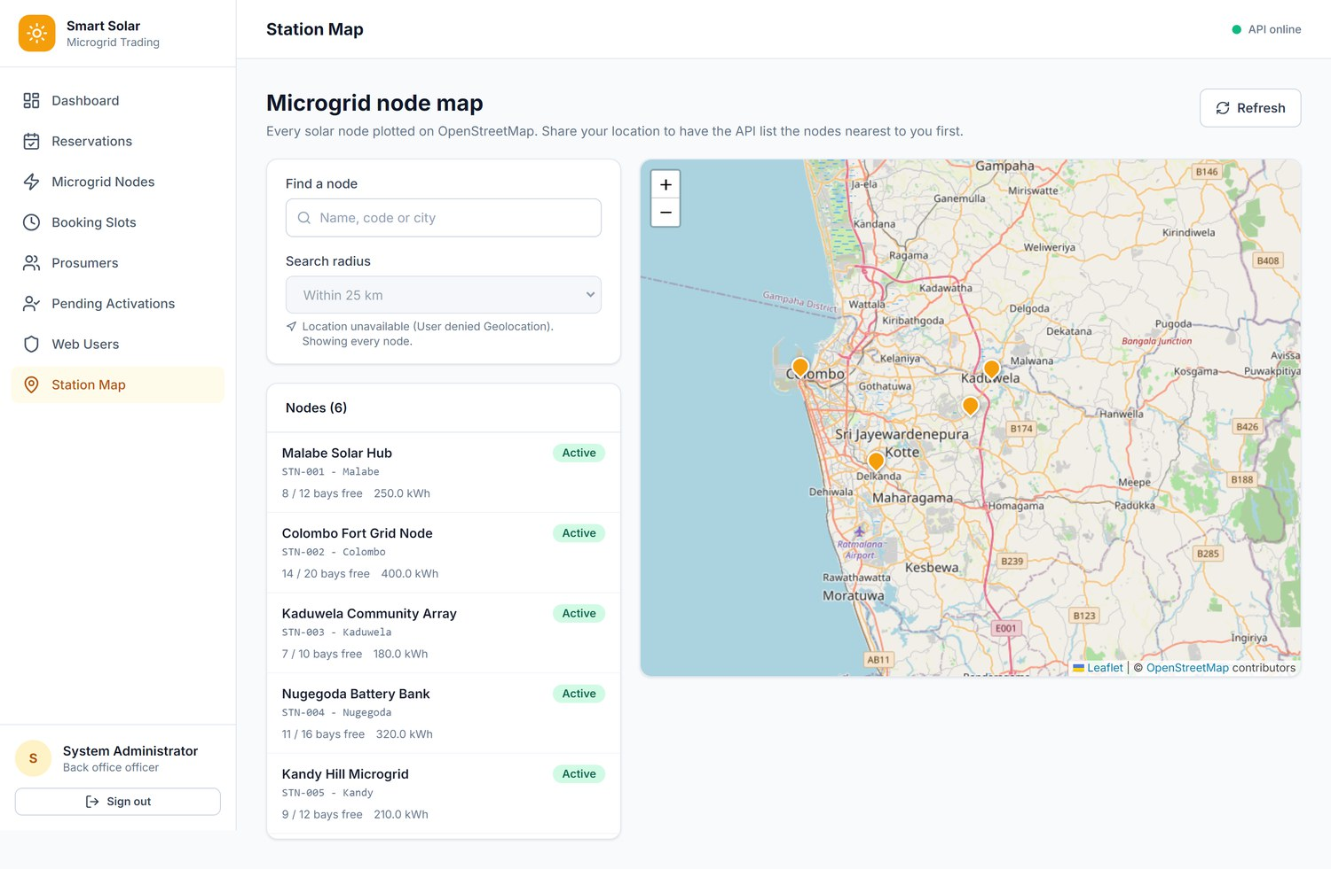
Figure 20: Station map — every microgrid node plotted from its stored GPS coordinates (Leaflet)
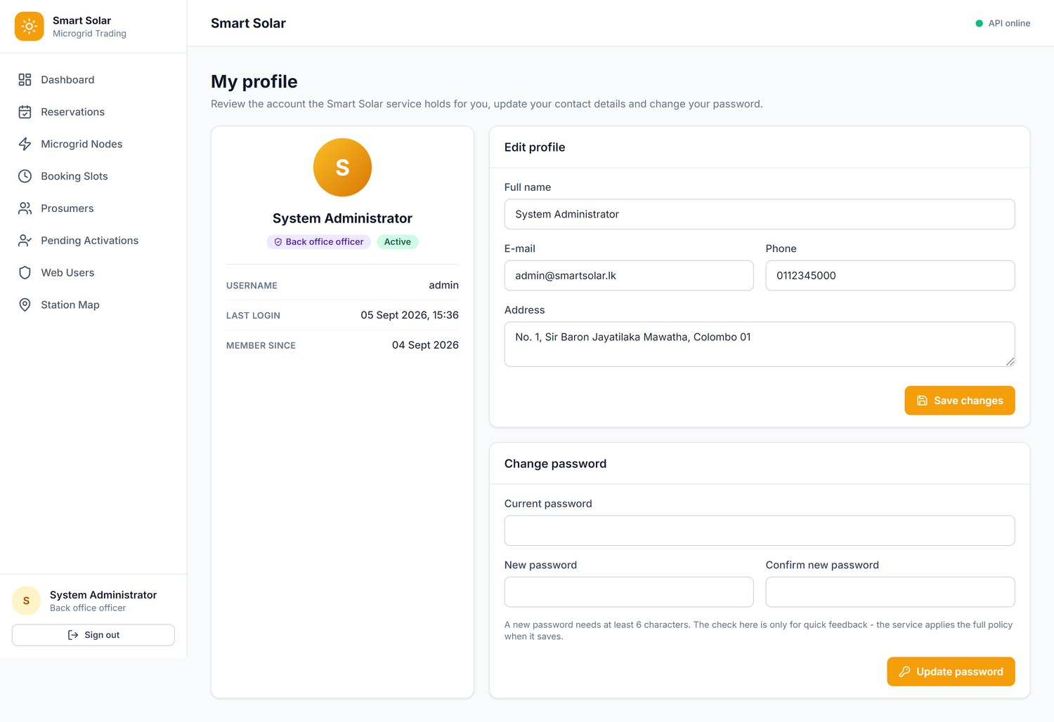
Figure 21: Profile — edit own details and change password
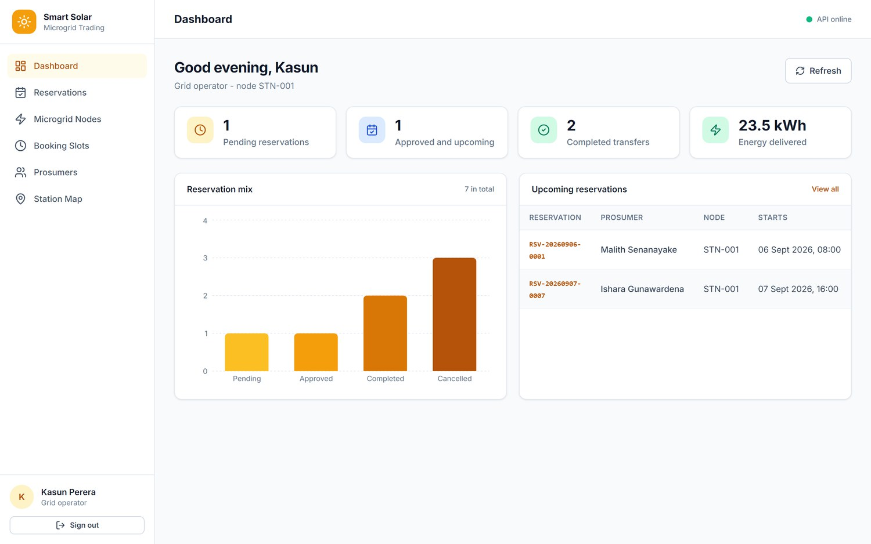
Figure 22: Grid Operator dashboard — counters scoped to the operator's assigned node (STN-001)
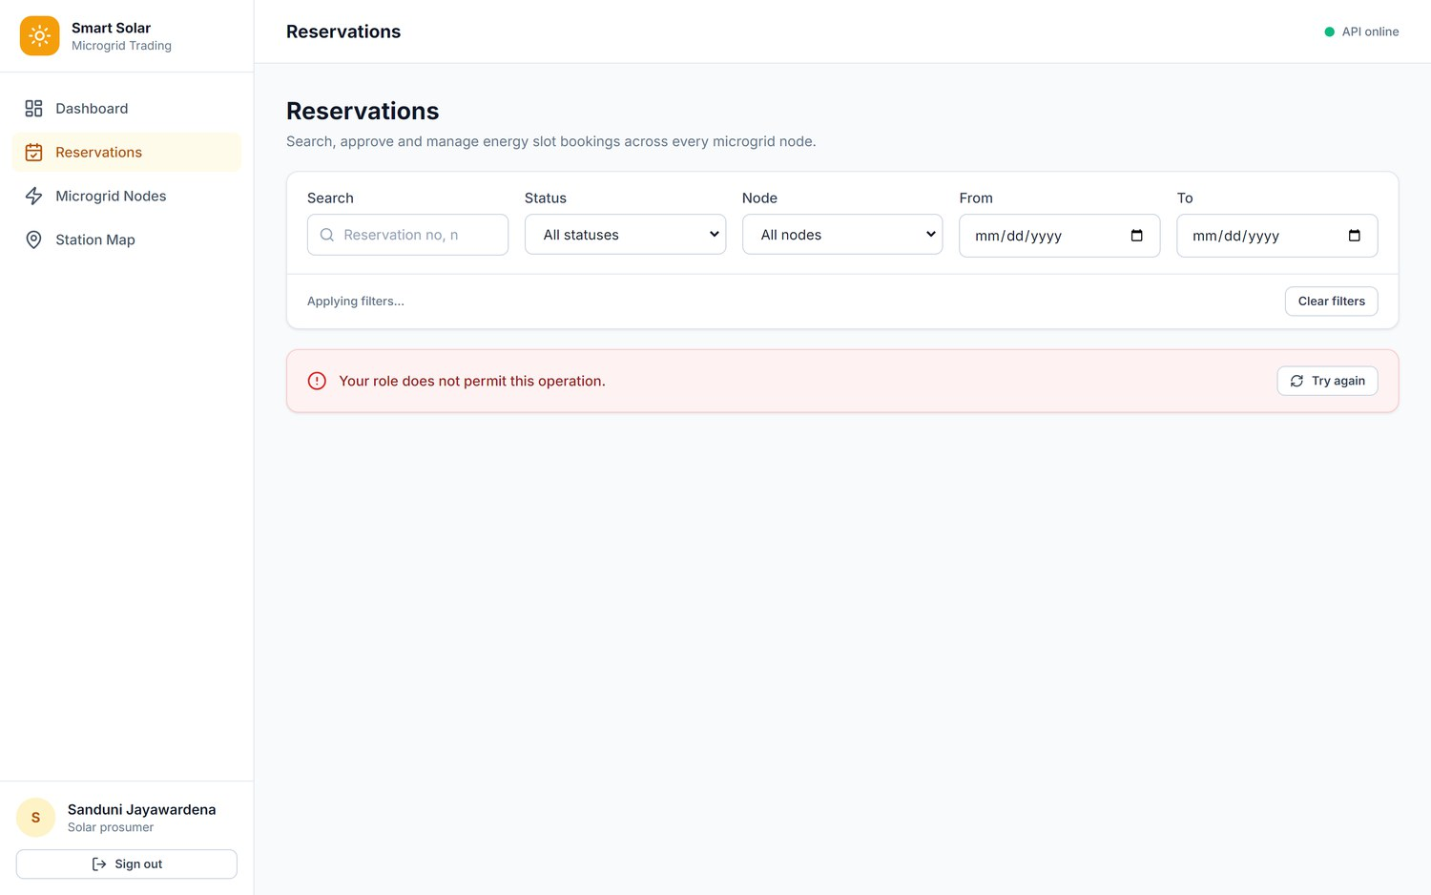
Figure 23: Role enforcement — a prosumer signed in to the web portal sees reduced navigation and the API refuses the staff-only list
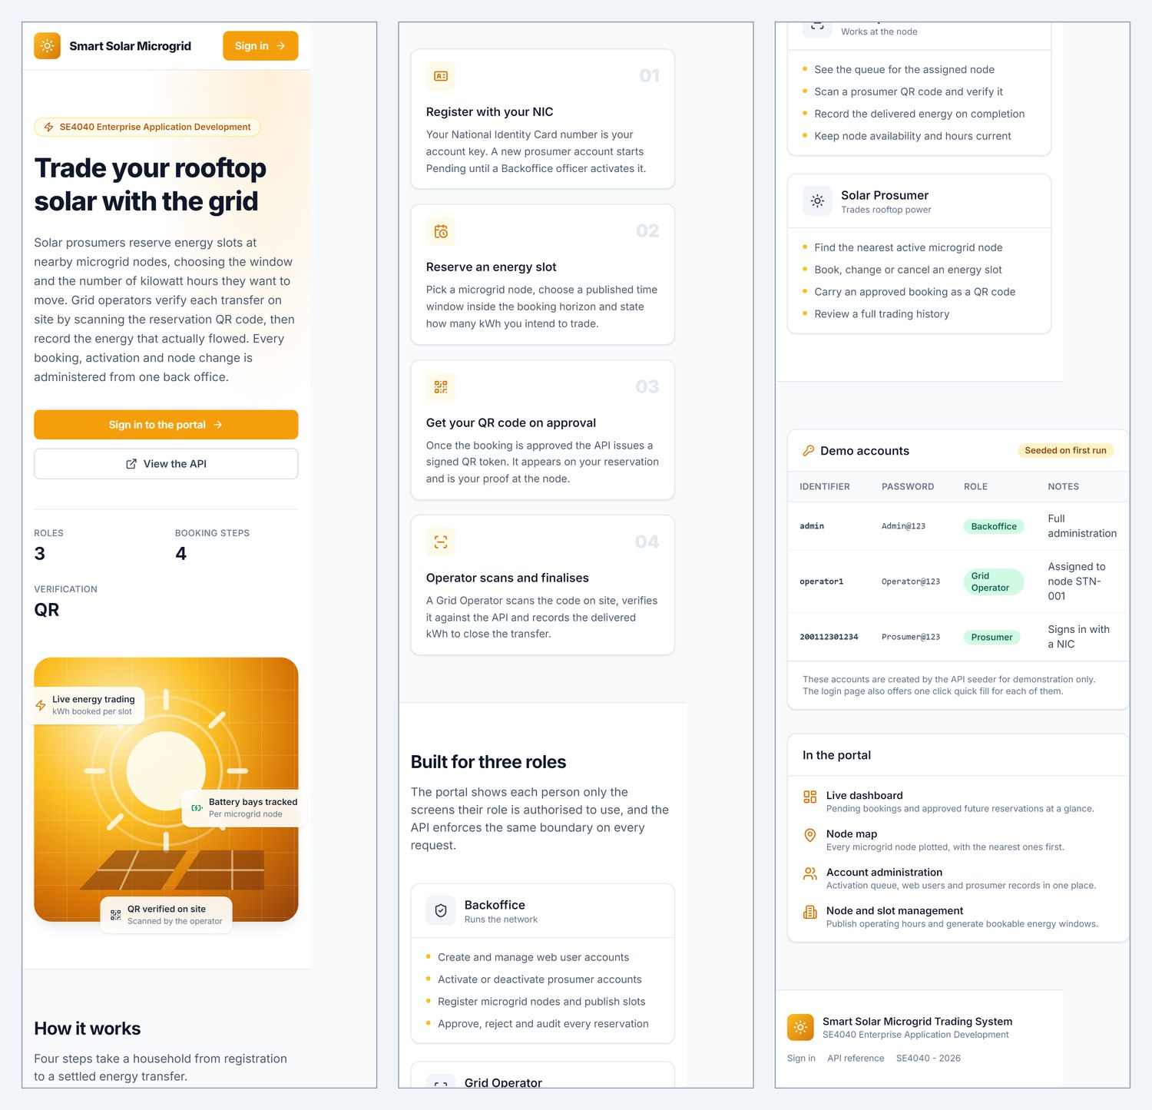
Figure 24: Responsive layout — the home page at 390 px phone width, shown in three consecutive segments

11.2 Android Application
The Prosumer Home screen (Figure 28) is the main opening screen of the app and is also supplied as a separate image in the submission archive, as the instructions require. Screens were captured on an Android emulator (API 35, Google APIs image) following docs/CAPTURE_MOBILE_SCREENSHOTS.md.
Action needed before submission: paste each Android screenshot into its frame below (click the frame text, then Insert → Pictures), and delete this note.
Paste screenshot 01  Splash screen | Paste screenshot 02  Login | Paste screenshot 03  Register with NIC
Figure 25: Android — Splash screen | Figure 26: Android — Login | Figure 27: Android — Register with NIC
Paste screenshot 04  Prosumer Home — main opening screen | Paste screenshot 05  New booking — node selected | Paste screenshot 06  New booking — slots listed
Figure 28: Android — Prosumer Home — main opening screen | Figure 29: Android — New booking — node selected | Figure 30: Android — New booking — slots listed
Paste screenshot 07  Booking summary | Paste screenshot 08  My bookings — Current tab | Paste screenshot 09  My bookings — History tab
Figure 31: Android — Booking summary | Figure 32: Android — My bookings — Current tab | Figure 33: Android — My bookings — History tab
Paste screenshot 10  Booking detail with QR code | Paste screenshot 11  Edit booking | Paste screenshot 12  Nearby nodes on Google Maps
Figure 34: Android — Booking detail with QR code | Figure 35: Android — Edit booking | Figure 36: Android — Nearby nodes on Google Maps
Paste screenshot 13  Station detail | Paste screenshot 14  Profile and deactivation request | Paste screenshot 15  Grid Operator home
Figure 37: Android — Station detail | Figure 38: Android — Profile and deactivation request | Figure 39: Android — Grid Operator home
Paste screenshot 16  QR scanner | Paste screenshot 17  Verification result and finalise transfer | Paste screenshot 18  Operator node bookings
Figure 40: Android — QR scanner | Figure 41: Android — Verification result and finalise transfer | Figure 42: Android — Operator node bookings

12 Testing and Verification

12.1 API Verification Suite
The API was verified end to end against a live MongoDB instance with a scripted suite of 90 assertions (docs/verify-api.ps1) covering authentication, seed data, the map feature, the reservation workflow, every business rule, role enforcement, account management and the response envelope. The final run passed 90 of 90.
Table 20: API verification results
Area | Assertions | Result
Authentication and role routing | 11 | all pass
Seed data and collections | 9 | all pass
Map / nearby with server-side distance | 4 | all pass
Reservation workflow — R1, R8, R13 | 8 | all pass
12-hour rule — R2, R3 | 7 | all pass
Approval, QR issue / verify / complete — R9 | 9 | all pass
Dashboard counters | 7 | all pass
Prosumer views and search | 8 | all pass
Station deactivation guard — R4 | 1 | pass
Role enforcement — R10, R11 | 5 | all pass
Account management — R5, R6, R7 | 13 | all pass
Cancellation and validation envelope | 7 | all pass
HTTP verb override | 1 | pass
Total | 90 | 90 pass, 0 fail

Rules confirmed by direct observation include: a pending account refused login with ACCOUNT_PENDING; a deactivated account refused with ACCOUNT_DEACTIVATED and restored only by a Backoffice caller; a booking more than seven days out refused with RES_WINDOW_7_DAYS; a cancellation inside the twelve-hour window refused with RES_CANCEL_12H while canCancel was already false on the same record; a node with future bookings refused deactivation with STATION_HAS_ACTIVE_RES; a QR token accepted bare or as the full payload and rejected outside its window with QR_OUT_OF_WINDOW; and a prosumer blocked from reading another prosumer's profile.

12.2 Defects Found and Fixed
Table 21: Defects found during testing and their fixes
Defect | Root cause | Fix
Duplicate booking reported as SLOT_UNAVAILABLE | R8 ran before R13; the prosumer's own first booking had already filled a single-booking slot | Reordered checks in CreateAsync and UpdateAsync so R13 runs first
HTTP verb override had no effect | WebApplication inserts UseRouting() at the start of the pipeline, so routing rejected the POST with 405 before the header was read | Call app.UseRouting() explicitly after UseMethodOverride()
Android build: XML ParseError | -- is illegal inside an XML comment; five layouts used ---- Section ---- dividers | Removed the hyphen dividers
Android build: resource linking failed | Widget.SmartSolar.StatusChip had no parent, so Android inferred a non-existent parent from its dotted name | Added parent="android:Widget.TextView"
Android build: interface mismatch | ProsumerHomeActivity implemented a listener name that the adapter did not declare | Aligned it with OnReservationClick.onClick

12.3 Build Verification
Table 22: Build verification
Target | Command | Result
Web API | dotnet clean && dotnet build SmartSolar.sln | Succeeded, 0 warnings, 0 errors
Web application | npm run build (tsc -b && vite build) | Succeeded, 0 type errors
Android | ./gradlew assembleDebug (clean build directory) | Succeeded — app-debug.apk, 6.7 MB

13 Deployment

13.1 Prerequisites
Table 23: Prerequisites
Component | Version | Notes
.NET SDK | 8.0 | Required to build and publish the API
MongoDB Server | 6.0 or later | Listening on localhost:27017; indexes and seed data are created automatically
Node.js | 18 or later | For the web client
Android Studio / SDK | API level 35, JDK 17 | Android Gradle Plugin 8.7
IIS | Windows with the .NET 8 Hosting Bundle | Without the bundle IIS returns HTTP 500.19 / 500.31

13.2 Hosting the API on IIS
- Install the .NET 8 Hosting Bundle on the server, then restart IIS.
- Publish the API: dotnet publish SmartSolar.Api -c Release -o C:\inetpub\SmartSolarApi.
- In IIS Manager create an application pool with No Managed Code, and a site whose physical path is the publish folder.
- Grant the application-pool identity read and execute permission on the folder.
- Set MongoDbSettings:ConnectionString in the published appsettings.json.
- Browse to http://<host>/api/v1/health and confirm "database": "Connected"; Swagger is available at /swagger.
- Point the clients at the server: VITE_API_BASE_URL in web/.env and API_BASE_URL_DEBUG in mobile/local.properties, then rebuild both.
The published web.config registers the ASP.NET Core Module (AspNetCoreModuleV2) so IIS forwards requests to the application, and it permits the PUT, PATCH and DELETE verbs the API uses.

13.3 Running Locally
# 1. Web API (creates indexes and seeds data on first run)
cd backend
dotnet run --project SmartSolar.Api --urls "http://localhost:5218"

# 2. Web application -> http://localhost:5173
cd web
npm install
npm run dev

# 3. Android (emulator reaches the host through 10.0.2.2)
# mobile/local.properties: API_BASE_URL_DEBUG=http\://10.0.2.2\:5218/api/v1/ and MAPS_API_KEY=<key>
cd mobile
./gradlew installDebug

13.4 Demonstration Accounts
Table 24: Seeded demonstration accounts
Login | Password | Role | Purpose
admin | Admin@123 | Backoffice | Full administration
backoffice2 | Back@123 | Backoffice | Second officer
operator1 | Operator@123 | Grid Operator | Assigned to STN-001
operator2 | Operator@123 | Grid Operator | Assigned to STN-002
200112301234 | Prosumer@123 | Prosumer | Active, has bookings
199845600789 | Prosumer@123 | Prosumer | Active, has bookings
200234501122 | Prosumer@123 | Prosumer | Pending — demonstrates R6
199756403311 | Prosumer@123 | Prosumer | Deactivated — demonstrates R5

14 Git Repository and Demonstration Video
Git repository | https://github.com/wahallu/SmartSolarMicrogridTradingSystem
Demonstration video | [Add the YouTube / OneDrive link — max. 5 minutes]

The complete development history, including every commit, is available in the repository above. The README in the repository root gives the same links, the build instructions and the individual contributions.

15 Individual Contributions
The work was divided into four areas of roughly equal size, one per member, with architecture, testing and documentation shared.
Action needed: fill in the member for each work area and adjust the detail so it matches what each person actually built — every member will be questioned on their own area at the viva.
Table 25: Individual contributions
Work area | Member | Contribution
Web API — authentication, users and prosumers | [IT number — Name] | AuthController/AuthService (login by NIC, username or e-mail; prosumer self-registration as Pending; change password); UsersController/UserService (Backoffice-only web user management, activate, deactivate, reset password — R10); ProsumersController/ProsumerService (NIC-keyed profiles, pending-activation queue, deactivation requests — R5, R6, R7, R11); PasswordHasher (PBKDF2), JwtTokenService, CurrentUser.
Web API — stations, slots, reservations and QR; MongoDB | [IT number — Name] | StationService (nodes, schedules, availability, Haversine nearby search, R4); SlotService (slot publishing and bulk generation, R12); ReservationService (booking workflow, R1–R3, R8, R9, R13, dashboards, QR issue and verification with QRCoder, atomic $inc); MongoDbContext indexes and DataSeeder.
React web application | [IT number — Name] | All twelve pages, routing and ProtectedRoute; AuthContext; axios client and typed service layer; Tailwind design system and shared UI components; Recharts dashboard; Leaflet station map; responsive layout.
Native Android application | [IT number — Name] | All sixteen activities and layouts; ApiClient over HttpURLConnection; DatabaseHelper, SessionManager and LocalDataStore (SQLite); Google Maps nearby-node screen; ZXing QR scanner; operator verification and transfer completion.
Shared (whole group) | All members | API contract (docs/API_CONTRACT.md), architecture and diagrams, IIS deployment, the 90-assertion verification script, screenshots and this report.

15.1 Declared Use of AI Tools
The assignment is set at AI Assessment Scale Level 2 — AI Planning: AI tools may be used only while planning (brainstorming, outlining and preliminary research), and the implementation must be the members' own work [1]. Each member declares below which tools, if any, were used during planning and reflects on how those initial ideas became the final solution.
Table 26: AI tool disclosure
Member | AI tool(s) used during planning | Purpose | Reflection
[IT number — Name] | [Complete] | [Complete] | [Complete]
[IT number — Name] | [Complete] | [Complete] | [Complete]
[IT number — Name] | [Complete] | [Complete] | [Complete]
[IT number — Name] | [Complete] | [Complete] | [Complete]

16 Challenges and Lessons Learned
Keeping business logic out of the clients. The FAT service constraint is easy to violate accidentally. What made it hold was to stop sending the clients the inputs to a rule and send them the answer instead: canModify and canCancel are computed per record on the server, and the clients only enable or disable a control. Slot availability (isBookable) and node distance (distanceKm) were solved the same way.
Rule ordering changes the user experience. R8 and R13 both correctly rejected a duplicate booking, but in the wrong order the user was told "this slot is full" when the truth was "you already booked this slot". Getting a rule right is not the same as getting it helpful.
Pipeline ordering in ASP.NET Core. The verb-override middleware was correct but never ran in time, because WebApplication silently inserts UseRouting() at the front of the pipeline. Only an explicit app.UseRouting() moves it. The defect was caught only because the verification script asserted on the override path.
Cross-platform QR rendering. The obvious QRCoder renderer depends on System.Drawing.Common, which is Windows-only on .NET 8 and throws elsewhere. PngByteQRCode produces PNG bytes without it, and rendering on the server means the phone needs no QR encoding library at all — only a scanner.
Unique indexes over optional fields. A plain unique index on nic rejected a second staff account, because documents with nic: null collide. A sparse index scopes uniqueness to documents that actually have the field.
Denormalisation versus consistency. Copying node and prosumer names onto reservations removed an N+1 query on every list screen, but created an obligation to propagate renames, handled explicitly in StationService.UpdateAsync.
Time zones. Storing wall-clock strings alone made every rule ambiguous. Storing an absolute startUtc alongside the display string, and reading "now" through an injected IClock, removed a whole class of bugs and made the rules testable.
QR replay. A screenshot of a QR code is trivially reusable. The token is therefore cleared when a transfer completes and re-issued if an approved booking is moved to another slot.
Android build surprises. Three defects surfaced only when the APK was built: hyphen dividers inside XML comments, a style whose parent Android inferred from its dotted name, and a mismatched listener interface. Building early and often would have found them sooner.
Demonstrating QR scanning on an emulator. An emulator camera cannot easily present a real QR code, so ScannerActivity offers "Enter code manually". Rule R9 also refuses scans more than two hours from the slot, so demonstrations need a booking that starts soon.

17 Conclusion
The Smart Solar Microgrid Trading System meets the specification as a genuine three-tier client–server application. A single ASP.NET Core Web API hosted on IIS holds all thirteen business rules and is the only component that touches MongoDB; a React and Tailwind web application serves Backoffice officers and Grid Operators; and a pure native Android application with SQLite serves prosumers and operators in the field, including Google Maps node discovery and QR-based verification of each energy transfer.
The most valuable lesson was that an architectural constraint must be designed in, not just declared: returning rule verdicts instead of rule inputs, re-validating every write, and keeping database drivers out of the clients are what made the FAT service pattern hold. The verification suite of 90 assertions, all passing, gives confidence that the rules behave as specified.

18 References
[1] Sri Lanka Institute of Information Technology, "SE4040 Enterprise Application Development — Assignment 1: Smart Solar Microgrid Trading System," Faculty of Computing, SLIIT, Malabe, Sri Lanka, Aug. 2026.
[2] Microsoft, "Create web APIs with ASP.NET Core," Microsoft Learn. [Online]. Available: https://learn.microsoft.com/aspnet/core/web-api/
[3] Microsoft, "Host ASP.NET Core on Windows with IIS," Microsoft Learn. [Online]. Available: https://learn.microsoft.com/aspnet/core/host-and-deploy/iis/
[4] Microsoft, "Hash passwords in ASP.NET Core," Microsoft Learn. [Online]. Available: https://learn.microsoft.com/aspnet/core/security/data-protection/consumer-apis/password-hashing
[5] Microsoft, "ASP.NET Core middleware," Microsoft Learn. [Online]. Available: https://learn.microsoft.com/aspnet/core/fundamentals/middleware/
[6] MongoDB, Inc., "C#/.NET driver — fundamentals," MongoDB Documentation. [Online]. Available: https://www.mongodb.com/docs/drivers/csharp/current/fundamentals/
[7] MongoDB, Inc., "Indexes," MongoDB Manual. [Online]. Available: https://www.mongodb.com/docs/manual/indexes/
[8] MongoDB, Inc., "Sparse indexes," MongoDB Manual. [Online]. Available: https://www.mongodb.com/docs/manual/core/index-sparse/
[9] MongoDB, Inc., "$inc (update operator)," MongoDB Manual. [Online]. Available: https://www.mongodb.com/docs/manual/reference/operator/update/inc/
[10] Android Developers, "Save data using SQLite." [Online]. Available: https://developer.android.com/training/data-storage/sqlite
[11] Android Developers, "Connect to the network." [Online]. Available: https://developer.android.com/develop/connectivity/network-ops/connecting
[12] Android Developers, "Request runtime permissions." [Online]. Available: https://developer.android.com/training/permissions/requesting
[13] Google, "Maps SDK for Android overview," Google for Developers. [Online]. Available: https://developers.google.com/maps/documentation/android-sdk/overview
[14] Google, "Fused Location Provider API," Google for Developers. [Online]. Available: https://developers.google.com/location-context/fused-location-provider
[15] JourneyApps, "ZXing Android Embedded," GitHub repository. [Online]. Available: https://github.com/journeyapps/zxing-android-embedded
[16] codebude, "QRCoder — a pure C# QR code generator," GitHub repository. [Online]. Available: https://github.com/codebude/QRCoder
[17] Meta Open Source, "React documentation." [Online]. Available: https://react.dev/
[18] Tailwind Labs, "Tailwind CSS documentation." [Online]. Available: https://tailwindcss.com/docs
[19] Remix Software, "React Router." [Online]. Available: https://reactrouter.com/
[20] Recharts Group, "Recharts." [Online]. Available: https://recharts.org/
[21] V. Agafonkin, "Leaflet — an open-source JavaScript library for interactive maps." [Online]. Available: https://leafletjs.com/
[22] OpenStreetMap Foundation, "Tile usage policy." [Online]. Available: https://operations.osmfoundation.org/policies/tiles/
[23] C. Veness, "Calculate distance, bearing and more between latitude/longitude points," Movable Type Scripts. [Online]. Available: https://www.movable-type.co.uk/scripts/latlong.html
[24] M. Jones, J. Bradley and N. Sakimura, "JSON Web Token (JWT)," IETF RFC 7519, May 2015. [Online]. Available: https://datatracker.ietf.org/doc/html/rfc7519
[25] OWASP Foundation, "Password storage cheat sheet," OWASP Cheat Sheet Series. [Online]. Available: https://cheatsheetseries.owasp.org/cheatsheets/Password_Storage_Cheat_Sheet.html
[26] Swashbuckle.AspNetCore contributors, "Swashbuckle.AspNetCore," GitHub repository. [Online]. Available: https://github.com/domaindrivendev/Swashbuckle.AspNetCore
[27] Mermaid contributors, "Mermaid — diagramming and charting tool." [Online]. Available: https://mermaid.js.org/

Appendix A — Source Code
The principal source files are reproduced below as text, as the submission instructions require. They were chosen to show the FAT service layer, the data model, security, the web client's API layer and the Android client's networking, SQLite persistence and QR workflow. The complete source code — every controller, service, page, activity and layout — is in the submitted archive and in the Git repository listed in Section 14.

A.1 Web API (C#)

A.1.1 Program.cs
backend/SmartSolar.Api/Program.cs
/* =============================================================================
* File : Program.cs
* Project : Smart Solar Microgrid Trading System - Central Web API
* Module : Host / Composition root
* Description : Application entry point. Binds configuration, registers every
* service in the dependency injection container, configures JWT
* bearer authentication and CORS for the two clients, wires the
* HTTP pipeline and runs the MongoDB index and seed routines once
* at start-up.
*
* This is the only file that knows how the pieces fit together;
* the services themselves depend on interfaces only.
* Author : Smart Solar Microgrid Team - SE4040 Enterprise Application Dev
* Created : 2026-09-04
* =============================================================================
*/

using System.Text;
using System.Text.Json.Serialization;
using Microsoft.AspNetCore.Authentication.JwtBearer;
using Microsoft.AspNetCore.Mvc;
using Microsoft.IdentityModel.Tokens;
using Microsoft.OpenApi.Models;
using SmartSolar.Api.Common;
using SmartSolar.Api.Configuration;
using SmartSolar.Api.Data;
using SmartSolar.Api.Middleware;
using SmartSolar.Api.Security;
using SmartSolar.Api.Services.Implementations;
using SmartSolar.Api.Services.Interfaces;

var builder = WebApplication.CreateBuilder(args);

// -----------------------------------------------------------------------------
// 1. Configuration binding - a mis-spelled key now fails here rather than deep
// inside a service at request time.
// -----------------------------------------------------------------------------
builder.Services.Configure<MongoDbSettings>(builder.Configuration.GetSection(MongoDbSettings.SectionName));
builder.Services.Configure<JwtSettings>(builder.Configuration.GetSection(JwtSettings.SectionName));
builder.Services.Configure<BusinessRuleSettings>(builder.Configuration.GetSection(BusinessRuleSettings.SectionName));
builder.Services.Configure<SeedDataSettings>(builder.Configuration.GetSection(SeedDataSettings.SectionName));

var jwtSettings = builder.Configuration.GetSection(JwtSettings.SectionName).Get<JwtSettings>() ?? new JwtSettings();

// The signing secret must be long enough for HMAC-SHA256; refuse to start otherwise.
if (string.IsNullOrWhiteSpace(jwtSettings.Secret) || jwtSettings.Secret.Length < 32)
{
throw new InvalidOperationException(
"JwtSettings:Secret is missing or too short. Provide at least 32 characters in appsettings.json.");
}

// -----------------------------------------------------------------------------
// 2. Framework services
// -----------------------------------------------------------------------------
builder.Services.AddControllers()
.AddJsonOptions(options =>
{
// camelCase matches the contract and what both clients deserialise.
options.JsonSerializerOptions.PropertyNamingPolicy = System.Text.Json.JsonNamingPolicy.CamelCase;
options.JsonSerializerOptions.DefaultIgnoreCondition = JsonIgnoreCondition.WhenWritingNull;
// Enums are exchanged as their names ("Approved"), never as integers.
options.JsonSerializerOptions.Converters.Add(new JsonStringEnumConverter());
});

// Model binding failures are returned in the same envelope as every other error,
// so the clients need exactly one error handling path.
builder.Services.Configure<ApiBehaviorOptions>(options =>
{
options.InvalidModelStateResponseFactory = context =>
{
var errors = context.ModelState
.Where(entry => entry.Value is { Errors.Count: > 0 })
.ToDictionary(
entry => entry.Key,
entry => entry.Value!.Errors.Select(e => e.ErrorMessage).ToList());

var response = ApiResponse<object>.Fail(
"One or more validation errors occurred.",
ErrorCodes.ValidationFailed,
errors);

return new BadRequestObjectResult(response);
};
});

builder.Services.AddHttpContextAccessor();
builder.Services.AddEndpointsApiExplorer();

// Swagger doubles as the API documentation the report references, so it is
// configured with a bearer scheme that lets a marker try the secured endpoints.
builder.Services.AddSwaggerGen(options =>
{
options.SwaggerDoc("v1", new OpenApiInfo
{
Title = "Smart Solar Microgrid Trading System API",
Version = "v1",
Description = "FAT service for the SE4040 Enterprise Application Development assignment. "
+ "All business logic lives here; the web and Android clients are UI only."
});

options.AddSecurityDefinition("Bearer", new OpenApiSecurityScheme
{
Name = "Authorization",
Type = SecuritySchemeType.Http,
Scheme = "bearer",
BearerFormat = "JWT",
In = ParameterLocation.Header,
Description = "Paste the JWT returned by POST /api/v1/auth/login."
});

options.AddSecurityRequirement(new OpenApiSecurityRequirement
{
{
new OpenApiSecurityScheme
{
Reference = new OpenApiReference { Type = ReferenceType.SecurityScheme, Id = "Bearer" }
},
Array.Empty<string>()
}
});
});

// -----------------------------------------------------------------------------
// 3. Authentication and authorisation
// -----------------------------------------------------------------------------
builder.Services.AddAuthentication(options =>
{
options.DefaultAuthenticateScheme = JwtBearerDefaults.AuthenticationScheme;
options.DefaultChallengeScheme = JwtBearerDefaults.AuthenticationScheme;
})
.AddJwtBearer(options =>
{
// Tokens are validated on every request; ClockSkew is zeroed so an expired
// token is rejected immediately rather than up to five minutes later.
options.RequireHttpsMetadata = false;
options.SaveToken = true;
options.TokenValidationParameters = new TokenValidationParameters
{
ValidateIssuer = true,
ValidateAudience = true,
ValidateLifetime = true,
ValidateIssuerSigningKey = true,
ValidIssuer = jwtSettings.Issuer,
ValidAudience = jwtSettings.Audience,
IssuerSigningKey = new SymmetricSecurityKey(Encoding.UTF8.GetBytes(jwtSettings.Secret)),
ClockSkew = TimeSpan.Zero
};

// A rejected token must still produce the standard JSON envelope.
options.Events = new JwtBearerEvents
{
OnChallenge = async context =>
{
context.HandleResponse();
if (context.Response.HasStarted)
{
return;
}

context.Response.StatusCode = StatusCodes.Status401Unauthorized;
context.Response.ContentType = "application/json";
await context.Response.WriteAsJsonAsync(
ApiResponse<object>.Fail("Authentication is required to access this resource.", "UNAUTHENTICATED"));
},
OnForbidden = async context =>
{
if (context.Response.HasStarted)
{
return;
}

context.Response.StatusCode = StatusCodes.Status403Forbidden;
context.Response.ContentType = "application/json";
await context.Response.WriteAsJsonAsync(
ApiResponse<object>.Fail("Your role does not permit this operation.", ErrorCodes.Forbidden));
}
};
});

builder.Services.AddAuthorization();

// -----------------------------------------------------------------------------
// 4. CORS - the React development server and the Android emulator both call in
// from a different origin than the API itself.
// -----------------------------------------------------------------------------
const string CorsPolicy = "SmartSolarClients";
builder.Services.AddCors(options =>
{
options.AddPolicy(CorsPolicy, policy =>
{
// AllowAnyOrigin is acceptable here because the API is stateless and
// authenticated by bearer token rather than by cookie.
policy.AllowAnyOrigin()
.AllowAnyHeader()
.AllowAnyMethod();
});
});

// -----------------------------------------------------------------------------
// 5. Application services - the FAT service layer
// -----------------------------------------------------------------------------
builder.Services.AddSingleton<MongoDbContext>();
builder.Services.AddSingleton<IClock, SystemClock>();
builder.Services.AddSingleton<IPasswordHasher, PasswordHasher>();
builder.Services.AddSingleton<IJwtTokenService, JwtTokenService>();
builder.Services.AddSingleton<IQrCodeGenerator, QrCodeGenerator>();
builder.Services.AddScoped<ICurrentUserAccessor, CurrentUserAccessor>();

builder.Services.AddScoped<IAuthService, AuthService>();
builder.Services.AddScoped<IUserService, UserService>();
builder.Services.AddScoped<IProsumerService, ProsumerService>();
builder.Services.AddScoped<IStationService, StationService>();
builder.Services.AddScoped<ISlotService, SlotService>();
builder.Services.AddScoped<IReservationService, ReservationService>();
builder.Services.AddScoped<DataSeeder>();

var app = builder.Build();

// -----------------------------------------------------------------------------
// 6. HTTP pipeline. Order matters: exception handling must be outermost so it
// can catch anything thrown further in.
// -----------------------------------------------------------------------------
app.UseExceptionHandlingMiddleware();

// The verb override MUST run before routing, otherwise routing has already rejected
// the POST with 405 by the time the header is read.
//
// Note the explicit UseRouting() below. WebApplication normally inserts UseRouting()
// automatically at the very START of the pipeline when endpoints are mapped, which
// would place it ahead of this middleware and defeat it. Calling UseRouting()
// explicitly suppresses that automatic insertion and pins routing to this position.
app.UseMethodOverride();
app.UseRouting();

// Swagger is left enabled outside Development as well, because the marker needs
// a way to exercise the API on the IIS deployment.
app.UseSwagger();
app.UseSwaggerUI(options =>
{
options.SwaggerEndpoint("/swagger/v1/swagger.json", "Smart Solar Microgrid API v1");
options.DocumentTitle = "Smart Solar Microgrid Trading System - API";
});

app.UseCors(CorsPolicy);
app.UseAuthentication();
app.UseAuthorization();
app.MapControllers();

// A friendly root so hitting the site in a browser confirms the deployment.
app.MapGet("/", () => Results.Ok(new
{
service = "Smart Solar Microgrid Trading System - Central Web API",
version = "1.0.0",
documentation = "/swagger",
health = "/api/v1/health"
})).AllowAnonymous();

// -----------------------------------------------------------------------------
// 7. Start-up work: verify indexes, then seed the demonstration data set.
// -----------------------------------------------------------------------------
using (var scope = app.Services.CreateScope())
{
var logger = scope.ServiceProvider.GetRequiredService<ILogger<Program>>();

try
{
var context = scope.ServiceProvider.GetRequiredService<MongoDbContext>();
await context.EnsureIndexesAsync();

var seedSettings = scope.ServiceProvider
.GetRequiredService<Microsoft.Extensions.Options.IOptions<SeedDataSettings>>().Value;

if (seedSettings.Enabled)
{
var seeder = scope.ServiceProvider.GetRequiredService<DataSeeder>();
await seeder.SeedAsync();
}
else
{
logger.LogInformation("Seeding is disabled by configuration.");
}
}
catch (Exception ex)
{
// The API must still start when MongoDB is unreachable so that /health
// can report the problem instead of the process simply dying.
logger.LogError(ex, "Start-up initialisation failed. The API will run but the database may be unavailable.");
}
}

app.Run();

A.1.2 web.config
backend/SmartSolar.Api/web.config
<?xml version="1.0" encoding="utf-8"?>
<!--
=============================================================================
File : web.config
Project : Smart Solar Microgrid Trading System - Central Web API
Module : IIS deployment
Description : Tells IIS how to host this ASP.NET Core application. The ASP.NET
Core Module V2 (AspNetCoreModuleV2) forwards requests from IIS to
the Kestrel server embedded in the published executable.

hostingModel="inprocess" runs the app inside the IIS worker
process, which is the faster of the two options. Switch it to
"outofprocess" only if a hosting restriction requires it.

REQUIRED ON THE SERVER: the .NET 8 Hosting Bundle must be
installed, otherwise IIS returns HTTP 500.19 / 500.31.
Download: https://dotnet.microsoft.com/download/dotnet/8.0
Author : Smart Solar Microgrid Team - SE4040 Enterprise Application Dev
Created : 2026-09-04
=============================================================================
-->
<configuration>
<location path="." inheritInChildApplications="false">
<system.webServer>
<handlers>
<!-- Route every request to the ASP.NET Core Module. -->
<add name="aspNetCore" path="*" verb="*" modules="AspNetCoreModuleV2" resourceType="Unspecified" />
</handlers>

<aspNetCore processPath="dotnet"
arguments=".\SmartSolar.Api.dll"
stdoutLogEnabled="false"
stdoutLogFile=".\logs\stdout"
hostingModel="inprocess">
<environmentVariables>
<!-- Production disables the developer exception page; the middleware
returns the standard JSON envelope instead. -->
<environmentVariable name="ASPNETCORE_ENVIRONMENT" value="Production" />
</environmentVariables>
</aspNetCore>

<!-- The Android client and the React client both send an Authorization
header on every call, so it must survive the IIS request pipeline. -->
<security>
<requestFiltering>
<!-- 10 MB is ample for this API; it accepts JSON only. -->
<requestLimits maxAllowedContentLength="10485760" />
</requestFiltering>
</security>

<httpProtocol>
<customHeaders>
<!-- Remove the header that advertises the server technology. -->
<remove name="X-Powered-By" />
</customHeaders>
</httpProtocol>
</system.webServer>
</location>
</configuration>

A.1.3 MongoDbContext.cs
backend/SmartSolar.Api/Data/MongoDbContext.cs
/* =============================================================================
* File : MongoDbContext.cs
* Project : Smart Solar Microgrid Trading System - Central Web API
* Module : Data
* Description : The single point at which this application talks to MongoDB. It
* resolves the four collections named in the specification and
* creates their indexes once at start-up. Registered as a
* singleton because MongoClient maintains its own connection pool
* and is designed to be shared for the lifetime of the process.
* Author : Smart Solar Microgrid Team - SE4040 Enterprise Application Dev
* Created : 2026-09-04
* References : Index creation follows the MongoDB .NET driver guidance at
* https://www.mongodb.com/docs/drivers/csharp/current/fundamentals/indexes/
* =============================================================================
*/

using Microsoft.Extensions.Options;
using MongoDB.Driver;
using SmartSolar.Api.Configuration;
using SmartSolar.Api.Models;

namespace SmartSolar.Api.Data;

/// <summary>Exposes the four collections and owns index management.</summary>
public class MongoDbContext
{
private readonly IMongoDatabase _database;
private readonly ILogger<MongoDbContext> _logger;

/// <summary>Opens the client, resolves the database and caches the collections.</summary>
public MongoDbContext(IOptions<MongoDbSettings> settings, ILogger<MongoDbContext> logger)
{
// MongoClient is thread safe and pools connections, so one instance serves the whole app.
_logger = logger;
var config = settings.Value;

var client = new MongoClient(config.ConnectionString);
_database = client.GetDatabase(config.DatabaseName);

Users = _database.GetCollection<User>(config.UsersCollection);
Stations = _database.GetCollection<SolarStationInfo>(config.StationsCollection);
Slots = _database.GetCollection<EnergyBookingSlot>(config.SlotsCollection);
Reservations = _database.GetCollection<EnergyReservation>(config.ReservationsCollection);

Client = client;
DatabaseName = config.DatabaseName;
}

/// <summary>Underlying client, used by the health endpoint to ping the server.</summary>
public IMongoClient Client { get; }

public string DatabaseName { get; }

/// <summary>Collection 1 of 4 - every principal in the system.</summary>
public IMongoCollection<User> Users { get; }

/// <summary>Collection 2 of 4 - microgrid nodes.</summary>
public IMongoCollection<SolarStationInfo> Stations { get; }

/// <summary>Collection 3 of 4 - bookable energy windows.</summary>
public IMongoCollection<EnergyBookingSlot> Slots { get; }

/// <summary>Collection 4 of 4 - power trading reservations.</summary>
public IMongoCollection<EnergyReservation> Reservations { get; }

/// <summary>Creates every index the query patterns rely on. Safe to run repeatedly.</summary>
public async Task EnsureIndexesAsync(CancellationToken ct = default)
{
// CreateMany is idempotent - an index that already exists with the same shape is left alone.
try
{
await Users.Indexes.CreateManyAsync(new[]
{
// NIC is the prosumer primary key: unique, but sparse so web users may omit it.
new CreateIndexModel<User>(
Builders<User>.IndexKeys.Ascending(u => u.Nic),
new CreateIndexOptions { Unique = true, Sparse = true, Name = "ux_users_nic" }),
new CreateIndexModel<User>(
Builders<User>.IndexKeys.Ascending(u => u.Username),
new CreateIndexOptions { Unique = true, Name = "ux_users_username" }),
new CreateIndexModel<User>(
Builders<User>.IndexKeys.Ascending(u => u.Email),
new CreateIndexOptions { Unique = true, Sparse = true, Name = "ux_users_email" }),
new CreateIndexModel<User>(
Builders<User>.IndexKeys.Ascending(u => u.Role).Ascending(u => u.Status),
new CreateIndexOptions { Name = "ix_users_role_status" })
}, ct);

await Stations.Indexes.CreateManyAsync(new[]
{
new CreateIndexModel<SolarStationInfo>(
Builders<SolarStationInfo>.IndexKeys.Ascending(s => s.StationCode),
new CreateIndexOptions { Unique = true, Name = "ux_stations_code" }),
new CreateIndexModel<SolarStationInfo>(
Builders<SolarStationInfo>.IndexKeys.Ascending(s => s.Status),
new CreateIndexOptions { Name = "ix_stations_status" })
}, ct);

await Slots.Indexes.CreateManyAsync(new[]
{
new CreateIndexModel<EnergyBookingSlot>(
Builders<EnergyBookingSlot>.IndexKeys
.Ascending(s => s.StationId)
.Ascending(s => s.SlotDate)
.Ascending(s => s.SlotCode),
new CreateIndexOptions { Unique = true, Name = "ux_slots_station_date_code" }),
new CreateIndexModel<EnergyBookingSlot>(
Builders<EnergyBookingSlot>.IndexKeys.Ascending(s => s.StartUtc),
new CreateIndexOptions { Name = "ix_slots_start" }),
new CreateIndexModel<EnergyBookingSlot>(
Builders<EnergyBookingSlot>.IndexKeys
.Ascending(s => s.StationId)
.Ascending(s => s.Status),
new CreateIndexOptions { Name = "ix_slots_station_status" })
}, ct);

await Reservations.Indexes.CreateManyAsync(new[]
{
new CreateIndexModel<EnergyReservation>(
Builders<EnergyReservation>.IndexKeys.Ascending(r => r.ReservationNo),
new CreateIndexOptions { Unique = true, Name = "ux_res_no" }),
// Sparse: only approved reservations carry a QR token.
new CreateIndexModel<EnergyReservation>(
Builders<EnergyReservation>.IndexKeys.Ascending(r => r.QrToken),
new CreateIndexOptions { Unique = true, Sparse = true, Name = "ux_res_qr" }),
new CreateIndexModel<EnergyReservation>(
Builders<EnergyReservation>.IndexKeys
.Ascending(r => r.ProsumerNic)
.Descending(r => r.ReservationStartUtc),
new CreateIndexOptions { Name = "ix_res_nic_start" }),
new CreateIndexModel<EnergyReservation>(
Builders<EnergyReservation>.IndexKeys
.Ascending(r => r.StationId)
.Ascending(r => r.Status)
.Ascending(r => r.ReservationStartUtc),
new CreateIndexOptions { Name = "ix_res_station_status_start" })
}, ct);

_logger.LogInformation("MongoDB indexes verified on database {Database}.", DatabaseName);
}
catch (MongoException ex)
{
// Index creation must never stop the API from starting - log and continue.
_logger.LogError(ex, "Failed to create one or more MongoDB indexes.");
}
}

/// <summary>Pings the server so the health endpoint can report connectivity.</summary>
public async Task<bool> PingAsync(CancellationToken ct = default)
{
// A failed ping is reported as "down" rather than thrown, so /health always answers.
try
{
await _database.RunCommandAsync<MongoDB.Bson.BsonDocument>(
new MongoDB.Bson.BsonDocument("ping", 1), cancellationToken: ct);
return true;
}
catch (Exception ex)
{
_logger.LogWarning(ex, "MongoDB ping failed.");
return false;
}
}
}

A.1.4 User.cs
backend/SmartSolar.Api/Models/User.cs
/* =============================================================================
* File : User.cs
* Project : Smart Solar Microgrid Trading System - Central Web API
* Module : Models (MongoDB collection: "Users")
* Description : A single Users collection stores every principal in the system:
* Backoffice officers, Grid Operators and Solar Prosumers. Using
* one collection keeps authentication uniform, while the Nic
* field carries the National Identity Card number that the
* specification names as the primary key for prosumers.
* Author : Smart Solar Microgrid Team - SE4040 Enterprise Application Dev
* Created : 2026-09-04
* =============================================================================
*/

using MongoDB.Bson;
using MongoDB.Bson.Serialization.Attributes;
using SmartSolar.Api.Models.Enums;

namespace SmartSolar.Api.Models;

/// <summary>
/// Persisted account document. Passwords are never stored in clear text - only
/// a PBKDF2 hash together with the per user salt that produced it.
/// </summary>
public class User
{
[BsonId]
[BsonRepresentation(BsonType.ObjectId)]
public string Id { get; set; } = ObjectId.GenerateNewId().ToString();

/// <summary>
/// National Identity Card number. This is the business primary key for a
/// prosumer and is null for Backoffice / GridOperator accounts.
/// </summary>
[BsonElement("nic")]
[BsonIgnoreIfNull]
public string? Nic { get; set; }

/// <summary>Login name. For prosumers the NIC is copied here as well.</summary>
[BsonElement("username")]
public string Username { get; set; } = string.Empty;

[BsonElement("email")]
public string Email { get; set; } = string.Empty;

/// <summary>Base64 PBKDF2-SHA256 hash (100,000 iterations).</summary>
[BsonElement("passwordHash")]
public string PasswordHash { get; set; } = string.Empty;

/// <summary>Base64 of the 16 random bytes used to salt the hash above.</summary>
[BsonElement("passwordSalt")]
public string PasswordSalt { get; set; } = string.Empty;

[BsonElement("fullName")]
public string FullName { get; set; } = string.Empty;

[BsonElement("phone")]
public string Phone { get; set; } = string.Empty;

[BsonElement("address")]
public string Address { get; set; } = string.Empty;

[BsonElement("role")]
[BsonRepresentation(BsonType.String)]
public UserRole Role { get; set; } = UserRole.Prosumer;

[BsonElement("status")]
[BsonRepresentation(BsonType.String)]
public AccountStatus Status { get; set; } = AccountStatus.Pending;

/// <summary>Raised by a prosumer from the mobile app; cleared by the back office.</summary>
[BsonElement("deactivationRequested")]
public bool DeactivationRequested { get; set; }

[BsonElement("deactivationRequestedAt")]
[BsonIgnoreIfNull]
public DateTime? DeactivationRequestedAt { get; set; }

[BsonElement("deactivationReason")]
[BsonIgnoreIfNull]
public string? DeactivationReason { get; set; }

/// <summary>Home microgrid node of a grid operator (null for other roles).</summary>
[BsonElement("assignedStationId")]
[BsonIgnoreIfNull]
public string? AssignedStationId { get; set; }

[BsonElement("assignedStationCode")]
[BsonIgnoreIfNull]
public string? AssignedStationCode { get; set; }

[BsonElement("lastLoginAt")]
[BsonIgnoreIfNull]
public DateTime? LastLoginAt { get; set; }

[BsonElement("createdAt")]
public DateTime CreatedAt { get; set; } = DateTime.UtcNow;

[BsonElement("updatedAt")]
public DateTime UpdatedAt { get; set; } = DateTime.UtcNow;

[BsonElement("createdBy")]
[BsonIgnoreIfNull]
public string? CreatedBy { get; set; }

[BsonElement("updatedBy")]
[BsonIgnoreIfNull]
public string? UpdatedBy { get; set; }
}

A.1.5 SolarStationInfo.cs
backend/SmartSolar.Api/Models/SolarStationInfo.cs
/* =============================================================================
* File : SolarStationInfo.cs
* Project : Smart Solar Microgrid Trading System - Central Web API
* Module : Models (MongoDB collection: "SolarStationInfo")
* Description : A microgrid node (solar grid hub). Carries the GPS position used
* by the Google Maps "nearby stations" feature on Android, the
* generation capacity in kWh, the number of battery storage bays
* and the weekly operating schedule maintained by the back office.
* Author : Smart Solar Microgrid Team - SE4040 Enterprise Application Dev
* Created : 2026-09-04
* =============================================================================
*/

using MongoDB.Bson;
using MongoDB.Bson.Serialization.Attributes;
using SmartSolar.Api.Models.Enums;

namespace SmartSolar.Api.Models;

/// <summary>Latitude / longitude pair for a microgrid node.</summary>
public class GeoLocation
{
[BsonElement("latitude")]
public double Latitude { get; set; }

[BsonElement("longitude")]
public double Longitude { get; set; }
}

/// <summary>Plain opening and closing wall clock times, "HH:mm".</summary>
public class OperatingHours
{
[BsonElement("openTime")]
public string OpenTime { get; set; } = "06:00";

[BsonElement("closeTime")]
public string CloseTime { get; set; } = "22:00";
}

/// <summary>One row of the seven day operating schedule of a node.</summary>
public class DaySchedule
{
/// <summary>0 = Sunday .. 6 = Saturday, matching System.DayOfWeek.</summary>
[BsonElement("dayOfWeek")]
public int DayOfWeek { get; set; }

[BsonElement("isOpen")]
public bool IsOpen { get; set; } = true;

[BsonElement("openTime")]
public string OpenTime { get; set; } = "06:00";

[BsonElement("closeTime")]
public string CloseTime { get; set; } = "22:00";
}

/// <summary>Persisted microgrid node document.</summary>
public class SolarStationInfo
{
[BsonId]
[BsonRepresentation(BsonType.ObjectId)]
public string Id { get; set; } = ObjectId.GenerateNewId().ToString();

/// <summary>Human readable unique code, e.g. "STN-001".</summary>
[BsonElement("stationCode")]
public string StationCode { get; set; } = string.Empty;

[BsonElement("name")]
public string Name { get; set; } = string.Empty;

[BsonElement("type")]
[BsonRepresentation(BsonType.String)]
public StationType Type { get; set; } = StationType.Solar;

[BsonElement("address")]
public string Address { get; set; } = string.Empty;

[BsonElement("city")]
public string City { get; set; } = string.Empty;

/// <summary>GPS position - drives the map screens on both clients.</summary>
[BsonElement("location")]
public GeoLocation Location { get; set; } = new();

/// <summary>Rated capacity of the node in kilowatt hours.</summary>
[BsonElement("capacityKwh")]
public double CapacityKwh { get; set; }

/// <summary>Total number of battery storage bays physically installed.</summary>
[BsonElement("totalBatterySlots")]
public int TotalBatterySlots { get; set; }

/// <summary>Bays currently free - maintained by the grid operator.</summary>
[BsonElement("availableBatterySlots")]
public int AvailableBatterySlots { get; set; }

[BsonElement("operatingHours")]
public OperatingHours OperatingHours { get; set; } = new();

/// <summary>Seven entries, one per day of the week.</summary>
[BsonElement("weeklySchedule")]
public List<DaySchedule> WeeklySchedule { get; set; } = new();

[BsonElement("contactNumber")]
public string ContactNumber { get; set; } = string.Empty;

[BsonElement("status")]
[BsonRepresentation(BsonType.String)]
public StationStatus Status { get; set; } = StationStatus.Active;

[BsonElement("createdAt")]
public DateTime CreatedAt { get; set; } = DateTime.UtcNow;

[BsonElement("updatedAt")]
public DateTime UpdatedAt { get; set; } = DateTime.UtcNow;

[BsonElement("createdBy")]
[BsonIgnoreIfNull]
public string? CreatedBy { get; set; }

[BsonElement("updatedBy")]
[BsonIgnoreIfNull]
public string? UpdatedBy { get; set; }
}

A.1.6 EnergyBookingSlot.cs
backend/SmartSolar.Api/Models/EnergyBookingSlot.cs
/* =============================================================================
* File : EnergyBookingSlot.cs
* Project : Smart Solar Microgrid Trading System - Central Web API
* Module : Models (MongoDB collection: "EnergyBookingSlots")
* Description : One bookable energy window at a microgrid node. A slot pins a
* battery bay to a time range; a prosumer reserves a slot in order
* to charge from, or drop energy off into, the node. StartUtc and
* EndUtc are the absolute instants every business rule is measured
* against - the "HH:mm" strings exist only for display.
* Author : Smart Solar Microgrid Team - SE4040 Enterprise Application Dev
* Created : 2026-09-04
* =============================================================================
*/

using MongoDB.Bson;
using MongoDB.Bson.Serialization.Attributes;
using SmartSolar.Api.Models.Enums;

namespace SmartSolar.Api.Models;

/// <summary>Persisted energy booking slot document.</summary>
public class EnergyBookingSlot
{
[BsonId]
[BsonRepresentation(BsonType.ObjectId)]
public string Id { get; set; } = ObjectId.GenerateNewId().ToString();

/// <summary>Reference to SolarStationInfo._id.</summary>
[BsonElement("stationId")]
[BsonRepresentation(BsonType.ObjectId)]
public string StationId { get; set; } = string.Empty;

/// <summary>Denormalised station code so slot lists need no second query.</summary>
[BsonElement("stationCode")]
public string StationCode { get; set; } = string.Empty;

[BsonElement("stationName")]
public string StationName { get; set; } = string.Empty;

/// <summary>Short label, unique within a station and a date, e.g. "S1".</summary>
[BsonElement("slotCode")]
public string SlotCode { get; set; } = string.Empty;

/// <summary>UTC midnight of the calendar day this slot belongs to.</summary>
[BsonElement("slotDate")]
public DateTime SlotDate { get; set; }

[BsonElement("startTime")]
public string StartTime { get; set; } = "08:00";

[BsonElement("endTime")]
public string EndTime { get; set; } = "10:00";

/// <summary>Absolute start instant - all rule arithmetic uses this field.</summary>
[BsonElement("startUtc")]
public DateTime StartUtc { get; set; }

[BsonElement("endUtc")]
public DateTime EndUtc { get; set; }

[BsonElement("slotType")]
[BsonRepresentation(BsonType.String)]
public SlotType SlotType { get; set; } = SlotType.Charging;

/// <summary>Energy that may be traded during this window, in kWh.</summary>
[BsonElement("energyCapacityKwh")]
public double EnergyCapacityKwh { get; set; }

/// <summary>Which physical battery bay at the node this slot occupies.</summary>
[BsonElement("batterySlotNumber")]
public int BatterySlotNumber { get; set; }

/// <summary>How many reservations this slot accepts (normally one).</summary>
[BsonElement("maxBookings")]
public int MaxBookings { get; set; } = 1;

/// <summary>Maintained by ReservationService as bookings are made / cancelled.</summary>
[BsonElement("bookedCount")]
public int BookedCount { get; set; }

[BsonElement("status")]
[BsonRepresentation(BsonType.String)]
public SlotStatus Status { get; set; } = SlotStatus.Available;

[BsonElement("createdAt")]
public DateTime CreatedAt { get; set; } = DateTime.UtcNow;

[BsonElement("updatedAt")]
public DateTime UpdatedAt { get; set; } = DateTime.UtcNow;

[BsonElement("createdBy")]
[BsonIgnoreIfNull]
public string? CreatedBy { get; set; }

[BsonElement("updatedBy")]
[BsonIgnoreIfNull]
public string? UpdatedBy { get; set; }
}

A.1.7 EnergyReservation.cs
backend/SmartSolar.Api/Models/EnergyReservation.cs
/* =============================================================================
* File : EnergyReservation.cs
* Project : Smart Solar Microgrid Trading System - Central Web API
* Module : Models (MongoDB collection: "EnergyReservation")
* Description : A power trading reservation placed by a solar prosumer against a
* booking slot. This document is the subject of the two headline
* business rules - it must start within 7 days, and it may only be
* updated or cancelled while at least 12 hours of notice remain.
* Once approved it carries the QR token a grid operator scans in
* the field to finalise the energy transfer.
* Author : Smart Solar Microgrid Team - SE4040 Enterprise Application Dev
* Created : 2026-09-04
* =============================================================================
*/

using MongoDB.Bson;
using MongoDB.Bson.Serialization.Attributes;
using SmartSolar.Api.Models.Enums;

namespace SmartSolar.Api.Models;

/// <summary>Persisted energy reservation document.</summary>
public class EnergyReservation
{
[BsonId]
[BsonRepresentation(BsonType.ObjectId)]
public string Id { get; set; } = ObjectId.GenerateNewId().ToString();

/// <summary>Human readable unique reference, e.g. "RSV-20260904-0001".</summary>
[BsonElement("reservationNo")]
public string ReservationNo { get; set; } = string.Empty;

/// <summary>Owning prosumer - references Users.nic (the prosumer primary key).</summary>
[BsonElement("prosumerNic")]
public string ProsumerNic { get; set; } = string.Empty;

[BsonElement("prosumerName")]
public string ProsumerName { get; set; } = string.Empty;

[BsonElement("prosumerPhone")]
public string ProsumerPhone { get; set; } = string.Empty;

[BsonElement("stationId")]
[BsonRepresentation(BsonType.ObjectId)]
public string StationId { get; set; } = string.Empty;

[BsonElement("stationCode")]
public string StationCode { get; set; } = string.Empty;

[BsonElement("stationName")]
public string StationName { get; set; } = string.Empty;

[BsonElement("slotId")]
[BsonRepresentation(BsonType.ObjectId)]
public string SlotId { get; set; } = string.Empty;

[BsonElement("slotCode")]
public string SlotCode { get; set; } = string.Empty;

/// <summary>Copied from the slot - the instant the 7 day and 12 hour rules use.</summary>
[BsonElement("reservationStartUtc")]
public DateTime ReservationStartUtc { get; set; }

[BsonElement("reservationEndUtc")]
public DateTime ReservationEndUtc { get; set; }

[BsonElement("startTime")]
public string StartTime { get; set; } = string.Empty;

[BsonElement("endTime")]
public string EndTime { get; set; } = string.Empty;

[BsonElement("slotType")]
[BsonRepresentation(BsonType.String)]
public SlotType SlotType { get; set; } = SlotType.Charging;

/// <summary>Energy the prosumer asked to trade, in kWh.</summary>
[BsonElement("energyKwh")]
public double EnergyKwh { get; set; }

/// <summary>Energy actually transferred, captured by the operator at completion.</summary>
[BsonElement("deliveredKwh")]
[BsonIgnoreIfNull]
public double? DeliveredKwh { get; set; }

[BsonElement("status")]
[BsonRepresentation(BsonType.String)]
public ReservationStatus Status { get; set; } = ReservationStatus.Pending;

/// <summary>Opaque 32 byte URL safe token issued when the booking is approved.</summary>
[BsonElement("qrToken")]
[BsonIgnoreIfNull]
public string? QrToken { get; set; }

/// <summary>Exact JSON string encoded inside the QR image shown on the phone.</summary>
[BsonElement("qrPayload")]
[BsonIgnoreIfNull]
public string? QrPayload { get; set; }

[BsonElement("qrIssuedAt")]
[BsonIgnoreIfNull]
public DateTime? QrIssuedAt { get; set; }

[BsonElement("approvedBy")]
[BsonIgnoreIfNull]
public string? ApprovedBy { get; set; }

[BsonElement("approvedAt")]
[BsonIgnoreIfNull]
public DateTime? ApprovedAt { get; set; }

[BsonElement("completedBy")]
[BsonIgnoreIfNull]
public string? CompletedBy { get; set; }

[BsonElement("completedAt")]
[BsonIgnoreIfNull]
public DateTime? CompletedAt { get; set; }

[BsonElement("cancelledBy")]
[BsonIgnoreIfNull]
public string? CancelledBy { get; set; }

[BsonElement("cancelledAt")]
[BsonIgnoreIfNull]
public DateTime? CancelledAt { get; set; }

[BsonElement("cancelReason")]
[BsonIgnoreIfNull]
public string? CancelReason { get; set; }

[BsonElement("rejectedReason")]
[BsonIgnoreIfNull]
public string? RejectedReason { get; set; }

[BsonElement("operatorNotes")]
[BsonIgnoreIfNull]
public string? OperatorNotes { get; set; }

[BsonElement("createdAt")]
public DateTime CreatedAt { get; set; } = DateTime.UtcNow;

[BsonElement("updatedAt")]
public DateTime UpdatedAt { get; set; } = DateTime.UtcNow;

[BsonElement("createdBy")]
[BsonIgnoreIfNull]
public string? CreatedBy { get; set; }

[BsonElement("updatedBy")]
[BsonIgnoreIfNull]
public string? UpdatedBy { get; set; }
}

A.1.8 ServiceResult.cs
backend/SmartSolar.Api/Common/ServiceResult.cs
/* =============================================================================
* File : ServiceResult.cs
* Project : Smart Solar Microgrid Trading System - Central Web API
* Module : Common
* Description : The value every service method returns. It carries the outcome
* of a business rule decision - not an HTTP concept - so the
* service layer stays free of ASP.NET types. Controllers translate
* the ResultStatus into a status code, which is what keeps this a
* FAT service: the decision is made in the service, the controller
* only reports it.
* Author : Smart Solar Microgrid Team - SE4040 Enterprise Application Dev
* Created : 2026-09-04
* =============================================================================
*/

namespace SmartSolar.Api.Common;

/// <summary>Outcome categories a service method can report.</summary>
public enum ResultStatus
{
Success = 0,
Created = 1,
ValidationError = 2,
NotFound = 3,
Conflict = 4,
Forbidden = 5,
Unauthorized = 6,
Error = 7
}

/// <summary>Result of a service operation that produces a value.</summary>
/// <typeparam name="T">Type of the produced value.</typeparam>
public class ServiceResult<T>
{
public ResultStatus Status { get; init; } = ResultStatus.Success;
public T? Value { get; init; }
public string Message { get; init; } = string.Empty;
public string? ErrorCode { get; init; }
public Dictionary<string, List<string>>? Errors { get; init; }

/// <summary>True when the operation completed without a rule violation.</summary>
public bool IsSuccess => Status is ResultStatus.Success or ResultStatus.Created;

/// <summary>Operation succeeded and returns a value.</summary>
public static ServiceResult<T> Ok(T value, string message = "Request completed successfully.")
{
// Success path - the caller may read Value safely.
return new ServiceResult<T> { Status = ResultStatus.Success, Value = value, Message = message };
}

/// <summary>A new resource was created; the controller maps this to HTTP 201.</summary>
public static ServiceResult<T> Created(T value, string message = "Resource created successfully.")
{
// Distinguished from Ok purely so the controller can emit 201 rather than 200.
return new ServiceResult<T> { Status = ResultStatus.Created, Value = value, Message = message };
}

/// <summary>Input failed validation or violated a business rule (HTTP 400).</summary>
public static ServiceResult<T> Invalid(string message, string? errorCode = null,
Dictionary<string, List<string>>? errors = null)
{
// Used for the 7 day window and the 12 hour notice rules among others.
return new ServiceResult<T>
{
Status = ResultStatus.ValidationError,
Message = message,
ErrorCode = errorCode ?? ErrorCodes.ValidationFailed,
Errors = errors
};
}

/// <summary>The requested document does not exist (HTTP 404).</summary>
public static ServiceResult<T> NotFound(string message, string? errorCode = null)
{
// Kept separate from Invalid so clients can distinguish "wrong id" from "bad request".
return new ServiceResult<T>
{
Status = ResultStatus.NotFound,
Message = message,
ErrorCode = errorCode ?? ErrorCodes.NotFound
};
}

/// <summary>The operation clashes with existing state (HTTP 409).</summary>
public static ServiceResult<T> Conflict(string message, string? errorCode = null)
{
// Duplicate NIC, station still holding reservations, slot already full.
return new ServiceResult<T>
{
Status = ResultStatus.Conflict,
Message = message,
ErrorCode = errorCode ?? ErrorCodes.Conflict
};
}

/// <summary>The caller is authenticated but not permitted (HTTP 403).</summary>
public static ServiceResult<T> Forbidden(string message, string? errorCode = null)
{
// Role checks and the "prosumers may only touch their own data" rule.
return new ServiceResult<T>
{
Status = ResultStatus.Forbidden,
Message = message,
ErrorCode = errorCode ?? ErrorCodes.Forbidden
};
}

/// <summary>Credentials are missing or wrong (HTTP 401).</summary>
public static ServiceResult<T> Unauthorized(string message, string? errorCode = null)
{
// Only produced by the authentication service.
return new ServiceResult<T>
{
Status = ResultStatus.Unauthorized,
Message = message,
ErrorCode = errorCode ?? ErrorCodes.InvalidCredentials
};
}

/// <summary>An unexpected failure (HTTP 500).</summary>
public static ServiceResult<T> Error(string message, string? errorCode = null)
{
// Reserved for genuinely unexpected conditions, never for rule violations.
return new ServiceResult<T>
{
Status = ResultStatus.Error,
Message = message,
ErrorCode = errorCode ?? ErrorCodes.InternalError
};
}
}

/// <summary>Convenience factory for service operations that produce no value.</summary>
public static class ServiceResult
{
/// <summary>Success with no payload.</summary>
public static ServiceResult<bool> Ok(string message = "Request completed successfully.")
{
// Returns true so a caller may still branch on Value if it wants to.
return ServiceResult<bool>.Ok(true, message);
}
}

A.1.9 ErrorCodes.cs
backend/SmartSolar.Api/Common/ErrorCodes.cs
/* =============================================================================
* File : ErrorCodes.cs
* Project : Smart Solar Microgrid Trading System - Central Web API
* Module : Common
* Description : Stable string constants returned in ApiResponse.ErrorCode. The
* clients branch on these codes rather than on English message
* text, so wording can change without breaking the web or the
* Android application. Each code maps to a rule in the contract.
* Author : Smart Solar Microgrid Team - SE4040 Enterprise Application Dev
* Created : 2026-09-04
* =============================================================================
*/

namespace SmartSolar.Api.Common;

/// <summary>Machine readable error identifiers shared with both clients.</summary>
public static class ErrorCodes
{
// ---- generic ------------------------------------------------------------
public const string ValidationFailed = "VALIDATION_FAILED";
public const string NotFound = "NOT_FOUND";
public const string Conflict = "CONFLICT";
public const string Forbidden = "FORBIDDEN";
public const string InternalError = "INTERNAL_ERROR";

// ---- authentication and accounts ---------------------------------------
public const string InvalidCredentials = "INVALID_CREDENTIALS";

/// <summary>R5 - account is Deactivated; only a Backoffice officer may restore it.</summary>
public const string AccountDeactivated = "ACCOUNT_DEACTIVATED";

/// <summary>R6 - self registered prosumer still awaiting back office activation.</summary>
public const string AccountPending = "ACCOUNT_PENDING";

/// <summary>R7 - the National Identity Card number is already registered.</summary>
public const string NicAlreadyExists = "NIC_ALREADY_EXISTS";

public const string UsernameAlreadyExists = "USERNAME_ALREADY_EXISTS";
public const string EmailAlreadyExists = "EMAIL_ALREADY_EXISTS";
public const string CannotDeleteSelf = "CANNOT_DELETE_SELF";
public const string WrongCurrentPassword = "WRONG_CURRENT_PASSWORD";

// ---- stations -----------------------------------------------------------
public const string StationCodeExists = "STATION_CODE_EXISTS";

/// <summary>R4 - deactivation refused because future reservations still exist.</summary>
public const string StationHasActiveReservations = "STATION_HAS_ACTIVE_RES";

public const string StationInactive = "STATION_INACTIVE";

/// <summary>R12 - the node is closed on the requested day of the week.</summary>
public const string StationClosed = "STATION_CLOSED";

// ---- slots --------------------------------------------------------------
/// <summary>R8 - slot is full, blocked, in the past, or its station is inactive.</summary>
public const string SlotUnavailable = "SLOT_UNAVAILABLE";

public const string SlotHasBookings = "SLOT_HAS_BOOKINGS";
public const string SlotCodeExists = "SLOT_CODE_EXISTS";

// ---- reservations -------------------------------------------------------
/// <summary>R1 - start instant must be in the future and within 7 days.</summary>
public const string ReservationWindow = "RES_WINDOW_7_DAYS";

/// <summary>R2 - updates need at least 12 hours of notice.</summary>
public const string ReservationUpdateNotice = "RES_UPDATE_12H";

/// <summary>R3 - cancellations need at least 12 hours of notice.</summary>
public const string ReservationCancelNotice = "RES_CANCEL_12H";

public const string ReservationBadState = "RES_BAD_STATE";

/// <summary>R13 - the prosumer already holds an active booking on this slot.</summary>
public const string DuplicateReservation = "DUPLICATE_RESERVATION";

// ---- QR verification (R9) ----------------------------------------------
public const string QrInvalid = "QR_INVALID";
public const string QrNotApproved = "QR_NOT_APPROVED";
public const string QrOutOfWindow = "QR_OUT_OF_WINDOW";
}

A.1.10 PasswordHasher.cs
backend/SmartSolar.Api/Security/PasswordHasher.cs
/* =============================================================================
* File : PasswordHasher.cs
* Project : Smart Solar Microgrid Trading System - Central Web API
* Module : Security
* Description : Salted PBKDF2-SHA256 password hashing. A fresh 16 byte salt is
* generated per account, 100,000 iterations are applied, and the
* verification compares in fixed time so the comparison itself
* leaks nothing about the stored hash.
* Author : Smart Solar Microgrid Team - SE4040 Enterprise Application Dev
* Created : 2026-09-04
* References : PBKDF2 usage follows the pattern documented by Microsoft at
* https://learn.microsoft.com/aspnet/core/security/data-protection/consumer-apis/password-hashing
* =============================================================================
*/

using System.Security.Cryptography;

namespace SmartSolar.Api.Security;

/// <summary>Creates and verifies password hashes.</summary>
public interface IPasswordHasher
{
/// <summary>Produces a new salt and the hash of the supplied password.</summary>
(string Hash, string Salt) Hash(string password);

/// <summary>Confirms a candidate password against a stored hash and salt.</summary>
bool Verify(string password, string hash, string salt);
}

/// <summary>PBKDF2-SHA256 implementation of <see cref="IPasswordHasher"/>.</summary>
public class PasswordHasher : IPasswordHasher
{
private const int SaltSizeBytes = 16;
private const int HashSizeBytes = 32;
private const int Iterations = 100_000;

/// <summary>Generates a cryptographically random salt and derives the hash from it.</summary>
public (string Hash, string Salt) Hash(string password)
{
// A per account salt means two users with the same password never share a hash.
var salt = RandomNumberGenerator.GetBytes(SaltSizeBytes);
var hash = Rfc2898DeriveBytes.Pbkdf2(password, salt, Iterations, HashAlgorithmName.SHA256, HashSizeBytes);
return (Convert.ToBase64String(hash), Convert.ToBase64String(salt));
}

/// <summary>Re-derives the hash from the candidate password and compares it in fixed time.</summary>
public bool Verify(string password, string hash, string salt)
{
// Malformed stored material must fail closed rather than throw during a login.
if (string.IsNullOrWhiteSpace(hash) || string.IsNullOrWhiteSpace(salt))
{
return false;
}

try
{
var saltBytes = Convert.FromBase64String(salt);
var expected = Convert.FromBase64String(hash);
var actual = Rfc2898DeriveBytes.Pbkdf2(password, saltBytes, Iterations, HashAlgorithmName.SHA256, expected.Length);

// FixedTimeEquals prevents a timing side channel on the comparison.
return CryptographicOperations.FixedTimeEquals(expected, actual);
}
catch (FormatException)
{
return false;
}
}
}

A.1.11 JwtTokenService.cs
backend/SmartSolar.Api/Security/JwtTokenService.cs
/* =============================================================================
* File : JwtTokenService.cs
* Project : Smart Solar Microgrid Trading System - Central Web API
* Module : Security
* Description : Issues the signed JSON Web Tokens that the React web client and
* the native Android client attach to every authenticated request.
* The token carries the caller's identity, role, NIC and assigned
* station so that authorisation decisions never need a database
* round trip on each call.
* Author : Smart Solar Microgrid Team - SE4040 Enterprise Application Dev
* Created : 2026-09-04
* =============================================================================
*/

using System.IdentityModel.Tokens.Jwt;
using System.Security.Claims;
using System.Text;
using Microsoft.Extensions.Options;
using Microsoft.IdentityModel.Tokens;
using SmartSolar.Api.Configuration;
using SmartSolar.Api.Models;

namespace SmartSolar.Api.Security;

/// <summary>Custom claim type names shared with the authorisation policies.</summary>
public static class AppClaimTypes
{
public const string Nic = "nic";
public const string StationId = "stationId";
public const string StationCode = "stationCode";
public const string FullName = "fullName";
public const string Status = "accountStatus";
}

/// <summary>Creates bearer tokens for authenticated accounts.</summary>
public interface IJwtTokenService
{
/// <summary>Builds a signed token for the supplied account.</summary>
(string Token, DateTime ExpiresAtUtc) CreateToken(User user);
}

/// <summary>HMAC-SHA256 implementation of <see cref="IJwtTokenService"/>.</summary>
public class JwtTokenService : IJwtTokenService
{
private readonly JwtSettings _settings;

/// <summary>Captures the signing settings bound from appsettings.json.</summary>
public JwtTokenService(IOptions<JwtSettings> settings)
{
// Options are validated at start-up, so a missing secret fails fast rather than at first login.
_settings = settings.Value;
}

/// <summary>Assembles the claim set, signs it and returns the token with its expiry.</summary>
public (string Token, DateTime ExpiresAtUtc) CreateToken(User user)
{
// Claims are the whole identity the clients and the [Authorize] filters see.
var claims = new List<Claim>
{
new(JwtRegisteredClaimNames.Sub, user.Id),
new(JwtRegisteredClaimNames.Jti, Guid.NewGuid().ToString()),
new(ClaimTypes.NameIdentifier, user.Id),
new(ClaimTypes.Name, user.Username),
new(ClaimTypes.Role, user.Role.ToString()),
new(AppClaimTypes.FullName, user.FullName),
new(AppClaimTypes.Status, user.Status.ToString())
};

// Only prosumers carry a NIC, and only operators carry an assigned station.
if (!string.IsNullOrWhiteSpace(user.Nic))
{
claims.Add(new Claim(AppClaimTypes.Nic, user.Nic));
}

if (!string.IsNullOrWhiteSpace(user.AssignedStationId))
{
claims.Add(new Claim(AppClaimTypes.StationId, user.AssignedStationId));
}

if (!string.IsNullOrWhiteSpace(user.AssignedStationCode))
{
claims.Add(new Claim(AppClaimTypes.StationCode, user.AssignedStationCode));
}

if (!string.IsNullOrWhiteSpace(user.Email))
{
claims.Add(new Claim(ClaimTypes.Email, user.Email));
}

var key = new SymmetricSecurityKey(Encoding.UTF8.GetBytes(_settings.Secret));
var credentials = new SigningCredentials(key, SecurityAlgorithms.HmacSha256);
var expires = DateTime.UtcNow.AddHours(_settings.ExpiryHours);

var token = new JwtSecurityToken(
issuer: _settings.Issuer,
audience: _settings.Audience,
claims: claims,
notBefore: DateTime.UtcNow,
expires: expires,
signingCredentials: credentials);

return (new JwtSecurityTokenHandler().WriteToken(token), expires);
}
}

A.1.12 MethodOverrideMiddleware.cs
backend/SmartSolar.Api/Middleware/MethodOverrideMiddleware.cs
/* =============================================================================
* File : MethodOverrideMiddleware.cs
* Project : Smart Solar Microgrid Trading System - Central Web API
* Module : Middleware
* Description : Translates a POST carrying an X-HTTP-Method-Override header back
* into the verb it names, before routing runs.
*
* WHY THIS EXISTS: the Android client sends PATCH for the approve,
* reject, cancel, activate and deactivate operations. Android's
* HttpURLConnection normally accepts PATCH, but a small number of
* older or vendor modified implementations reject it with a
* ProtocolException. The client falls back to POST plus this header
* in that case, and this middleware makes the fallback transparent
* to the controllers - they still only ever see [HttpPatch].
*
* Only PATCH, PUT and DELETE are honoured, and only on a POST, so
* the header cannot be used to reach an endpoint that would
* otherwise be unreachable.
* Author : Smart Solar Microgrid Team - SE4040 Enterprise Application Dev
* Created : 2026-09-04
* =============================================================================
*/

namespace SmartSolar.Api.Middleware;

/// <summary>Rewrites the request verb from the X-HTTP-Method-Override header.</summary>
public class MethodOverrideMiddleware
{
private const string HeaderName = "X-HTTP-Method-Override";

/// <summary>Verbs a client is permitted to reach through the override header.</summary>
private static readonly string[] AllowedOverrides = { "PATCH", "PUT", "DELETE" };

private readonly RequestDelegate _next;
private readonly ILogger<MethodOverrideMiddleware> _logger;

/// <summary>Captures the next delegate in the pipeline and the logger.</summary>
public MethodOverrideMiddleware(RequestDelegate next, ILogger<MethodOverrideMiddleware> logger)
{
// Standard middleware constructor - both dependencies are supplied by the host.
_next = next;
_logger = logger;
}

/// <summary>Applies the override when present, then passes the request along.</summary>
public async Task InvokeAsync(HttpContext context)
{
// The override is only ever honoured on a POST, so a GET can never be rewritten.
if (HttpMethods.IsPost(context.Request.Method)
&& context.Request.Headers.TryGetValue(HeaderName, out var headerValues))
{
var requested = headerValues.ToString().Trim().ToUpperInvariant();

if (AllowedOverrides.Contains(requested))
{
_logger.LogDebug("Rewriting POST {Path} as {Verb} via {Header}.",
context.Request.Path, requested, HeaderName);
context.Request.Method = requested;
}
else if (!string.IsNullOrWhiteSpace(requested))
{
// An unrecognised value is ignored rather than trusted.
_logger.LogWarning("Ignoring unsupported {Header} value '{Value}'.", HeaderName, requested);
}
}

await _next(context);
}
}

/// <summary>Registration helper for <see cref="MethodOverrideMiddleware"/>.</summary>
public static class MethodOverrideMiddlewareExtensions
{
/// <summary>Adds the verb override middleware to the pipeline.</summary>
public static IApplicationBuilder UseMethodOverride(this IApplicationBuilder app)
{
// Must be registered before UseAuthorization and MapControllers so routing sees the real verb.
return app.UseMiddleware<MethodOverrideMiddleware>();
}
}

A.1.13 AuthService.cs
backend/SmartSolar.Api/Services/Implementations/AuthService.cs
/* =============================================================================
* File : AuthService.cs
* Project : Smart Solar Microgrid Trading System - Central Web API
* Module : Services / Implementations
* Description : The authentication half of the FAT service layer. It owns every
* decision taken while a principal signs in or joins the system:
* resolving a login identifier (NIC, username or e-mail), checking
* the PBKDF2 password, refusing accounts that are still Pending
* (rule R6) or already Deactivated (rule R5), rejecting duplicate
* NIC self registrations (rule R7) and changing a caller's own
* password. Controllers only translate the returned ServiceResult
* into an HTTP status code - no rule is ever repeated in a client.
* Author : Smart Solar Microgrid Team - SE4040 Enterprise Application Dev
* Created : 2026-09-04
* =============================================================================
*/

using System.Text.RegularExpressions;
using MongoDB.Bson;
using MongoDB.Driver;
using SmartSolar.Api.Common;
using SmartSolar.Api.Data;
using SmartSolar.Api.DTOs.Auth;
using SmartSolar.Api.DTOs.Users;
using SmartSolar.Api.Models;
using SmartSolar.Api.Models.Enums;
using SmartSolar.Api.Security;
using SmartSolar.Api.Services.Interfaces;

namespace SmartSolar.Api.Services.Implementations;

/// <summary>
/// MongoDB backed implementation of <see cref="IAuthService"/>. Every branch in
/// this class is a business rule, which is precisely why none of them appear in
/// the React or Android clients.
/// </summary>
public class AuthService : IAuthService
{
private readonly MongoDbContext _db;
private readonly IPasswordHasher _hasher;
private readonly IJwtTokenService _jwt;
private readonly IClock _clock;
private readonly ILogger<AuthService> _logger;

/// <summary>
/// Message deliberately shared by "no such account" and "wrong password".
/// Returning one wording for both keeps the endpoint from confirming which
/// NICs, usernames or e-mail addresses actually exist (account enumeration).
/// </summary>
private const string InvalidCredentialsMessage =
"Invalid credentials. Please check your NIC / username and password.";

/// <summary>Captures the collections, the hasher, the token issuer and the clock.</summary>
public AuthService(
MongoDbContext db,
IPasswordHasher hasher,
IJwtTokenService jwt,
IClock clock,
ILogger<AuthService> logger)
{
// Everything is injected so the rules below can be unit tested against a frozen clock.
_db = db;
_hasher = hasher;
_jwt = jwt;
_clock = clock;
_logger = logger;
}

/// <summary>
/// Validates a set of credentials and issues a bearer token. Enforces rule R6
/// (a self registered prosumer may not sign in until the back office activates
/// the account) and rule R5 (a deactivated account may only be restored by a
/// Backoffice officer).
/// </summary>
/// <param name="request">Identifier (NIC, username or e-mail) and password.</param>
/// <param name="ct">Cancellation token for the request in flight.</param>
/// <returns>A token, its expiry and the caller profile, or a rule violation.</returns>
public async Task<ServiceResult<AuthResponse>> LoginAsync(LoginRequest request, CancellationToken ct = default)
{
// A login identifier is one of three different fields, so it is resolved with a single OR query.
var identifier = (request.Identifier ?? string.Empty).Trim();

if (string.IsNullOrWhiteSpace(identifier) || string.IsNullOrEmpty(request.Password))
{
// An empty identifier or password can never match; fail with the shared wording.
return ServiceResult<AuthResponse>.Unauthorized(
InvalidCredentialsMessage, ErrorCodes.InvalidCredentials);
}

try
{
var filter = BuildIdentifierFilter(identifier);

var user = await _db.Users
.Find(filter)
.FirstOrDefaultAsync(ct);

// Account enumeration guard: a missing account and a wrong password answer identically.
if (user is null || !_hasher.Verify(request.Password, user.PasswordHash, user.PasswordSalt))
{
_logger.LogWarning("Failed login attempt for identifier {Identifier}.", identifier);
return ServiceResult<AuthResponse>.Unauthorized(
InvalidCredentialsMessage, ErrorCodes.InvalidCredentials);
}

// Rule R6 - self registered prosumers stay Pending until a Backoffice officer approves them.
if (user.Status == AccountStatus.Pending)
{
return ServiceResult<AuthResponse>.Forbidden(
"Your account is awaiting activation by a Backoffice officer. Please try again once it has been approved.",
ErrorCodes.AccountPending);
}

// Rule R5 - a deactivated account is blocked and only the back office may reactivate it.
if (user.Status == AccountStatus.Deactivated)
{
return ServiceResult<AuthResponse>.Forbidden(
"This account has been deactivated. Only a Backoffice officer can reactivate it.",
ErrorCodes.AccountDeactivated);
}

// The sign in instant comes from IClock so a frozen clock makes the behaviour testable.
var now = _clock.UtcNow;
user.LastLoginAt = now;

// Only the audit field is written back - a full replace could clobber a concurrent edit.
var idFilter = Builders<User>.Filter.Eq(u => u.Id, user.Id);
var update = Builders<User>.Update.Set(u => u.LastLoginAt, now);
await _db.Users.UpdateOneAsync(idFilter, update, cancellationToken: ct);

var (token, expiresAtUtc) = _jwt.CreateToken(user);

_logger.LogInformation("User {Username} ({Role}) signed in.", user.Username, user.Role);

return ServiceResult<AuthResponse>.Ok(
new AuthResponse
{
Token = token,
ExpiresAtUtc = expiresAtUtc,
User = user.ToDto()
},
"Login successful.");
}
catch (MongoException ex)
{
// A database outage is an infrastructure fault, never a credential problem.
_logger.LogError(ex, "Database failure while authenticating identifier {Identifier}.", identifier);
return ServiceResult<AuthResponse>.Error(
"The sign in service is temporarily unavailable. Please try again.");
}
}

/// <summary>
/// Registers a solar prosumer from the Android application. The NIC is the
/// business primary key (rule R7) and the new account is always created in the
/// Pending state so a Backoffice officer must approve it first (rule R6).
/// </summary>
/// <param name="request">Self registration payload posted by the mobile client.</param>
/// <param name="ct">Cancellation token for the request in flight.</param>
/// <returns>The created profile, or a conflict when the NIC or e-mail is taken.</returns>
public async Task<ServiceResult<UserDto>> RegisterProsumerAsync(RegisterProsumerRequest request, CancellationToken ct = default)
{
// NIC is compared in upper case and e-mail in lower case so duplicates cannot slip through on casing.
var nic = (request.Nic ?? string.Empty).Trim().ToUpperInvariant();
var email = (request.Email ?? string.Empty).Trim().ToLowerInvariant();

try
{
// Rule R7 - the NIC is unique across the Users collection, and it doubles as the username.
var nicTaken = Builders<User>.Filter.Or(
Builders<User>.Filter.Eq(u => u.Nic, nic),
Builders<User>.Filter.Eq(u => u.Username, nic));

if (await _db.Users.Find(nicTaken).AnyAsync(ct))
{
return ServiceResult<UserDto>.Conflict(
"An account already exists for this NIC. Please sign in instead, or contact the back office.",
ErrorCodes.NicAlreadyExists);
}

// E-mail is a secondary login identifier, so it must be unique as well.
var emailTaken = Builders<User>.Filter.Regex(nameof(User.Email), CaseInsensitiveExact(email));

if (await _db.Users.Find(emailTaken).AnyAsync(ct))
{
return ServiceResult<UserDto>.Conflict(
"This e-mail address is already registered to another account.",
ErrorCodes.EmailAlreadyExists);
}

var now = _clock.UtcNow;
var (hash, salt) = _hasher.Hash(request.Password);

var user = new User
{
Nic = nic,
Username = nic,
Email = email,
PasswordHash = hash,
PasswordSalt = salt,
FullName = (request.FullName ?? string.Empty).Trim(),
Phone = (request.Phone ?? string.Empty).Trim(),
Address = (request.Address ?? string.Empty).Trim(),
Role = UserRole.Prosumer,

// Rule R6 - a self registered prosumer cannot log in until the back office activates them.
Status = AccountStatus.Pending,
CreatedAt = now,
UpdatedAt = now,
CreatedBy = "self-registration"
};

await _db.Users.InsertOneAsync(user, cancellationToken: ct);

_logger.LogInformation("Prosumer {Nic} self registered and is awaiting activation.", nic);

return ServiceResult<UserDto>.Created(
user.ToDto(),
"Registration successful. Your account is pending activation by a Backoffice officer.");
}
catch (MongoWriteException ex) when (ex.WriteError?.Category == ServerErrorCategory.DuplicateKey)
{
// Two devices can register the same NIC at once; the unique index is the final arbiter of R7.
_logger.LogWarning(ex, "Duplicate key rejected the registration of NIC {Nic}.", nic);
return ServiceResult<UserDto>.Conflict(
"An account already exists for this NIC or e-mail address.",
ErrorCodes.NicAlreadyExists);
}
catch (MongoException ex)
{
// Any other database fault is reported as an infrastructure error, not a validation failure.
_logger.LogError(ex, "Database failure while registering NIC {Nic}.", nic);
return ServiceResult<UserDto>.Error(
"The registration service is temporarily unavailable. Please try again.");
}
}

/// <summary>
/// Returns the profile of whoever presented the bearer token, so a client can
/// refresh a cached profile without holding stale role or status information.
/// </summary>
/// <param name="caller">Identity projected from the validated JWT.</param>
/// <param name="ct">Cancellation token for the request in flight.</param>
/// <returns>The caller profile, or NotFound when the account has been removed.</returns>
public async Task<ServiceResult<UserDto>> GetCurrentUserAsync(CurrentUser caller, CancellationToken ct = default)
{
// The token may outlive the account it describes, so the document is re-read every time.
try
{
var user = await FindByIdAsync(caller.UserId, ct);

if (user is null)
{
return ServiceResult<UserDto>.NotFound(
"Your account could no longer be found. Please sign in again.");
}

return ServiceResult<UserDto>.Ok(user.ToDto(), "Profile loaded successfully.");
}
catch (MongoException ex)
{
// Reading a profile must never surface a raw driver exception to a client.
_logger.LogError(ex, "Database failure while loading the profile of user {UserId}.", caller.UserId);
return ServiceResult<UserDto>.Error("The profile service is temporarily unavailable. Please try again.");
}
}

/// <summary>
/// Changes the caller's own password. The current password must be proved
/// first, and the replacement must actually differ from it.
/// </summary>
/// <param name="caller">Identity projected from the validated JWT.</param>
/// <param name="request">Current and new password supplied by the caller.</param>
/// <param name="ct">Cancellation token for the request in flight.</param>
/// <returns>True on success, or the rule that refused the change.</returns>
public async Task<ServiceResult<bool>> ChangePasswordAsync(CurrentUser caller, ChangePasswordRequest request, CancellationToken ct = default)
{
// A password change is always self service - the account edited is the one in the token.
try
{
var user = await FindByIdAsync(caller.UserId, ct);

if (user is null)
{
return ServiceResult<bool>.NotFound(
"Your account could no longer be found. Please sign in again.");
}

// Proving knowledge of the current password stops a stolen token from locking the owner out.
if (!_hasher.Verify(request.CurrentPassword, user.PasswordHash, user.PasswordSalt))
{
_logger.LogWarning("Rejected password change for {Username}: wrong current password.", user.Username);
return ServiceResult<bool>.Invalid(
"The current password is incorrect.",
ErrorCodes.WrongCurrentPassword);
}

// Re-using the same secret would leave the account exactly as exposed as before.
if (string.Equals(request.NewPassword, request.CurrentPassword, StringComparison.Ordinal))
{
return ServiceResult<bool>.Invalid(
"The new password must be different from the current password.");
}

var now = _clock.UtcNow;
var (hash, salt) = _hasher.Hash(request.NewPassword);

// A fresh salt is stored alongside the new hash - the pair is only ever valid together.
var idFilter = Builders<User>.Filter.Eq(u => u.Id, user.Id);
var update = Builders<User>.Update
.Set(u => u.PasswordHash, hash)
.Set(u => u.PasswordSalt, salt)
.Set(u => u.UpdatedAt, now);

await _db.Users.UpdateOneAsync(idFilter, update, cancellationToken: ct);

_logger.LogInformation("User {Username} changed their password.", user.Username);

return ServiceResult<bool>.Ok(true, "Password changed successfully.");
}
catch (MongoException ex)
{
// The caller is told the operation failed rather than being shown driver internals.
_logger.LogError(ex, "Database failure while changing the password of user {UserId}.", caller.UserId);
return ServiceResult<bool>.Error("The password service is temporarily unavailable. Please try again.");
}
}

// -------------------------------------------------------------------------
// Private helpers
// -------------------------------------------------------------------------

/// <summary>
/// Builds the "NIC or username or e-mail" filter used by the login endpoint,
/// matching case insensitively without letting the caller inject a pattern.
/// </summary>
private static FilterDefinition<User> BuildIdentifierFilter(string identifier)
{
// One anchored, escaped, case insensitive pattern is reused across the three login fields.
var pattern = CaseInsensitiveExact(identifier);
var builder = Builders<User>.Filter;

// Field names are given as member names so the class map resolves them to the BSON elements.
return builder.Or(
builder.Regex(nameof(User.Nic), pattern),
builder.Regex(nameof(User.Username), pattern),
builder.Regex(nameof(User.Email), pattern));
}

/// <summary>
/// Turns user supplied text into an anchored, case insensitive regular
/// expression that can only ever match that exact literal value.
/// </summary>
private static BsonRegularExpression CaseInsensitiveExact(string value)
{
// Regex.Escape neutralises metacharacters such as . * + ( ) so no pattern can be injected,
// and the ^...$ anchors keep the match to the whole field rather than a substring.
return new BsonRegularExpression("^" + Regex.Escape(value) + "$", "i");
}

/// <summary>Loads an account by its Mongo identifier, tolerating a malformed id.</summary>
private async Task<User?> FindByIdAsync(string id, CancellationToken ct)
{
// A token carrying a non ObjectId subject must read as "no such account", never throw.
if (string.IsNullOrWhiteSpace(id) || !ObjectId.TryParse(id, out _))
{
return null;
}

var filter = Builders<User>.Filter.Eq(u => u.Id, id);
return await _db.Users.Find(filter).FirstOrDefaultAsync(ct);
}
}

A.1.14 ReservationService.cs
backend/SmartSolar.Api/Services/Implementations/ReservationService.cs
/* =============================================================================
* File : ReservationService.cs
* Project : Smart Solar Microgrid Trading System - Central Web API
* Module : Services / Implementations
* Description : The heart of the system. Every step of the power trading booking
* life cycle lives here: create, update, cancel, approve, reject,
* QR issue, QR verification and completion, plus the dashboard the
* web and Android clients render. This one class owns rules R1 (the
* 7 day booking window), R2 and R3 (the 12 hour update / cancel
* notice), R8 (slot availability), R9 (QR validity), R11 (a
* prosumer may only touch their own bookings), R12 (a node closed
* that day cannot be booked) and R13 (no duplicate booking on one
* slot). Because all of it sits behind the service interface, the
* controllers stay thin and neither client re-implements a rule -
* they only display the message this service returns.
* Author : Smart Solar Microgrid Team - SE4040 Enterprise Application Dev
* Created : 2026-09-04
* =============================================================================
*/

using System.Globalization;
using System.Text.Json;
using System.Text.RegularExpressions;
using Microsoft.Extensions.Options;
using MongoDB.Bson;
using MongoDB.Driver;
using SmartSolar.Api.Common;
using SmartSolar.Api.Configuration;
using SmartSolar.Api.Data;
using SmartSolar.Api.DTOs.Reservations;
using SmartSolar.Api.Models;
using SmartSolar.Api.Models.Enums;
using SmartSolar.Api.Security;
using SmartSolar.Api.Services.Interfaces;

namespace SmartSolar.Api.Services.Implementations;

/// <summary>
/// MongoDB backed implementation of <see cref="IReservationService"/> - the single
/// authority on energy reservations and the only place the reservation rules run.
/// </summary>
public class ReservationService : IReservationService
{
/// <summary>How many sequence numbers the reservation number probe will try before giving up.</summary>
private const int MaxReservationNoAttempts = 20;

/// <summary>How many future bookings the dashboard "upcoming" strip shows.</summary>
private const int UpcomingLimit = 5;

/// <summary>
/// Serialiser settings for the QR payload. The naming policy is deliberately left
/// null so the anonymous object's member names (v, t, r, n, s, e) are written to
/// the JSON verbatim - the contract fixes those single letter names exactly.
/// </summary>
private static readonly JsonSerializerOptions QrPayloadJsonOptions = new()
{
PropertyNamingPolicy = null,
WriteIndented = false
};

private readonly MongoDbContext _db;
private readonly IQrCodeGenerator _qr;
private readonly BusinessRuleSettings _rules;
private readonly IClock _clock;
private readonly ILogger<ReservationService> _logger;

/// <summary>Captures the data context, the QR generator, the rule constants, the clock and the logger.</summary>
/// <param name="db">Access to the four MongoDB collections.</param>
/// <param name="qr">Issues QR tokens and renders the PNG shown on the prosumer's phone.</param>
/// <param name="rules">Business rule constants bound from appsettings.json.</param>
/// <param name="clock">Injected clock - every rule reads "now" from here so it stays testable.</param>
/// <param name="logger">Diagnostics sink for the reservation life cycle.</param>
public ReservationService(
MongoDbContext db,
IQrCodeGenerator qr,
IOptions<BusinessRuleSettings> rules,
IClock clock,
ILogger<ReservationService> logger)
{
// Dependencies are stored once; the options value is unwrapped here so the rule code below stays readable.
_db = db;
_qr = qr;
_rules = rules.Value;
_clock = clock;
_logger = logger;
}

/// <summary>R2 and R3 - hours of notice a change or cancellation needs (12 by configuration).</summary>
private int NoticeHours => _rules.ModificationNoticeHours;

/// <summary>R1 - how far ahead a booking may be scheduled (7 days by configuration).</summary>
private int WindowDays => _rules.ReservationWindowDays;

// =========================================================================
// Queries
// =========================================================================

/// <summary>Paged, filtered reservation list for the staff search screens.</summary>
/// <param name="query">NIC, node, status, date range and free text filters plus paging.</param>
/// <param name="caller">The authenticated caller; a prosumer is confined to their own rows (rule R11).</param>
/// <param name="ct">Cancellation token flowed through to MongoDB.</param>
/// <returns>One page of <see cref="ReservationDto"/>, newest slot first.</returns>
public async Task<ServiceResult<PagedResult<ReservationDto>>> GetReservationsAsync(
ReservationQuery query, CurrentUser caller, CancellationToken ct = default)
{
// ***RULE R11*** - a prosumer may never widen the search past their own NIC, whatever the query string says.
if (caller.IsProsumer)
{
query.Nic = caller.Nic;
}

try
{
var builder = Builders<EnergyReservation>.Filter;
var filter = builder.Empty;

if (!string.IsNullOrWhiteSpace(query.Nic))
{
// Anchored and case insensitive so "199845600789v" still matches the stored "199845600789V".
filter &= builder.Regex(r => r.ProsumerNic, AnchoredIgnoreCase(query.Nic));
}

if (!string.IsNullOrWhiteSpace(query.StationId))
{
// StationId is persisted as an ObjectId, so a malformed value can only ever match nothing.
if (!ObjectId.TryParse(query.StationId.Trim(), out _))
{
var empty = PagedResult<ReservationDto>.Create(
new List<ReservationDto>(), query.Page, query.PageSize, 0);
return ServiceResult<PagedResult<ReservationDto>>.Ok(empty, "Retrieved 0 of 0 reservation(s).");
}

filter &= builder.Eq(r => r.StationId, query.StationId.Trim());
}

if (query.Status.HasValue)
{
filter &= builder.Eq(r => r.Status, query.Status.Value);
}

if (query.FromDate.HasValue)
{
filter &= builder.Gte(r => r.ReservationStartUtc, query.FromDate.Value);
}

if (query.ToDate.HasValue)
{
filter &= builder.Lte(r => r.ReservationStartUtc, query.ToDate.Value);
}

if (!string.IsNullOrWhiteSpace(query.Search))
{
// The term is escaped before it becomes a regex so a user typed "(" cannot break the query.
var pattern = new BsonRegularExpression(Regex.Escape(query.Search.Trim()), "i");
filter &= builder.Or(
builder.Regex(r => r.ReservationNo, pattern),
builder.Regex(r => r.ProsumerName, pattern),
builder.Regex(r => r.ProsumerNic, pattern),
builder.Regex(r => r.StationName, pattern),
builder.Regex(r => r.StationCode, pattern));
}

var totalCount = await _db.Reservations.CountDocumentsAsync(filter, cancellationToken: ct);

// Skip/Limit paging keeps a long booking history off a phone's memory.
var reservations = await _db.Reservations
.Find(filter)
.SortByDescending(r => r.ReservationStartUtc)
.Skip(query.Skip)
.Limit(query.PageSize)
.ToListAsync(ct);

var items = reservations.Select(Project).ToList();
var page = PagedResult<ReservationDto>.Create(items, query.Page, query.PageSize, totalCount);

return ServiceResult<PagedResult<ReservationDto>>.Ok(
page, $"Retrieved {items.Count} of {totalCount} reservation(s).");
}
catch (MongoException ex)
{
_logger.LogError(ex, "Failed to read the reservation list.");
return ServiceResult<PagedResult<ReservationDto>>.Error("Reservations could not be read at this time.");
}
}

/// <summary>Reads a single reservation; the owner or staff only (rule R11).</summary>
/// <param name="id">Mongo ObjectId of the reservation, as a string.</param>
/// <param name="caller">The authenticated caller.</param>
/// <param name="ct">Cancellation token flowed through to MongoDB.</param>
/// <returns>The reservation, NotFound for an unknown id, or Forbidden for someone else's booking.</returns>
public async Task<ServiceResult<ReservationDto>> GetByIdAsync(
string id, CurrentUser caller, CancellationToken ct = default)
{
try
{
var reservation = await LoadByIdAsync(id, ct);
if (reservation is null)
{
return ServiceResult<ReservationDto>.NotFound("Reservation not found.");
}

// ***RULE R11*** - a prosumer may only ever read their own booking.
if (!CanTouch(reservation, caller))
{
return ServiceResult<ReservationDto>.Forbidden(
"You may only view your own reservations.", ErrorCodes.Forbidden);
}

return ServiceResult<ReservationDto>.Ok(Project(reservation), "Reservation retrieved successfully.");
}
catch (MongoException ex)
{
_logger.LogError(ex, "Failed to read reservation {ReservationId}.", id);
return ServiceResult<ReservationDto>.Error("The reservation could not be read at this time.");
}
}

/// <summary>A prosumer's own bookings, sliced by the scope the mobile app asked for.</summary>
/// <param name="scope">Current, Pending, History or All.</param>
/// <param name="caller">The authenticated caller - must carry a NIC.</param>
/// <param name="ct">Cancellation token flowed through to MongoDB.</param>
/// <returns>The matching bookings, ordered so the most relevant one is first.</returns>
public async Task<ServiceResult<List<ReservationDto>>> GetMyReservationsAsync(
ReservationScope scope, CurrentUser caller, CancellationToken ct = default)
{
// Only a prosumer account owns bookings, so a staff token has nothing personal to return here.
if (string.IsNullOrWhiteSpace(caller.Nic))
{
return ServiceResult<List<ReservationDto>>.Forbidden(
"Only a prosumer account has personal reservations.", ErrorCodes.Forbidden);
}

try
{
var now = _clock.UtcNow;
var builder = Builders<EnergyReservation>.Filter;

// ***RULE R11*** - the base filter is pinned to the caller's own NIC and is never relaxed.
var baseFilter = builder.Regex(r => r.ProsumerNic, AnchoredIgnoreCase(caller.Nic));

FilterDefinition<EnergyReservation> filter;
bool ascending;

switch (scope)
{
case ReservationScope.Current:
// "Current" is what the prosumer is about to attend - approved and still in the future.
filter = baseFilter
& builder.Eq(r => r.Status, ReservationStatus.Approved)
& builder.Gt(r => r.ReservationStartUtc, now);
ascending = true;
break;

case ReservationScope.Pending:
// Bookings still waiting for a staff decision.
filter = baseFilter & builder.Eq(r => r.Status, ReservationStatus.Pending);
ascending = true;
break;

case ReservationScope.History:
// Anything finished by status, plus anything whose window has simply passed.
filter = baseFilter
& (builder.In(r => r.Status, new[]
{
ReservationStatus.Completed,
ReservationStatus.Cancelled,
ReservationStatus.Rejected
})
| builder.Lt(r => r.ReservationEndUtc, now));
ascending = false;
break;

default:
// All - every booking the prosumer has ever placed.
filter = baseFilter;
ascending = false;
break;
}

var find = _db.Reservations.Find(filter);
var sorted = ascending
? find.SortBy(r => r.ReservationStartUtc)
: find.SortByDescending(r => r.ReservationStartUtc);

var reservations = await sorted.ToListAsync(ct);
var items = reservations.Select(Project).ToList();

return ServiceResult<List<ReservationDto>>.Ok(items, $"Retrieved {items.Count} reservation(s).");
}
catch (MongoException ex)
{
_logger.LogError(ex, "Failed to read the personal reservations of {Nic}.", caller.Nic);
return ServiceResult<List<ReservationDto>>.Error("Your reservations could not be read at this time.");
}
}

/// <summary>Full booking history for a NIC; a prosumer is forced onto their own (rule R11).</summary>
/// <param name="nic">NIC to report on - ignored when the caller is a prosumer.</param>
/// <param name="caller">The authenticated caller.</param>
/// <param name="ct">Cancellation token flowed through to MongoDB.</param>
/// <returns>Every reservation held by that NIC, newest first.</returns>
public async Task<ServiceResult<List<ReservationDto>>> GetHistoryAsync(
string? nic, CurrentUser caller, CancellationToken ct = default)
{
// ***RULE R11*** - staff may inspect any NIC, a prosumer is silently pinned to their own.
var targetNic = caller.IsProsumer ? caller.Nic : nic;

if (string.IsNullOrWhiteSpace(targetNic))
{
// A prosumer token without a NIC cannot own history; a staff caller simply forgot the parameter.
return caller.IsProsumer
? ServiceResult<List<ReservationDto>>.Forbidden(
"Only a prosumer account has personal reservations.", ErrorCodes.Forbidden)
: ServiceResult<List<ReservationDto>>.Invalid("A NIC is required.");
}

try
{
var filter = Builders<EnergyReservation>.Filter.Regex(
r => r.ProsumerNic, AnchoredIgnoreCase(targetNic));

var reservations = await _db.Reservations
.Find(filter)
.SortByDescending(r => r.ReservationStartUtc)
.ToListAsync(ct);

var items = reservations.Select(Project).ToList();
return ServiceResult<List<ReservationDto>>.Ok(
items, $"Retrieved {items.Count} reservation(s) for NIC {targetNic}.");
}
catch (MongoException ex)
{
_logger.LogError(ex, "Failed to read the reservation history of {Nic}.", targetNic);
return ServiceResult<List<ReservationDto>>.Error("The booking history could not be read at this time.");
}
}

/// <summary>Live dashboard counters, scoped to a node and/or a prosumer.</summary>
/// <param name="stationId">Optional node scope - ignored for a prosumer caller.</param>
/// <param name="nic">Optional prosumer scope - forced to the caller's own NIC for a prosumer.</param>
/// <param name="caller">The authenticated caller; staff see the account counters too.</param>
/// <param name="ct">Cancellation token flowed through to MongoDB.</param>
/// <returns>The fully populated <see cref="DashboardDto"/>.</returns>
public async Task<ServiceResult<DashboardDto>> GetDashboardAsync(
string? stationId, string? nic, CurrentUser caller, CancellationToken ct = default)
{
// ***RULE R11*** - a prosumer only ever sees their own numbers, so the node scope is dropped entirely
// and the NIC scope is overwritten with the NIC on their token.
if (caller.IsProsumer)
{
nic = caller.Nic;
stationId = null;
}

try
{
var now = _clock.UtcNow;
var todayUtc = now.Date;
var tomorrowUtc = todayUtc.AddDays(1);

var builder = Builders<EnergyReservation>.Filter;

// Every counter below is this scope filter combined with one more condition, so the whole
// dashboard is guaranteed to describe the same set of reservations.
var baseFilter = builder.Empty;

if (!string.IsNullOrWhiteSpace(nic))
{
baseFilter &= builder.Regex(r => r.ProsumerNic, AnchoredIgnoreCase(nic));
}

if (!string.IsNullOrWhiteSpace(stationId) && ObjectId.TryParse(stationId.Trim(), out _))
{
baseFilter &= builder.Eq(r => r.StationId, stationId.Trim());
}

var dto = new DashboardDto
{
PendingReservations = await _db.Reservations.CountDocumentsAsync(
baseFilter & builder.Eq(r => r.Status, ReservationStatus.Pending), cancellationToken: ct),

// This is the "count of approved future reservations" the marking scheme names: status
// Approved AND a start instant that has not arrived yet.
ApprovedFutureReservations = await _db.Reservations.CountDocumentsAsync(
baseFilter
& builder.Eq(r => r.Status, ReservationStatus.Approved)
& builder.Gt(r => r.ReservationStartUtc, now), cancellationToken: ct),

TodayReservations = await _db.Reservations.CountDocumentsAsync(
baseFilter
& builder.Gte(r => r.ReservationStartUtc, todayUtc)
& builder.Lt(r => r.ReservationStartUtc, tomorrowUtc), cancellationToken: ct),

CompletedReservations = await _db.Reservations.CountDocumentsAsync(
baseFilter & builder.Eq(r => r.Status, ReservationStatus.Completed), cancellationToken: ct),

CancelledReservations = await _db.Reservations.CountDocumentsAsync(
baseFilter & builder.Eq(r => r.Status, ReservationStatus.Cancelled), cancellationToken: ct),

TotalReservations = await _db.Reservations.CountDocumentsAsync(
baseFilter, cancellationToken: ct),

ActiveStations = await _db.Stations.CountDocumentsAsync(
Builders<SolarStationInfo>.Filter.Eq(s => s.Status, StationStatus.Active), cancellationToken: ct),

TotalStations = await _db.Stations.CountDocumentsAsync(
Builders<SolarStationInfo>.Filter.Empty, cancellationToken: ct)
};

// The account counters are a back office / operator concern, so they stay zero for a prosumer.
if (caller.IsStaff)
{
var userBuilder = Builders<User>.Filter;

dto.PendingProsumerActivations = await _db.Users.CountDocumentsAsync(
userBuilder.Eq(u => u.Role, UserRole.Prosumer)
& userBuilder.Eq(u => u.Status, AccountStatus.Pending), cancellationToken: ct);

dto.TotalProsumers = await _db.Users.CountDocumentsAsync(
userBuilder.Eq(u => u.Role, UserRole.Prosumer), cancellationToken: ct);
}

// Only the delivered energy field is fetched and the sum is done here in memory. Projecting a
// single field keeps the payload tiny, and it avoids an aggregation pipeline that would be much
// harder to explain at the viva than this three line loop.
var completedFilter = baseFilter & builder.Eq(r => r.Status, ReservationStatus.Completed);
var deliveredDocuments = await _db.Reservations
.Find(completedFilter)
.Project(Builders<EnergyReservation>.Projection
.Include(r => r.DeliveredKwh)
.Exclude(r => r.Id))
.ToListAsync(ct);

var totalEnergyKwh = 0.0;
foreach (var document in deliveredDocuments)
{
// A completed booking always carries a figure, but a missing or non numeric value is skipped
// rather than allowed to throw while a dashboard is being rendered.
if (document.TryGetValue("deliveredKwh", out var value) && value.IsNumeric)
{
totalEnergyKwh += value.ToDouble();
}
}

dto.TotalEnergyKwh = Math.Round(totalEnergyKwh, 2);

// The upcoming strip shows what the caller has to deal with next, soonest first.
var upcoming = await _db.Reservations
.Find(baseFilter
& builder.In(r => r.Status, new[] { ReservationStatus.Pending, ReservationStatus.Approved })
& builder.Gt(r => r.ReservationStartUtc, now))
.SortBy(r => r.ReservationStartUtc)
.Limit(UpcomingLimit)
.ToListAsync(ct);

dto.Upcoming = upcoming.Select(Project).ToList();

return ServiceResult<DashboardDto>.Ok(dto, "Dashboard loaded.");
}
catch (MongoException ex)
{
_logger.LogError(ex, "Failed to build the dashboard for {User}.", caller.Username);
return ServiceResult<DashboardDto>.Error("The dashboard could not be loaded at this time.");
}
}

// =========================================================================
// Commands - the booking life cycle
// =========================================================================

/// <summary>Places a new booking - enforces rules R1, R8, R11, R12 and R13.</summary>
/// <param name="request">Target NIC (staff only), node, slot and requested energy.</param>
/// <param name="caller">The authenticated caller.</param>
/// <param name="ct">Cancellation token flowed through to MongoDB.</param>
/// <returns>Created with the stored booking, or the rule violation that stopped it.</returns>
public async Task<ServiceResult<ReservationDto>> CreateAsync(
CreateReservationRequest request, CurrentUser caller, CancellationToken ct = default)
{
try
{
// ***RULE R11*** - when a prosumer books, the NIC on the token always wins and any prosumerNic in
// the request body is ignored outright. That is what stops one prosumer booking energy as another.
string targetNic;
if (caller.IsProsumer)
{
targetNic = (caller.Nic ?? string.Empty).Trim();
if (targetNic.Length == 0)
{
return ServiceResult<ReservationDto>.Forbidden(
"Your account does not carry a NIC, so it cannot hold reservations.", ErrorCodes.Forbidden);
}
}
else
{
// Staff book on behalf of somebody, so they must name that somebody.
targetNic = (request.ProsumerNic ?? string.Empty).Trim();
if (targetNic.Length == 0)
{
return ServiceResult<ReservationDto>.Invalid("A prosumer NIC is required.");
}
}

// The owning account has to exist, be a prosumer, and be allowed to transact right now.
var prosumer = await _db.Users
.Find(Builders<User>.Filter.Regex(u => u.Nic, AnchoredIgnoreCase(targetNic)))
.FirstOrDefaultAsync(ct);

if (prosumer is null || prosumer.Role != UserRole.Prosumer)
{
return ServiceResult<ReservationDto>.NotFound($"No prosumer is registered with NIC {targetNic}.");
}

if (prosumer.Status == AccountStatus.Pending)
{
// R6 - a self registered account cannot transact until the back office activates it.
return ServiceResult<ReservationDto>.Forbidden(
"This prosumer account is still awaiting back office activation and cannot book energy yet.",
ErrorCodes.AccountPending);
}

if (prosumer.Status == AccountStatus.Deactivated)
{
// R5 - a deactivated account is blocked until a Backoffice officer restores it.
return ServiceResult<ReservationDto>.Forbidden(
"This prosumer account has been deactivated and cannot book energy.",
ErrorCodes.AccountDeactivated);
}

// The slot has to exist before anything can be checked against it.
var slotId = (request.SlotId ?? string.Empty).Trim();
if (!ObjectId.TryParse(slotId, out _))
{
return ServiceResult<ReservationDto>.NotFound("Booking slot not found.");
}

var slot = await _db.Slots
.Find(Builders<EnergyBookingSlot>.Filter.Eq(s => s.Id, slotId))
.FirstOrDefaultAsync(ct);

if (slot is null)
{
return ServiceResult<ReservationDto>.NotFound("Booking slot not found.");
}

// A slot belongs to exactly one node; a mismatched pair is a client bug, not a valid booking.
var stationId = (request.StationId ?? string.Empty).Trim();
if (!string.Equals(slot.StationId, stationId, StringComparison.Ordinal))
{
return ServiceResult<ReservationDto>.Invalid(
"The selected slot does not belong to the selected microgrid node.");
}

if (!ObjectId.TryParse(stationId, out _))
{
return ServiceResult<ReservationDto>.NotFound("Microgrid node not found.");
}

var station = await _db.Stations
.Find(Builders<SolarStationInfo>.Filter.Eq(s => s.Id, stationId))
.FirstOrDefaultAsync(ct);

if (station is null)
{
return ServiceResult<ReservationDto>.NotFound("Microgrid node not found.");
}

// ***RULE R13*** - the same prosumer may not hold two live bookings on one slot.
//
// ORDERING MATTERS: this runs BEFORE the R8 availability check on purpose. A slot
// normally has MaxBookings = 1, so a prosumer's own second attempt would otherwise be
// reported as SLOT_UNAVAILABLE ("this slot is full") when the truthful answer is
// "you already booked this slot". Checking the duplicate first gives the caller the
// accurate error code and a message they can act on.
var duplicateCheck = await HasActiveReservationOnSlotAsync(prosumer.Nic!, slot.Id, null, ct);
if (duplicateCheck)
{
return ServiceResult<ReservationDto>.Conflict(
"You already hold an active reservation for this slot.",
ErrorCodes.DuplicateReservation);
}

// The shared helper carries the node status check plus rules R1, R12, R8 and the energy cap, so
// create and update can never drift apart on what counts as a bookable slot.
var slotCheck = ValidateSlotForBooking(slot, station, request.EnergyKwh);
if (!slotCheck.IsSuccess)
{
return AsReservationFailure(slotCheck);
}

var now = _clock.UtcNow;
var reservation = new EnergyReservation
{
ReservationNo = await NextReservationNoAsync(ct),

// Prosumer and node details are denormalised so a list screen needs no second query.
ProsumerNic = prosumer.Nic!,
ProsumerName = prosumer.FullName,
ProsumerPhone = prosumer.Phone,
StationId = station.Id,
StationCode = station.StationCode,
StationName = station.Name,
SlotId = slot.Id,
SlotCode = slot.SlotCode,
ReservationStartUtc = slot.StartUtc,
ReservationEndUtc = slot.EndUtc,
StartTime = slot.StartTime,
EndTime = slot.EndTime,
SlotType = slot.SlotType,
EnergyKwh = request.EnergyKwh,

// A new booking always starts Pending - staff approval is what issues the QR token.
Status = ReservationStatus.Pending,
OperatorNotes = string.IsNullOrWhiteSpace(request.Notes) ? null : request.Notes.Trim(),
CreatedAt = now,
UpdatedAt = now,
CreatedBy = caller.Username,
UpdatedBy = caller.Username
};

await _db.Reservations.InsertOneAsync(reservation, cancellationToken: ct);

// The slot's booked count is claimed only once the document exists, so a failed insert can never
// leave a slot looking fuller than it really is.
await AdjustSlotCountAsync(slot.Id, 1, ct);

_logger.LogInformation(
"Reservation {ReservationNo} created for NIC {Nic} on slot {SlotCode} by {User}.",
reservation.ReservationNo, reservation.ProsumerNic, reservation.SlotCode, caller.Username);

return ServiceResult<ReservationDto>.Created(
Project(reservation), "Reservation request created successfully. It is pending approval.");
}
catch (MongoException ex)
{
_logger.LogError(ex, "Failed to create a reservation for {User}.", caller.Username);
return ServiceResult<ReservationDto>.Error("The reservation could not be created at this time.");
}
}

/// <summary>Changes a booking - enforces the 12 hour notice rule R2 and re-validates the new slot.</summary>
/// <param name="id">Mongo identifier of the booking.</param>
/// <param name="request">Optional new slot and/or new energy amount.</param>
/// <param name="caller">The authenticated caller - owner or staff (rule R11).</param>
/// <param name="ct">Cancellation token flowed through to MongoDB.</param>
/// <returns>The updated booking, or the rule violation that stopped the change.</returns>
public async Task<ServiceResult<ReservationDto>> UpdateAsync(
string id, UpdateReservationRequest request, CurrentUser caller, CancellationToken ct = default)
{
try
{
var reservation = await LoadByIdAsync(id, ct);
if (reservation is null)
{
return ServiceResult<ReservationDto>.NotFound("Reservation not found.");
}

// ***RULE R11*** - only the owning prosumer or a staff member may change a booking.
if (!CanTouch(reservation, caller))
{
return ServiceResult<ReservationDto>.Forbidden(
"You may only change your own reservations.", ErrorCodes.Forbidden);
}

// A completed, cancelled or rejected booking is history and must stay exactly as it is.
if (reservation.Status is not (ReservationStatus.Pending or ReservationStatus.Approved))
{
return ServiceResult<ReservationDto>.Invalid(
"Only pending or approved reservations can be updated.", ErrorCodes.ReservationBadState);
}

var now = _clock.UtcNow;

// ***RULE R2*** - a booking may only be changed while at least the configured notice period
// (12 hours) still separates now from the scheduled start instant.
var hoursUntilStart = (reservation.ReservationStartUtc - now).TotalHours;
if (hoursUntilStart < NoticeHours)
{
_logger.LogInformation(
"R2 blocked an update to {ReservationNo}: {Hours} hour(s) of notice remained.",
reservation.ReservationNo, Math.Round(hoursUntilStart, 2));

return ServiceResult<ReservationDto>.Invalid(
$"Reservations can only be updated at least {NoticeHours} hours before the scheduled start time.",
ErrorCodes.ReservationUpdateNotice);
}

var updateBuilder = Builders<EnergyReservation>.Update;
var updates = new List<UpdateDefinition<EnergyReservation>>
{
updateBuilder.Set(r => r.UpdatedAt, now),
updateBuilder.Set(r => r.UpdatedBy, caller.Username)
};

var previousSlotId = reservation.SlotId;
var requestedSlotId = (request.SlotId ?? string.Empty).Trim();
var slotChanged = requestedSlotId.Length > 0
&& !string.Equals(requestedSlotId, previousSlotId, StringComparison.Ordinal);

EnergyBookingSlot? effectiveSlot = null;

if (slotChanged)
{
if (!ObjectId.TryParse(requestedSlotId, out _))
{
return ServiceResult<ReservationDto>.NotFound("Booking slot not found.");
}

var newSlot = await _db.Slots
.Find(Builders<EnergyBookingSlot>.Filter.Eq(s => s.Id, requestedSlotId))
.FirstOrDefaultAsync(ct);

if (newSlot is null)
{
return ServiceResult<ReservationDto>.NotFound("Booking slot not found.");
}

if (!ObjectId.TryParse(newSlot.StationId, out _))
{
return ServiceResult<ReservationDto>.NotFound("Microgrid node not found.");
}

var newStation = await _db.Stations
.Find(Builders<SolarStationInfo>.Filter.Eq(s => s.Id, newSlot.StationId))
.FirstOrDefaultAsync(ct);

if (newStation is null)
{
return ServiceResult<ReservationDto>.NotFound("Microgrid node not found.");
}

// ***RULE R13*** - moving onto a slot the prosumer already holds would create the duplicate
// the rule forbids, so this booking itself is excluded and everything else is rejected.
//
// Checked BEFORE R8 for the same reason as in CreateAsync: on a single booking slot the
// duplicate would otherwise surface as the misleading "slot is full" error.
var duplicate = await HasActiveReservationOnSlotAsync(
reservation.ProsumerNic, newSlot.Id, reservation.Id, ct);

if (duplicate)
{
return ServiceResult<ReservationDto>.Conflict(
"You already hold an active reservation for this slot.",
ErrorCodes.DuplicateReservation);
}

// The new slot faces exactly the same gate a brand new booking faces: node active, R1, R12,
// R8 and the energy cap - checked through the one shared helper.
var energyForCheck = request.EnergyKwh ?? reservation.EnergyKwh;
var slotCheck = ValidateSlotForBooking(newSlot, newStation, energyForCheck);
if (!slotCheck.IsSuccess)
{
return AsReservationFailure(slotCheck);
}

// Capacity is handed back to the old slot and claimed on the new one only now that every
// rule has passed, so a rejected update never disturbs either count.
await AdjustSlotCountAsync(previousSlotId, -1, ct);
await AdjustSlotCountAsync(newSlot.Id, 1, ct);

// The in memory entity is moved onto the new slot as well, so the QR payload rebuilt below
// describes the new booking rather than the old one.
reservation.SlotId = newSlot.Id;
reservation.SlotCode = newSlot.SlotCode;
reservation.StationId = newSlot.StationId;
reservation.StationCode = newSlot.StationCode;
reservation.StationName = newStation.Name;
reservation.ReservationStartUtc = newSlot.StartUtc;
reservation.ReservationEndUtc = newSlot.EndUtc;
reservation.StartTime = newSlot.StartTime;
reservation.EndTime = newSlot.EndTime;
reservation.SlotType = newSlot.SlotType;

updates.Add(updateBuilder.Set(r => r.SlotId, newSlot.Id));
updates.Add(updateBuilder.Set(r => r.SlotCode, newSlot.SlotCode));
updates.Add(updateBuilder.Set(r => r.StationId, newSlot.StationId));
updates.Add(updateBuilder.Set(r => r.StationCode, newSlot.StationCode));
updates.Add(updateBuilder.Set(r => r.StationName, newStation.Name));
updates.Add(updateBuilder.Set(r => r.ReservationStartUtc, newSlot.StartUtc));
updates.Add(updateBuilder.Set(r => r.ReservationEndUtc, newSlot.EndUtc));
updates.Add(updateBuilder.Set(r => r.StartTime, newSlot.StartTime));
updates.Add(updateBuilder.Set(r => r.EndTime, newSlot.EndTime));
updates.Add(updateBuilder.Set(r => r.SlotType, newSlot.SlotType));

effectiveSlot = newSlot;
}

if (request.EnergyKwh.HasValue)
{
// The cap belongs to whichever slot the booking will actually sit on once this call finishes.
if (effectiveSlot is null && ObjectId.TryParse(reservation.SlotId, out _))
{
effectiveSlot = await _db.Slots
.Find(Builders<EnergyBookingSlot>.Filter.Eq(s => s.Id, reservation.SlotId))
.FirstOrDefaultAsync(ct);
}

if (effectiveSlot is not null && request.EnergyKwh.Value > effectiveSlot.EnergyCapacityKwh)
{
return ServiceResult<ReservationDto>.Invalid(
$"The selected slot can trade at most {FormatKwh(effectiveSlot.EnergyCapacityKwh)} kWh.");
}

reservation.EnergyKwh = request.EnergyKwh.Value;
updates.Add(updateBuilder.Set(r => r.EnergyKwh, request.EnergyKwh.Value));
}

if (reservation.Status == ReservationStatus.Approved)
{
// The booking has already been approved, so a QR code is out in the world on the prosumer's
// phone. Issuing a fresh token here retires that old image: a code screenshotted before the
// change can never be replayed against the new slot, because the token it carries no longer
// matches any reservation in the database.
reservation.QrToken = _qr.CreateToken();
reservation.QrPayload = BuildQrPayload(reservation);
reservation.QrIssuedAt = now;

updates.Add(updateBuilder.Set(r => r.QrToken, reservation.QrToken));
updates.Add(updateBuilder.Set(r => r.QrPayload, reservation.QrPayload));
updates.Add(updateBuilder.Set(r => r.QrIssuedAt, reservation.QrIssuedAt));

_logger.LogInformation(
"QR token re-issued for {ReservationNo} after an update by {User}.",
reservation.ReservationNo, caller.Username);
}

var updated = await _db.Reservations.FindOneAndUpdateAsync(
Builders<EnergyReservation>.Filter.Eq(r => r.Id, reservation.Id),
updateBuilder.Combine(updates),
new FindOneAndUpdateOptions<EnergyReservation> { ReturnDocument = ReturnDocument.After },
ct);

if (updated is null)
{
return ServiceResult<ReservationDto>.NotFound("Reservation not found.");
}

_logger.LogInformation(
"Reservation {ReservationNo} updated by {User}.", updated.ReservationNo, caller.Username);

return ServiceResult<ReservationDto>.Ok(Project(updated), "Reservation updated successfully.");
}
catch (MongoException ex)
{
_logger.LogError(ex, "Failed to update reservation {ReservationId}.", id);
return ServiceResult<ReservationDto>.Error("The reservation could not be updated at this time.");
}
}

/// <summary>Cancels a booking - enforces the 12 hour notice rule R3.</summary>
/// <param name="id">Mongo identifier of the booking.</param>
/// <param name="request">Optional free text cancellation reason.</param>
/// <param name="caller">The authenticated caller - owner or staff (rule R11).</param>
/// <param name="ct">Cancellation token flowed through to MongoDB.</param>
/// <returns>The cancelled booking, or the rule violation that stopped it.</returns>
public async Task<ServiceResult<ReservationDto>> CancelAsync(
string id, CancelReservationRequest request, CurrentUser caller, CancellationToken ct = default)
{
try
{
var reservation = await LoadByIdAsync(id, ct);
if (reservation is null)
{
return ServiceResult<ReservationDto>.NotFound("Reservation not found.");
}

// ***RULE R11*** - only the owning prosumer or a staff member may cancel a booking.
if (!CanTouch(reservation, caller))
{
return ServiceResult<ReservationDto>.Forbidden(
"You may only cancel your own reservations.", ErrorCodes.Forbidden);
}

if (reservation.Status is not (ReservationStatus.Pending or ReservationStatus.Approved))
{
return ServiceResult<ReservationDto>.Invalid(
"Only pending or approved reservations can be cancelled.", ErrorCodes.ReservationBadState);
}

var now = _clock.UtcNow;

// ***RULE R3*** - the same 12 hour notice the update rule uses, so an operator is never left with
// a slot that empties minutes before the prosumer was due to arrive.
var hoursUntilStart = (reservation.ReservationStartUtc - now).TotalHours;
if (hoursUntilStart < NoticeHours)
{
_logger.LogInformation(
"R3 blocked a cancellation of {ReservationNo}: {Hours} hour(s) of notice remained.",
reservation.ReservationNo, Math.Round(hoursUntilStart, 2));

return ServiceResult<ReservationDto>.Invalid(
$"Reservations can only be cancelled at least {NoticeHours} hours before the scheduled start time.",
ErrorCodes.ReservationCancelNotice);
}

var update = Builders<EnergyReservation>.Update
.Set(r => r.Status, ReservationStatus.Cancelled)
.Set(r => r.CancelledBy, caller.Username)
.Set(r => r.CancelledAt, now)
.Set(r => r.CancelReason, string.IsNullOrWhiteSpace(request.Reason) ? null : request.Reason.Trim())
.Set(r => r.UpdatedAt, now)
.Set(r => r.UpdatedBy, caller.Username)

// The QR material is removed so a cancelled booking can never be scanned into an energy
// transfer. Unset rather than Set(null) is used deliberately: qrToken carries a unique sparse
// index, and a sparse index skips a MISSING field but still indexes an explicit null - so
// storing null would make the second cancelled booking collide with the first.
.Unset(r => r.QrToken)
.Unset(r => r.QrPayload);

var updated = await _db.Reservations.FindOneAndUpdateAsync(
Builders<EnergyReservation>.Filter.Eq(r => r.Id, reservation.Id),
update,
new FindOneAndUpdateOptions<EnergyReservation> { ReturnDocument = ReturnDocument.After },
ct);

if (updated is null)
{
return ServiceResult<ReservationDto>.NotFound("Reservation not found.");
}

// The slot capacity goes back on sale now that nobody is coming to use it.
await AdjustSlotCountAsync(updated.SlotId, -1, ct);

_logger.LogInformation(
"Reservation {ReservationNo} cancelled by {User}.", updated.ReservationNo, caller.Username);

return ServiceResult<ReservationDto>.Ok(Project(updated), "Reservation cancelled successfully.");
}
catch (MongoException ex)
{
_logger.LogError(ex, "Failed to cancel reservation {ReservationId}.", id);
return ServiceResult<ReservationDto>.Error("The reservation could not be cancelled at this time.");
}
}

/// <summary>Approves a pending booking and issues its QR token - staff only.</summary>
/// <param name="id">Mongo identifier of the booking.</param>
/// <param name="caller">The authenticated caller, whose role gates the operation.</param>
/// <param name="ct">Cancellation token flowed through to MongoDB.</param>
/// <returns>The approved booking carrying its freshly issued token.</returns>
public async Task<ServiceResult<ReservationDto>> ApproveAsync(
string id, CurrentUser caller, CancellationToken ct = default)
{
// Approval is the moment a booking becomes a commitment for the node, so it is a staff decision.
if (!caller.IsStaff)
{
return ServiceResult<ReservationDto>.Forbidden(
"Only a Backoffice officer or a Grid Operator may approve a reservation.", ErrorCodes.Forbidden);
}

try
{
var reservation = await LoadByIdAsync(id, ct);
if (reservation is null)
{
return ServiceResult<ReservationDto>.NotFound("Reservation not found.");
}

if (reservation.Status != ReservationStatus.Pending)
{
return ServiceResult<ReservationDto>.Invalid(
$"Only a pending reservation can be approved; this one is {reservation.Status}.",
ErrorCodes.ReservationBadState);
}

var now = _clock.UtcNow;

// The token is the only thing the field scanner is trusted with, so it is generated here and the
// payload is built around it once the booking's own details are final.
reservation.QrToken = _qr.CreateToken();
reservation.QrPayload = BuildQrPayload(reservation);
reservation.QrIssuedAt = now;

var update = Builders<EnergyReservation>.Update
.Set(r => r.Status, ReservationStatus.Approved)
.Set(r => r.ApprovedBy, caller.Username)
.Set(r => r.ApprovedAt, now)
.Set(r => r.QrToken, reservation.QrToken)
.Set(r => r.QrPayload, reservation.QrPayload)
.Set(r => r.QrIssuedAt, reservation.QrIssuedAt)
.Set(r => r.UpdatedAt, now)
.Set(r => r.UpdatedBy, caller.Username);

var updated = await _db.Reservations.FindOneAndUpdateAsync(
Builders<EnergyReservation>.Filter.Eq(r => r.Id, reservation.Id),
update,
new FindOneAndUpdateOptions<EnergyReservation> { ReturnDocument = ReturnDocument.After },
ct);

if (updated is null)
{
return ServiceResult<ReservationDto>.NotFound("Reservation not found.");
}

_logger.LogInformation(
"Reservation {ReservationNo} approved by {User}; QR token issued.",
updated.ReservationNo, caller.Username);

return ServiceResult<ReservationDto>.Ok(
Project(updated), "Reservation approved. A QR code has been issued to the prosumer.");
}
catch (MongoException ex)
{
_logger.LogError(ex, "Failed to approve reservation {ReservationId}.", id);
return ServiceResult<ReservationDto>.Error("The reservation could not be approved at this time.");
}
}

/// <summary>Rejects a pending booking with a reason - staff only.</summary>
/// <param name="id">Mongo identifier of the booking.</param>
/// <param name="request">The mandatory rejection reason shown to the prosumer.</param>
/// <param name="caller">The authenticated caller, whose role gates the operation.</param>
/// <param name="ct">Cancellation token flowed through to MongoDB.</param>
/// <returns>The rejected booking.</returns>
public async Task<ServiceResult<ReservationDto>> RejectAsync(
string id, RejectReservationRequest request, CurrentUser caller, CancellationToken ct = default)
{
// Refusing a booking is a staff decision for exactly the same reason approving one is.
if (!caller.IsStaff)
{
return ServiceResult<ReservationDto>.Forbidden(
"Only a Backoffice officer or a Grid Operator may reject a reservation.", ErrorCodes.Forbidden);
}

try
{
var reservation = await LoadByIdAsync(id, ct);
if (reservation is null)
{
return ServiceResult<ReservationDto>.NotFound("Reservation not found.");
}

if (reservation.Status != ReservationStatus.Pending)
{
return ServiceResult<ReservationDto>.Invalid(
$"Only a pending reservation can be rejected; this one is {reservation.Status}.",
ErrorCodes.ReservationBadState);
}

var now = _clock.UtcNow;

var update = Builders<EnergyReservation>.Update
.Set(r => r.Status, ReservationStatus.Rejected)
.Set(r => r.RejectedReason, (request.Reason ?? string.Empty).Trim())
.Set(r => r.UpdatedAt, now)
.Set(r => r.UpdatedBy, caller.Username);

var updated = await _db.Reservations.FindOneAndUpdateAsync(
Builders<EnergyReservation>.Filter.Eq(r => r.Id, reservation.Id),
update,
new FindOneAndUpdateOptions<EnergyReservation> { ReturnDocument = ReturnDocument.After },
ct);

if (updated is null)
{
return ServiceResult<ReservationDto>.NotFound("Reservation not found.");
}

// The capacity this booking was holding is handed straight back so somebody else can take it.
await AdjustSlotCountAsync(updated.SlotId, -1, ct);

_logger.LogInformation(
"Reservation {ReservationNo} rejected by {User}.", updated.ReservationNo, caller.Username);

return ServiceResult<ReservationDto>.Ok(Project(updated), "Reservation rejected successfully.");
}
catch (MongoException ex)
{
_logger.LogError(ex, "Failed to reject reservation {ReservationId}.", id);
return ServiceResult<ReservationDto>.Error("The reservation could not be rejected at this time.");
}
}

/// <summary>Returns the QR payload and a rendered PNG for an approved booking.</summary>
/// <param name="id">Mongo identifier of the booking.</param>
/// <param name="caller">The authenticated caller - owner or staff (rule R11).</param>
/// <param name="ct">Cancellation token flowed through to MongoDB.</param>
/// <returns>The QR material, or the reason the code is not available.</returns>
public async Task<ServiceResult<QrCodeDto>> GetQrCodeAsync(
string id, CurrentUser caller, CancellationToken ct = default)
{
try
{
var reservation = await LoadByIdAsync(id, ct);
if (reservation is null)
{
return ServiceResult<QrCodeDto>.NotFound("Reservation not found.");
}

// ***RULE R11*** - a QR code is a bearer credential, so only its owner or staff may fetch it.
if (!CanTouch(reservation, caller))
{
return ServiceResult<QrCodeDto>.Forbidden(
"You may only view the QR code of your own reservations.", ErrorCodes.Forbidden);
}

if (reservation.Status != ReservationStatus.Approved)
{
return ServiceResult<QrCodeDto>.Invalid(
"A QR code is only available once the reservation has been approved.",
ErrorCodes.QrNotApproved);
}

if (string.IsNullOrWhiteSpace(reservation.QrToken))
{
// Defensive repair. An approved booking should always carry a token, but if a document was
// ever written by an older build or edited by hand, the prosumer would be stranded with an
// approved booking and no way to prove it at the node. Issuing and persisting one here costs
// a single write and keeps the field workflow moving.
var issuedAt = _clock.UtcNow;
reservation.QrToken = _qr.CreateToken();
reservation.QrPayload = BuildQrPayload(reservation);
reservation.QrIssuedAt = issuedAt;

await _db.Reservations.UpdateOneAsync(
Builders<EnergyReservation>.Filter.Eq(r => r.Id, reservation.Id),
Builders<EnergyReservation>.Update
.Set(r => r.QrToken, reservation.QrToken)
.Set(r => r.QrPayload, reservation.QrPayload)
.Set(r => r.QrIssuedAt, reservation.QrIssuedAt)
.Set(r => r.UpdatedAt, issuedAt),
cancellationToken: ct);

_logger.LogWarning(
"Approved reservation {ReservationNo} had no QR token; a replacement was issued.",
reservation.ReservationNo);
}

// The payload is rebuilt when it is missing so the image and the stored string always agree.
var payload = string.IsNullOrWhiteSpace(reservation.QrPayload)
? BuildQrPayload(reservation)
: reservation.QrPayload;

var dto = new QrCodeDto
{
ReservationNo = reservation.ReservationNo,
QrToken = reservation.QrToken!,
QrPayload = payload,
QrImageBase64 = _qr.GeneratePngBase64(payload, 10),
IssuedAt = reservation.QrIssuedAt
};

return ServiceResult<QrCodeDto>.Ok(dto, "QR code retrieved successfully.");
}
catch (MongoException ex)
{
_logger.LogError(ex, "Failed to read the QR code of reservation {ReservationId}.", id);
return ServiceResult<QrCodeDto>.Error("The QR code could not be read at this time.");
}
}

/// <summary>Validates a scanned token against the server - rule R9, staff only.</summary>
/// <param name="request">The token, or the whole payload string, read out of the scanned image.</param>
/// <param name="caller">The authenticated caller, whose role gates the operation.</param>
/// <param name="ct">Cancellation token flowed through to MongoDB.</param>
/// <returns>The booking behind the token, or the R9 failure that rejected it.</returns>
public async Task<ServiceResult<ReservationDto>> VerifyQrAsync(
VerifyQrRequest request, CurrentUser caller, CancellationToken ct = default)
{
// Scanning happens at the node, so only a grid operator or the back office may verify a code.
if (!caller.IsStaff)
{
return ServiceResult<ReservationDto>.Forbidden(
"Only a Backoffice officer or a Grid Operator may verify a QR code.", ErrorCodes.Forbidden);
}

try
{
// ***RULE R9*** lives once, in the shared resolver, so verify and complete can never disagree.
var resolved = await ResolveApprovedByTokenAsync(request.QrToken, ct);
if (!resolved.IsSuccess)
{
return AsReservationFailure(resolved);
}

var reservation = resolved.Value!;

_logger.LogInformation(
"QR code for {ReservationNo} verified by {User}.", reservation.ReservationNo, caller.Username);

return ServiceResult<ReservationDto>.Ok(Project(reservation), "QR code verified successfully.");
}
catch (MongoException ex)
{
_logger.LogError(ex, "Failed to verify a QR code for {User}.", caller.Username);
return ServiceResult<ReservationDto>.Error("The QR code could not be verified at this time.");
}
}

/// <summary>Finalises the energy transfer after a successful scan - staff only.</summary>
/// <param name="request">The scanned token, the delivered kWh and optional operator notes.</param>
/// <param name="caller">The authenticated caller, whose role gates the operation.</param>
/// <param name="ct">Cancellation token flowed through to MongoDB.</param>
/// <returns>The completed booking, or the R9 failure that rejected the scan.</returns>
public async Task<ServiceResult<ReservationDto>> CompleteAsync(
CompleteReservationRequest request, CurrentUser caller, CancellationToken ct = default)
{
// Completing a transfer records what physically happened at the node, so it is staff only.
if (!caller.IsStaff)
{
return ServiceResult<ReservationDto>.Forbidden(
"Only a Backoffice officer or a Grid Operator may finalise an energy transfer.",
ErrorCodes.Forbidden);
}

try
{
// ***RULE R9*** - the very same resolver the verify endpoint uses, so a token that would fail
// verification can never be completed either. The rule is written once and reused.
var resolved = await ResolveApprovedByTokenAsync(request.QrToken, ct);
if (!resolved.IsSuccess)
{
return AsReservationFailure(resolved);
}

var reservation = resolved.Value!;
var now = _clock.UtcNow;

var update = Builders<EnergyReservation>.Update
.Set(r => r.Status, ReservationStatus.Completed)
.Set(r => r.DeliveredKwh, request.DeliveredKwh)
.Set(r => r.OperatorNotes, string.IsNullOrWhiteSpace(request.Notes) ? null : request.Notes.Trim())
.Set(r => r.CompletedBy, caller.Username)
.Set(r => r.CompletedAt, now)
.Set(r => r.UpdatedAt, now)
.Set(r => r.UpdatedBy, caller.Username)

// The token is retired the instant the transfer is recorded, which prevents replay: a
// photograph of the same QR code scanned a second time now resolves to nothing at all.
// Unset is used rather than Set(null) because the unique sparse index on qrToken skips a
// missing field but would still index an explicit null, colliding on the next completion.
.Unset(r => r.QrToken)
.Unset(r => r.QrPayload);

var updated = await _db.Reservations.FindOneAndUpdateAsync(
Builders<EnergyReservation>.Filter.Eq(r => r.Id, reservation.Id),
update,
new FindOneAndUpdateOptions<EnergyReservation> { ReturnDocument = ReturnDocument.After },
ct);

if (updated is null)
{
return ServiceResult<ReservationDto>.NotFound("Reservation not found.");
}

_logger.LogInformation(
"Reservation {ReservationNo} completed by {User} with {DeliveredKwh} kWh delivered.",
updated.ReservationNo, caller.Username, request.DeliveredKwh);

return ServiceResult<ReservationDto>.Ok(Project(updated), "Energy transfer finalised successfully.");
}
catch (MongoException ex)
{
_logger.LogError(ex, "Failed to complete an energy transfer for {User}.", caller.Username);
return ServiceResult<ReservationDto>.Error("The energy transfer could not be finalised at this time.");
}
}

// =========================================================================
// Private helpers
// =========================================================================

/// <summary>Projects an entity to its wire DTO, evaluating rules R2 and R3 on the way out.</summary>
/// <param name="r">The reservation to project.</param>
/// <returns>The DTO, with CanModify and CanCancel already decided by the server.</returns>
private ReservationDto Project(EnergyReservation r)
{
// The clock and the notice period are supplied here so no client ever re-implements the 12 hour rule.
return r.ToDto(_clock.UtcNow, NoticeHours);
}

/// <summary>Loads one reservation by id, answering null for a malformed or unknown identifier.</summary>
/// <param name="id">Mongo ObjectId of the reservation, as a string.</param>
/// <param name="ct">Cancellation token flowed through to MongoDB.</param>
/// <returns>The stored document, or null when it does not exist.</returns>
private async Task<EnergyReservation?> LoadByIdAsync(string id, CancellationToken ct)
{
// A malformed id is answered as "not found" rather than being handed to the driver, which would throw.
if (!ObjectId.TryParse(id, out _))
{
return null;
}

return await _db.Reservations
.Find(Builders<EnergyReservation>.Filter.Eq(r => r.Id, id))
.FirstOrDefaultAsync(ct);
}

/// <summary>Allocates the next reservation number of the day, e.g. "RSV-20260904-0001".</summary>
/// <param name="ct">Cancellation token flowed through to MongoDB.</param>
/// <returns>A reservation number that no stored document is currently using.</returns>
private async Task<string> NextReservationNoAsync(CancellationToken ct)
{
// Numbering restarts every day, so the count of documents created since UTC midnight is the seed.
var now = _clock.UtcNow;
var todayUtc = now.Date;
var datePart = now.ToString("yyyyMMdd", CultureInfo.InvariantCulture);

var todayCount = await _db.Reservations.CountDocumentsAsync(
Builders<EnergyReservation>.Filter.Gte(r => r.CreatedAt, todayUtc), cancellationToken: ct);

var sequence = (int)todayCount + 1;

// The probe covers a race between two concurrent creates: both can read the same count and derive the
// same number, so each candidate is tested against the collection and the loser simply steps up to the
// next free sequence rather than failing on the unique index.
for (var attempt = 0; attempt < MaxReservationNoAttempts; attempt++)
{
var candidate = $"RSV-{datePart}-{sequence:0000}";

var taken = await _db.Reservations.CountDocumentsAsync(
Builders<EnergyReservation>.Filter.Eq(r => r.ReservationNo, candidate), cancellationToken: ct);

if (taken == 0)
{
return candidate;
}

sequence++;
}

// Twenty collisions in a row means something very unusual is happening; a random suffix guarantees the
// booking can still be saved instead of failing the prosumer outright.
var suffix = Guid.NewGuid().ToString("N")[..4].ToUpperInvariant();
_logger.LogWarning("Reservation number probe exhausted for {DatePart}; falling back to a random suffix.", datePart);
return $"RSV-{datePart}-{sequence:0000}-{suffix}";
}

/// <summary>Rule R11 - decides whether a caller is allowed to see or change a booking.</summary>
/// <param name="r">The booking being accessed.</param>
/// <param name="caller">The authenticated caller.</param>
/// <returns>True for any staff member, or for the prosumer whose NIC owns the booking.</returns>
private static bool CanTouch(EnergyReservation r, CurrentUser caller)
{
// ***RULE R11*** - staff see everything; a prosumer is matched on NIC, case insensitively so that a
// token carrying "199845600789v" still owns a booking stored as "199845600789V".
return caller.IsStaff
|| (caller.IsProsumer
&& string.Equals(caller.Nic, r.ProsumerNic, StringComparison.OrdinalIgnoreCase));
}

/// <summary>Moves a slot's booked count and re-derives its availability status.</summary>
/// <param name="slotId">Mongo identifier of the slot to adjust.</param>
/// <param name="delta">+1 when capacity is claimed, -1 when it is handed back.</param>
/// <param name="ct">Cancellation token flowed through to MongoDB.</param>
private async Task AdjustSlotCountAsync(string slotId, int delta, CancellationToken ct)
{
// A slot that cannot be addressed cannot be adjusted; answering quietly keeps the caller's flow intact.
if (!ObjectId.TryParse(slotId, out _))
{
return;
}

var idFilter = Builders<EnergyBookingSlot>.Filter.Eq(s => s.Id, slotId);
var now = _clock.UtcNow;

// $inc is applied atomically by the MongoDB server itself, so two concurrent bookings can never both
// read a stale count and write the same new value - one increment cannot overwrite the other. Reading
// the count into C#, adding one and writing it back would lose a booking under exactly that race.
await _db.Slots.UpdateOneAsync(
idFilter,
Builders<EnergyBookingSlot>.Update
.Inc(s => s.BookedCount, delta)
.Set(s => s.UpdatedAt, now),
cancellationToken: ct);

// The status is derived from the count that the server actually stored, not from the one this process
// predicted, so a concurrent adjustment is reflected correctly.
var slot = await _db.Slots.Find(idFilter).FirstOrDefaultAsync(ct);
if (slot is null)
{
return;
}

var bookedCount = slot.BookedCount;
var update = Builders<EnergyBookingSlot>.Update.Set(s => s.UpdatedAt, now);

if (bookedCount < 0)
{
// A negative count would be nonsense on a screen, so it is clamped back to zero if it ever occurs.
bookedCount = 0;
update = update.Set(s => s.BookedCount, 0);
}

// A Blocked slot was taken out of service by an operator and must stay blocked whatever the count says.
if (slot.Status != SlotStatus.Blocked)
{
var status = bookedCount >= slot.MaxBookings ? SlotStatus.Full : SlotStatus.Available;
update = update.Set(s => s.Status, status);
}

await _db.Slots.UpdateOneAsync(idFilter, update, cancellationToken: ct);
}

/// <summary>Builds the exact JSON string that is encoded into the QR image.</summary>
/// <param name="r">The approved reservation the code represents.</param>
/// <returns>The payload string, matching section 9 of the API contract.</returns>
private static string BuildQrPayload(EnergyReservation r)
{
// System.Text.Json serialises an anonymous object here rather than the string being concatenated by
// hand, so quoting and escaping are always correct even if a prosumer name ever reaches this payload.
// The member names v, t, r, n, s and e are written verbatim because the serialiser options above set
// no naming policy - the contract fixes those single letter keys.
var payload = new
{
v = 1,
t = r.QrToken,
r = r.ReservationNo,
n = r.ProsumerNic,
s = r.StationCode,
e = r.ReservationStartUtc.ToString("yyyy-MM-ddTHH:mm:ssZ", CultureInfo.InvariantCulture)
};

return JsonSerializer.Serialize(payload, QrPayloadJsonOptions);
}

/// <summary>Rule R9 - resolves a scanned token to an approved booking inside its scan window.</summary>
/// <param name="rawToken">Either the bare token or the whole JSON payload read from the image.</param>
/// <param name="ct">Cancellation token flowed through to MongoDB.</param>
/// <returns>The booking behind the token, or the specific R9 failure that rejected it.</returns>
private async Task<ServiceResult<EnergyReservation>> ResolveApprovedByTokenAsync(
string rawToken, CancellationToken ct)
{
var token = (rawToken ?? string.Empty).Trim();

// A scanner may hand over the entire payload string instead of just the token, so a JSON looking
// input is parsed and its "t" member is taken.
//
// IMPORTANT: the server trusts ONLY the token. Every other fact about this booking - the prosumer,
// the node, the status, the times - is re-read from the database below. Nothing that was printed in
// the scanned payload is believed, because anybody can generate a QR image containing any text they
// like. The token is the sole credential; the database is the sole authority.
if (token.StartsWith("{", StringComparison.Ordinal))
{
try
{
using var document = JsonDocument.Parse(token);
if (document.RootElement.ValueKind == JsonValueKind.Object
&& document.RootElement.TryGetProperty("t", out var tokenElement)
&& tokenElement.ValueKind == JsonValueKind.String)
{
token = (tokenElement.GetString() ?? string.Empty).Trim();
}
}
catch (JsonException)
{
// Not valid JSON after all - fall back to treating the whole string as the token itself.
token = (rawToken ?? string.Empty).Trim();
}
}

if (token.Length == 0)
{
return ServiceResult<EnergyReservation>.Invalid(
"This QR code is not recognised.", ErrorCodes.QrInvalid);
}

var reservation = await _db.Reservations
.Find(Builders<EnergyReservation>.Filter.Eq(r => r.QrToken, token))
.FirstOrDefaultAsync(ct);

// No document carries this token: either it was never issued, or it has already been retired by a
// completion or a cancellation.
if (reservation is null)
{
return ServiceResult<EnergyReservation>.Invalid(
"This QR code is not recognised.", ErrorCodes.QrInvalid);
}

// R9 part two - the booking must currently be Approved. The message names the ACTUAL status so the
// operator on site understands what they are looking at instead of retrying the scan.
if (reservation.Status != ReservationStatus.Approved)
{
var message = reservation.Status switch
{
ReservationStatus.Completed => "This reservation has already been completed.",
ReservationStatus.Cancelled => "This reservation has been cancelled.",
ReservationStatus.Rejected => "This reservation was rejected.",
ReservationStatus.Pending => "This reservation has not been approved yet.",
_ => $"This reservation is not approved; its current status is {reservation.Status}."
};

return ServiceResult<EnergyReservation>.Invalid(message, ErrorCodes.QrNotApproved);
}

// R9 part three - the scan must fall inside the booked window plus the configured grace either side,
// so a code cannot be used days early or long after the slot has passed.
var now = _clock.UtcNow;
var windowOpensUtc = reservation.ReservationStartUtc.AddHours(-_rules.QrGraceHoursBefore);
var windowClosesUtc = reservation.ReservationEndUtc.AddHours(_rules.QrGraceHoursAfter);

if (now < windowOpensUtc || now > windowClosesUtc)
{
return ServiceResult<EnergyReservation>.Invalid(
"This QR code is outside its valid scan window. It can only be used between " +
$"{FormatUtc(windowOpensUtc)} and {FormatUtc(windowClosesUtc)}.",
ErrorCodes.QrOutOfWindow);
}

return ServiceResult<EnergyReservation>.Ok(reservation, "QR code resolved successfully.");
}

/// <summary>
/// The single gate a slot must pass before a booking may sit on it. Both CreateAsync and
/// UpdateAsync call this, so a slot change is held to exactly the same standard as a brand
/// new booking and the two paths can never drift apart.
/// </summary>
/// <param name="slot">The slot being booked.</param>
/// <param name="station">The node that owns the slot.</param>
/// <param name="energyKwh">The energy the caller wants to trade in that window.</param>
/// <returns>Ok when the slot may be booked, otherwise the rule violation that stops it.</returns>
private ServiceResult<bool> ValidateSlotForBooking(
EnergyBookingSlot slot, SolarStationInfo station, double energyKwh)
{
// A node that has been taken out of service cannot trade energy, whatever its slots still say.
if (station.Status != StationStatus.Active)
{
return ServiceResult<bool>.Invalid(
"The selected microgrid node is not currently in service.", ErrorCodes.StationInactive);
}

var now = _clock.UtcNow;

// ***RULE R1*** - the booking must start in the future and no more than the configured window
// (7 days) from now. Both halves are checked together so the message can explain the whole rule.
if (slot.StartUtc <= now || slot.StartUtc > now.AddDays(WindowDays))
{
return ServiceResult<bool>.Invalid(
$"Reservations must be scheduled within the next {WindowDays} days and cannot be in the past.",
ErrorCodes.ReservationWindow);
}

// ***RULE R12*** - the node publishes a seven day schedule, and a day marked closed cannot be booked.
// DayOfWeek is 0 = Sunday, which is exactly how the schedule rows are numbered.
var dayIndex = (int)slot.StartUtc.DayOfWeek;
var daySchedule = station.WeeklySchedule.FirstOrDefault(d => d.DayOfWeek == dayIndex);

if (daySchedule is not null && !daySchedule.IsOpen)
{
return ServiceResult<bool>.Invalid(
$"The microgrid node {station.StationCode} is closed on {DomainMapper.DayName(dayIndex)}. " +
"Please choose a slot on a day the node is open.",
ErrorCodes.StationClosed);
}

// ***RULE R8*** - the slot must still be on sale and must still have room. Blocked and Full slots and
// any slot already at its maximum are all refused as a conflict rather than a validation error,
// because the request was well formed - somebody simply got there first.
if (slot.Status != SlotStatus.Available || slot.BookedCount >= slot.MaxBookings)
{
var reason = slot.Status switch
{
SlotStatus.Blocked => "has been blocked by the node operator",
SlotStatus.Full => "is already fully booked",
_ => "is no longer available"
};

return ServiceResult<bool>.Conflict(
$"Slot {slot.SlotCode} {reason}. Please choose another slot.", ErrorCodes.SlotUnavailable);
}

// The prosumer cannot trade more energy than the window was published to carry.
if (energyKwh > slot.EnergyCapacityKwh)
{
return ServiceResult<bool>.Invalid(
$"The selected slot can trade at most {FormatKwh(slot.EnergyCapacityKwh)} kWh.");
}

return ServiceResult<bool>.Ok(true, "The slot may be booked.");
}

/// <summary>Rule R13 - asks whether a NIC already holds a live booking on a slot.</summary>
/// <param name="nic">NIC of the prosumer being checked.</param>
/// <param name="slotId">The slot in question.</param>
/// <param name="excludeReservationId">Booking to ignore, so an update does not clash with itself.</param>
/// <param name="ct">Cancellation token flowed through to MongoDB.</param>
/// <returns>True when a Pending or Approved booking already exists for that pair.</returns>
private async Task<bool> HasActiveReservationOnSlotAsync(
string nic, string slotId, string? excludeReservationId, CancellationToken ct)
{
// SlotId is stored as an ObjectId, so an unparsable value could never match a stored booking anyway.
if (!ObjectId.TryParse(slotId, out _))
{
return false;
}

var builder = Builders<EnergyReservation>.Filter;

// ***RULE R13*** - only Pending and Approved bookings count as "held"; a cancelled or rejected one
// has released the slot and must not block the prosumer from trying again.
var filter = builder.Regex(r => r.ProsumerNic, AnchoredIgnoreCase(nic))
& builder.Eq(r => r.SlotId, slotId)
& builder.In(r => r.Status, new[] { ReservationStatus.Pending, ReservationStatus.Approved });

if (!string.IsNullOrWhiteSpace(excludeReservationId) && ObjectId.TryParse(excludeReservationId, out _))
{
filter &= builder.Ne(r => r.Id, excludeReservationId);
}

var count = await _db.Reservations.CountDocumentsAsync(filter, cancellationToken: ct);
return count > 0;
}

/// <summary>Builds an anchored, case insensitive regex for matching a whole stored value.</summary>
/// <param name="value">The raw user supplied text to match.</param>
/// <returns>A BSON regex that matches the trimmed value exactly, ignoring case.</returns>
private static BsonRegularExpression AnchoredIgnoreCase(string? value)
{
// The value is escaped before it becomes a regex, so a NIC containing a regex metacharacter is
// matched literally instead of changing the meaning of the query.
return new BsonRegularExpression($"^{Regex.Escape((value ?? string.Empty).Trim())}$", "i");
}

/// <summary>Re-shapes a failed result of any payload type into a reservation shaped failure.</summary>
/// <typeparam name="TSource">Payload type of the failing result.</typeparam>
/// <param name="failure">The failed result whose status, message and code must be preserved.</param>
/// <returns>The same failure, typed for a reservation endpoint.</returns>
private static ServiceResult<ReservationDto> AsReservationFailure<TSource>(ServiceResult<TSource> failure)
{
// The helpers above report rule violations against bool or entity payloads; this keeps the exact
// status and error code so the controller still emits 400, 403, 404 or 409 as the contract requires.
return failure.Status switch
{
ResultStatus.NotFound => ServiceResult<ReservationDto>.NotFound(failure.Message, failure.ErrorCode),
ResultStatus.Conflict => ServiceResult<ReservationDto>.Conflict(failure.Message, failure.ErrorCode),
ResultStatus.Forbidden => ServiceResult<ReservationDto>.Forbidden(failure.Message, failure.ErrorCode),
ResultStatus.Unauthorized => ServiceResult<ReservationDto>.Unauthorized(failure.Message, failure.ErrorCode),
ResultStatus.Error => ServiceResult<ReservationDto>.Error(failure.Message, failure.ErrorCode),
_ => ServiceResult<ReservationDto>.Invalid(failure.Message, failure.ErrorCode)
};
}

/// <summary>Formats a kWh figure for a user facing message.</summary>
/// <param name="value">The energy value in kilowatt hours.</param>
/// <returns>The value with at most two decimals, using invariant formatting.</returns>
private static string FormatKwh(double value)
{
// Invariant formatting keeps the message identical whatever culture the server happens to run under.
return value.ToString("0.##", CultureInfo.InvariantCulture);
}

/// <summary>Formats a UTC instant for a user facing message.</summary>
/// <param name="value">The instant to render.</param>
/// <returns>A readable "yyyy-MM-dd HH:mm UTC" string.</returns>
private static string FormatUtc(DateTime value)
{
// The suffix is spelled out so an operator reading the message on a phone is in no doubt about the zone.
return value.ToString("yyyy-MM-dd HH:mm", CultureInfo.InvariantCulture) + " UTC";
}
}

A.1.15 ReservationsController.cs
backend/SmartSolar.Api/Controllers/ReservationsController.cs
/* =============================================================================
* File : ReservationsController.cs
* Project : Smart Solar Microgrid Trading System - Central Web API
* Module : Controllers / Reservations
* Description : HTTP surface for the whole power trading reservation workflow:
* staff search, a prosumer's own bookings, booking history, the
* live dashboard counters, creation, modification, cancellation,
* approval with QR issue, rejection, QR retrieval, QR verification
* and completion of the energy transfer. The controller is
* deliberately THIN - it binds a DTO, calls exactly one
* IReservationService method and maps the returned ServiceResult
* onto a status code. Every rule that governs a reservation lives
* in the FAT service: R1 (7 day window), R2 / R3 (12 hour notice),
* R9 (QR scan window), R11 (a prosumer may only touch their own
* data), R12 (node closed) and R13 (duplicate booking). Neither
* the React screens nor the Android app re-derives any of them.
* Author : Smart Solar Microgrid Team - SE4040 Enterprise Application Dev
* Created : 2026-09-04
* =============================================================================
*/

using Microsoft.AspNetCore.Authorization;
using Microsoft.AspNetCore.Mvc;
using SmartSolar.Api.Common;
using SmartSolar.Api.DTOs.Reservations;
using SmartSolar.Api.Security;
using SmartSolar.Api.Services.Interfaces;

namespace SmartSolar.Api.Controllers;

/// <summary>
/// Energy reservation endpoints shared by the React back office screens, the
/// React grid operator console and the Android prosumer application. The class
/// level [Authorize] means no reservation is ever readable anonymously; the
/// finer grained decisions - "is this caller the owner of this booking", "may
/// this booking still be cancelled" - are taken inside the service, which is
/// handed the CurrentUser so it can apply rule R11 itself. Only the two coarse
/// staff-only gates (the search grid and the approve / reject / scan actions)
/// are declared here with [Authorize(Roles = ...)], and the service repeats the
/// same check so the rule survives if this controller is ever re-hosted.
/// </summary>
[ApiController]
[Authorize]
[Route("api/v1/reservations")]
[Produces("application/json")]
public class ReservationsController : ControllerBase
{
private readonly IReservationService _reservationService;
private readonly ICurrentUserAccessor _currentUser;

/// <summary>Captures the reservation service and the caller accessor.</summary>
/// <param name="reservationService">The FAT service holding every reservation rule.</param>
/// <param name="currentUser">Resolves the caller of the request in flight from the JWT.</param>
public ReservationsController(IReservationService reservationService, ICurrentUserAccessor currentUser)
{
// Dependencies are stored once; the controller itself keeps no state between requests.
_reservationService = reservationService;
_currentUser = currentUser;
}

// =========================================================================
// LITERAL ROUTES - THESE MUST STAY ABOVE EVERY "{id}" ROUTE
//
// *** CRITICAL ROUTING NOTE ***
// "my", "history", "dashboard", "verify-qr" and "complete" are constant path
// segments that sit in exactly the same position as the reservation
// identifier in "{id}". They are therefore declared FIRST, before any route
// containing "{id}". If somebody later moves "{id}" above them, a request
// for GET /api/v1/reservations/my would be matched as
// GET /api/v1/reservations/{id} with id = "my", the service would fail to
// parse "my" as a Mongo ObjectId and the endpoint would answer 404 for a
// perfectly valid request. Keep the literals first.
// =========================================================================

/// <summary>
/// Paged and filtered reservation list for the staff search screens. NIC,
/// node, status, date range, free text and paging all arrive on the query
/// string and are interpreted by the service, never here.
/// </summary>
/// <param name="query">NIC, station, status, from/to dates, search text and paging.</param>
/// <param name="ct">Cancellation token flowed through to the service.</param>
/// <returns>One page of reservations together with the pager counters.</returns>
[HttpGet("")]
[Authorize(Roles = "Backoffice,GridOperator")]
[ProducesResponseType(typeof(ApiResponse<PagedResult<ReservationDto>>), StatusCodes.Status200OK)]
[ProducesResponseType(typeof(ApiResponse<PagedResult<ReservationDto>>), StatusCodes.Status400BadRequest)]
[ProducesResponseType(typeof(ApiResponse<PagedResult<ReservationDto>>), StatusCodes.Status401Unauthorized)]
[ProducesResponseType(typeof(ApiResponse<PagedResult<ReservationDto>>), StatusCodes.Status403Forbidden)]
public async Task<ActionResult<ApiResponse<PagedResult<ReservationDto>>>> GetReservationsAsync(
[FromQuery] ReservationQuery query, CancellationToken ct)
{
// The caller is forwarded so the service can narrow the result set for a grid operator if it chooses to.
var caller = _currentUser.User;
var result = await _reservationService.GetReservationsAsync(query, caller, ct);
return Respond(result);
}

/// <summary>
/// The signed in prosumer's own bookings, sliced by scope. Which statuses and
/// which time boundaries belong to "current", "pending" or "history" is a
/// service decision, so the Android tabs simply render what comes back.
/// </summary>
/// <param name="scope">Current, Pending, History or All; defaults to All.</param>
/// <param name="ct">Cancellation token flowed through to the service.</param>
/// <returns>The caller's reservations for the requested slice.</returns>
/// <remarks>
/// LITERAL ROUTE - declared before "{id}" so the segment "my" is never read as
/// a reservation identifier.
/// </remarks>
[HttpGet("my")]
[ProducesResponseType(typeof(ApiResponse<List<ReservationDto>>), StatusCodes.Status200OK)]
[ProducesResponseType(typeof(ApiResponse<List<ReservationDto>>), StatusCodes.Status400BadRequest)]
[ProducesResponseType(typeof(ApiResponse<List<ReservationDto>>), StatusCodes.Status401Unauthorized)]
[ProducesResponseType(typeof(ApiResponse<List<ReservationDto>>), StatusCodes.Status403Forbidden)]
public async Task<ActionResult<ApiResponse<List<ReservationDto>>>> GetMyReservationsAsync(
[FromQuery] ReservationScope scope = ReservationScope.All, CancellationToken ct = default)
{
// The owning NIC is taken from the token by the service (rule R11), never from the query string.
var caller = _currentUser.User;
var result = await _reservationService.GetMyReservationsAsync(scope, caller, ct);
return Respond(result);
}

/// <summary>
/// Full booking history for one NIC. Staff may pass any NIC; a prosumer caller
/// is forced onto their own NIC by the service under rule R11, so passing
/// somebody else's number simply returns the caller's own history or a 403.
/// </summary>
/// <param name="nic">NIC to report on; ignored for a prosumer caller.</param>
/// <param name="ct">Cancellation token flowed through to the service.</param>
/// <returns>Every reservation ever placed for the resolved NIC.</returns>
/// <remarks>
/// LITERAL ROUTE - declared before "{id}" so the segment "history" is never read
/// as a reservation identifier.
/// </remarks>
[HttpGet("history")]
[ProducesResponseType(typeof(ApiResponse<List<ReservationDto>>), StatusCodes.Status200OK)]
[ProducesResponseType(typeof(ApiResponse<List<ReservationDto>>), StatusCodes.Status400BadRequest)]
[ProducesResponseType(typeof(ApiResponse<List<ReservationDto>>), StatusCodes.Status401Unauthorized)]
[ProducesResponseType(typeof(ApiResponse<List<ReservationDto>>), StatusCodes.Status403Forbidden)]
[ProducesResponseType(typeof(ApiResponse<List<ReservationDto>>), StatusCodes.Status404NotFound)]
public async Task<ActionResult<ApiResponse<List<ReservationDto>>>> GetHistoryAsync(
[FromQuery] string? nic, CancellationToken ct)
{
// No role branching happens here - deciding whose history may be read is rule R11, owned by the service.
var caller = _currentUser.User;
var result = await _reservationService.GetHistoryAsync(nic, caller, ct);
return Respond(result);
}

/// <summary>
/// Live dashboard counters plus the next few upcoming bookings, optionally
/// scoped to one node and/or one prosumer. Every count - including the staff
/// only prosumer activation figures, which are zeroed for a prosumer caller -
/// is aggregated in the service so both dashboards show identical numbers.
/// </summary>
/// <param name="stationId">Optional node filter applied to every counter.</param>
/// <param name="nic">Optional prosumer filter; forced to self for a prosumer caller.</param>
/// <param name="ct">Cancellation token flowed through to the service.</param>
/// <returns>The populated dashboard payload.</returns>
/// <remarks>
/// LITERAL ROUTE - declared before "{id}" so the segment "dashboard" is never
/// read as a reservation identifier.
/// </remarks>
[HttpGet("dashboard")]
[ProducesResponseType(typeof(ApiResponse<DashboardDto>), StatusCodes.Status200OK)]
[ProducesResponseType(typeof(ApiResponse<DashboardDto>), StatusCodes.Status400BadRequest)]
[ProducesResponseType(typeof(ApiResponse<DashboardDto>), StatusCodes.Status401Unauthorized)]
[ProducesResponseType(typeof(ApiResponse<DashboardDto>), StatusCodes.Status403Forbidden)]
public async Task<ActionResult<ApiResponse<DashboardDto>>> GetDashboardAsync(
[FromQuery] string? stationId, [FromQuery] string? nic, CancellationToken ct)
{
// The controller performs no counting and no scoping; it forwards two optional filters and the caller.
var caller = _currentUser.User;
var result = await _reservationService.GetDashboardAsync(stationId, nic, caller, ct);
return Respond(result);
}

/// <summary>
/// Places a new energy reservation against a published slot. ***RULES R1, R8,
/// R12 and R13*** - the seven day booking window, slot capacity, the node's
/// weekly schedule and the "one active booking per slot per prosumer" guard
/// are all evaluated in the service. A prosumer caller cannot book for anybody
/// else: the service overwrites ProsumerNic with the NIC on the token (R11).
/// </summary>
/// <param name="request">Node, slot, requested energy and optional notes.</param>
/// <param name="ct">Cancellation token flowed through to the service.</param>
/// <returns>The created reservation, reported as HTTP 201.</returns>
/// <remarks>
/// LITERAL ROUTE - kept in the literal block so the route table reads in the
/// intended order.
/// </remarks>
[HttpPost("")]
[ProducesResponseType(typeof(ApiResponse<ReservationDto>), StatusCodes.Status201Created)]
[ProducesResponseType(typeof(ApiResponse<ReservationDto>), StatusCodes.Status400BadRequest)]
[ProducesResponseType(typeof(ApiResponse<ReservationDto>), StatusCodes.Status401Unauthorized)]
[ProducesResponseType(typeof(ApiResponse<ReservationDto>), StatusCodes.Status403Forbidden)]
[ProducesResponseType(typeof(ApiResponse<ReservationDto>), StatusCodes.Status404NotFound)]
[ProducesResponseType(typeof(ApiResponse<ReservationDto>), StatusCodes.Status409Conflict)]
public async Task<ActionResult<ApiResponse<ReservationDto>>> CreateAsync(
[FromBody] CreateReservationRequest request, CancellationToken ct)
{
// No date arithmetic here: whether the slot starts inside the seven day window is rule R1, a service decision.
var caller = _currentUser.User;
var result = await _reservationService.CreateAsync(request, caller, ct);
return Respond(result);
}

/// <summary>
/// Validates a token read out of a scanned QR image. ***RULE R9*** - the token
/// must exist, the reservation must be Approved and the current instant must
/// fall inside the grace window around the slot. The scanner must not trust any
/// other field in the QR payload: this endpoint is the authority.
/// </summary>
/// <param name="request">The token lifted from the scanned QR payload.</param>
/// <param name="ct">Cancellation token flowed through to the service.</param>
/// <returns>The reservation behind the token, or the R9 failure that rejected it.</returns>
/// <remarks>
/// LITERAL ROUTE - declared before "{id}" so the segment "verify-qr" is never
/// read as a reservation identifier.
/// </remarks>
[HttpPost("verify-qr")]
[Authorize(Roles = "Backoffice,GridOperator")]
[ProducesResponseType(typeof(ApiResponse<ReservationDto>), StatusCodes.Status200OK)]
[ProducesResponseType(typeof(ApiResponse<ReservationDto>), StatusCodes.Status400BadRequest)]
[ProducesResponseType(typeof(ApiResponse<ReservationDto>), StatusCodes.Status401Unauthorized)]
[ProducesResponseType(typeof(ApiResponse<ReservationDto>), StatusCodes.Status403Forbidden)]
[ProducesResponseType(typeof(ApiResponse<ReservationDto>), StatusCodes.Status404NotFound)]
public async Task<ActionResult<ApiResponse<ReservationDto>>> VerifyQrAsync(
[FromBody] VerifyQrRequest request, CancellationToken ct)
{
// The whole of rule R9 - token lookup, status check and scan window - is evaluated inside the service.
var caller = _currentUser.User;
var result = await _reservationService.VerifyQrAsync(request, caller, ct);
return Respond(result);
}

/// <summary>
/// Finalises an energy transfer after a successful scan: the operator records
/// the kWh actually delivered and the reservation moves to Completed. The same
/// rule R9 checks are re-applied by the service, so a token that has drifted
/// out of its window between the scan and the confirmation is still refused.
/// </summary>
/// <param name="request">Token, delivered energy in kWh and optional operator notes.</param>
/// <param name="ct">Cancellation token flowed through to the service.</param>
/// <returns>The completed reservation, or the rule violation that stopped it.</returns>
/// <remarks>
/// LITERAL ROUTE - declared before "{id}" so the segment "complete" is never
/// read as a reservation identifier.
/// </remarks>
[HttpPost("complete")]
[Authorize(Roles = "Backoffice,GridOperator")]
[ProducesResponseType(typeof(ApiResponse<ReservationDto>), StatusCodes.Status200OK)]
[ProducesResponseType(typeof(ApiResponse<ReservationDto>), StatusCodes.Status400BadRequest)]
[ProducesResponseType(typeof(ApiResponse<ReservationDto>), StatusCodes.Status401Unauthorized)]
[ProducesResponseType(typeof(ApiResponse<ReservationDto>), StatusCodes.Status403Forbidden)]
[ProducesResponseType(typeof(ApiResponse<ReservationDto>), StatusCodes.Status404NotFound)]
[ProducesResponseType(typeof(ApiResponse<ReservationDto>), StatusCodes.Status409Conflict)]
public async Task<ActionResult<ApiResponse<ReservationDto>>> CompleteAsync(
[FromBody] CompleteReservationRequest request, CancellationToken ct)
{
// The status transition to Completed and the release of the slot capacity both belong to the service.
var caller = _currentUser.User;
var result = await _reservationService.CompleteAsync(request, caller, ct);
return Respond(result);
}

// =========================================================================
// IDENTIFIER ROUTES - everything below carries "{id}"
//
// Nothing with a constant first segment may be added below this line. See the
// critical routing note above: a literal declared after "{id}" is at risk of
// being swallowed by the parameter route.
// =========================================================================

/// <summary>
/// Reads one reservation. Visible to the owning prosumer and to staff only -
/// rule R11 is applied by the service against the caller passed to it.
/// </summary>
/// <param name="id">Mongo ObjectId of the reservation, as a string.</param>
/// <param name="ct">Cancellation token flowed through to the service.</param>
/// <returns>The reservation, or the not found / forbidden envelope.</returns>
[HttpGet("{id}")]
[ProducesResponseType(typeof(ApiResponse<ReservationDto>), StatusCodes.Status200OK)]
[ProducesResponseType(typeof(ApiResponse<ReservationDto>), StatusCodes.Status401Unauthorized)]
[ProducesResponseType(typeof(ApiResponse<ReservationDto>), StatusCodes.Status403Forbidden)]
[ProducesResponseType(typeof(ApiResponse<ReservationDto>), StatusCodes.Status404NotFound)]
public async Task<ActionResult<ApiResponse<ReservationDto>>> GetByIdAsync(string id, CancellationToken ct)
{
// A malformed identifier is answered as NotFound by the service, so no guard is needed in the controller.
var caller = _currentUser.User;
var result = await _reservationService.GetByIdAsync(id, caller, ct);
return Respond(result);
}

/// <summary>
/// Returns the QR material for an approved reservation: the token, the exact
/// payload string and a base64 PNG with no data URI prefix, ready for the
/// Android app to show on screen. Only an approved booking has QR material,
/// which is why the service, not this method, decides whether to hand it over.
/// </summary>
/// <param name="id">Mongo identifier of the reservation whose QR is wanted.</param>
/// <param name="ct">Cancellation token flowed through to the service.</param>
/// <returns>The QR payload and rendered image, or the failure envelope.</returns>
[HttpGet("{id}/qr")]
[ProducesResponseType(typeof(ApiResponse<QrCodeDto>), StatusCodes.Status200OK)]
[ProducesResponseType(typeof(ApiResponse<QrCodeDto>), StatusCodes.Status400BadRequest)]
[ProducesResponseType(typeof(ApiResponse<QrCodeDto>), StatusCodes.Status401Unauthorized)]
[ProducesResponseType(typeof(ApiResponse<QrCodeDto>), StatusCodes.Status403Forbidden)]
[ProducesResponseType(typeof(ApiResponse<QrCodeDto>), StatusCodes.Status404NotFound)]
public async Task<ActionResult<ApiResponse<QrCodeDto>>> GetQrCodeAsync(string id, CancellationToken ct)
{
// Ownership (R11) and the "is it approved yet" check are both made by the service before the PNG is rendered.
var caller = _currentUser.User;
var result = await _reservationService.GetQrCodeAsync(id, caller, ct);
return Respond(result);
}

/// <summary>
/// Moves a reservation to another slot and/or changes the requested energy.
///
/// ***RULE R2 - EXPECTED OUTCOME, NOT A BUG.*** A reservation may be updated
/// only while its status is Pending or Approved AND at least twelve hours of
/// notice remain before the slot starts. When that is not the case the service
/// returns a ValidationError, which this controller reports as HTTP 400 with
/// errorCode "RES_UPDATE_12H". That 400 is the rule working correctly - both
/// clients are expected to show the returned message to the user. The clients
/// never compute the twelve hours themselves; they read ReservationDto.CanModify,
/// which the server has already evaluated.
/// </summary>
/// <param name="id">Mongo identifier of the reservation to change.</param>
/// <param name="request">Optional new slot and/or new energy amount.</param>
/// <param name="ct">Cancellation token flowed through to the service.</param>
/// <returns>The updated reservation, or the R2 violation that stopped the edit.</returns>
[HttpPut("{id}")]
[ProducesResponseType(typeof(ApiResponse<ReservationDto>), StatusCodes.Status200OK)]
[ProducesResponseType(typeof(ApiResponse<ReservationDto>), StatusCodes.Status400BadRequest)]
[ProducesResponseType(typeof(ApiResponse<ReservationDto>), StatusCodes.Status401Unauthorized)]
[ProducesResponseType(typeof(ApiResponse<ReservationDto>), StatusCodes.Status403Forbidden)]
[ProducesResponseType(typeof(ApiResponse<ReservationDto>), StatusCodes.Status404NotFound)]
[ProducesResponseType(typeof(ApiResponse<ReservationDto>), StatusCodes.Status409Conflict)]
public async Task<ActionResult<ApiResponse<ReservationDto>>> UpdateAsync(
string id, [FromBody] UpdateReservationRequest request, CancellationToken ct)
{
// No hour counting and no status comparison happen here - rule R2 is decided entirely in the service.
var caller = _currentUser.User;
var result = await _reservationService.UpdateAsync(id, request, caller, ct);
return Respond(result);
}

/// <summary>
/// Withdraws a reservation, optionally recording why.
///
/// ***RULE R3 - EXPECTED OUTCOME, NOT A BUG.*** A reservation may be cancelled
/// only while its status is Pending or Approved AND at least twelve hours of
/// notice remain before the slot starts. Outside that window the service
/// returns a ValidationError which becomes HTTP 400 with errorCode
/// "RES_CANCEL_12H". That 400 is the rule firing as designed, and the message
/// it carries is meant to be shown to the prosumer. The buttons on both
/// clients are driven by the server computed ReservationDto.CanCancel flag,
/// so no client ever re-implements the twelve hour arithmetic.
/// </summary>
/// <param name="id">Mongo identifier of the reservation to cancel.</param>
/// <param name="request">Optional cancellation reason; the body may be omitted entirely.</param>
/// <param name="ct">Cancellation token flowed through to the service.</param>
/// <returns>The cancelled reservation, or the R3 violation that stopped it.</returns>
[HttpPatch("{id}/cancel")]
[ProducesResponseType(typeof(ApiResponse<ReservationDto>), StatusCodes.Status200OK)]
[ProducesResponseType(typeof(ApiResponse<ReservationDto>), StatusCodes.Status400BadRequest)]
[ProducesResponseType(typeof(ApiResponse<ReservationDto>), StatusCodes.Status401Unauthorized)]
[ProducesResponseType(typeof(ApiResponse<ReservationDto>), StatusCodes.Status403Forbidden)]
[ProducesResponseType(typeof(ApiResponse<ReservationDto>), StatusCodes.Status404NotFound)]
[ProducesResponseType(typeof(ApiResponse<ReservationDto>), StatusCodes.Status409Conflict)]
public async Task<ActionResult<ApiResponse<ReservationDto>>> CancelAsync(
string id, [FromBody] CancelReservationRequest? request, CancellationToken ct)
{
// The reason is optional, so an absent body is normalised into an empty request before the single service call.
var caller = _currentUser.User;
var result = await _reservationService.CancelAsync(id, request ?? new CancelReservationRequest(), caller, ct);
return Respond(result);
}

/// <summary>
/// Approves a pending reservation and issues its QR token. Token generation,
/// the QR payload string and the stamping of the approver are all performed by
/// the service; this method only names the reservation and the caller.
/// </summary>
/// <param name="id">Mongo identifier of the reservation to approve.</param>
/// <param name="ct">Cancellation token flowed through to the service.</param>
/// <returns>The approved reservation carrying its new QR token.</returns>
[HttpPatch("{id}/approve")]
[Authorize(Roles = "Backoffice,GridOperator")]
[ProducesResponseType(typeof(ApiResponse<ReservationDto>), StatusCodes.Status200OK)]
[ProducesResponseType(typeof(ApiResponse<ReservationDto>), StatusCodes.Status400BadRequest)]
[ProducesResponseType(typeof(ApiResponse<ReservationDto>), StatusCodes.Status401Unauthorized)]
[ProducesResponseType(typeof(ApiResponse<ReservationDto>), StatusCodes.Status403Forbidden)]
[ProducesResponseType(typeof(ApiResponse<ReservationDto>), StatusCodes.Status404NotFound)]
[ProducesResponseType(typeof(ApiResponse<ReservationDto>), StatusCodes.Status409Conflict)]
public async Task<ActionResult<ApiResponse<ReservationDto>>> ApproveAsync(string id, CancellationToken ct)
{
// Whether the reservation is in an approvable state is a service decision, so this method holds no branch.
var caller = _currentUser.User;
var result = await _reservationService.ApproveAsync(id, caller, ct);
return Respond(result);
}

/// <summary>
/// Refuses a reservation with a mandatory reason, which the prosumer sees in
/// the mobile app. Releasing the capacity the booking was holding on its slot
/// is part of the same service operation.
/// </summary>
/// <param name="id">Mongo identifier of the reservation to reject.</param>
/// <param name="request">The rejection reason, required by the DTO.</param>
/// <param name="ct">Cancellation token flowed through to the service.</param>
/// <returns>The rejected reservation, or the failure envelope.</returns>
[HttpPatch("{id}/reject")]
[Authorize(Roles = "Backoffice,GridOperator")]
[ProducesResponseType(typeof(ApiResponse<ReservationDto>), StatusCodes.Status200OK)]
[ProducesResponseType(typeof(ApiResponse<ReservationDto>), StatusCodes.Status400BadRequest)]
[ProducesResponseType(typeof(ApiResponse<ReservationDto>), StatusCodes.Status401Unauthorized)]
[ProducesResponseType(typeof(ApiResponse<ReservationDto>), StatusCodes.Status403Forbidden)]
[ProducesResponseType(typeof(ApiResponse<ReservationDto>), StatusCodes.Status404NotFound)]
[ProducesResponseType(typeof(ApiResponse<ReservationDto>), StatusCodes.Status409Conflict)]
public async Task<ActionResult<ApiResponse<ReservationDto>>> RejectAsync(
string id, [FromBody] RejectReservationRequest request, CancellationToken ct)
{
// The state machine check - only a Pending booking may be rejected - lives in the service, not here.
var caller = _currentUser.User;
var result = await _reservationService.RejectAsync(id, request, caller, ct);
return Respond(result);
}

// =========================================================================
// Private helper
// =========================================================================

/// <summary>Translates a service outcome into the matching HTTP status code and envelope.</summary>
/// <typeparam name="T">Payload type carried by the result.</typeparam>
/// <param name="result">The outcome produced by the FAT service layer.</param>
/// <returns>The uniform ApiResponse envelope wrapped in the correct status code.</returns>
private ActionResult<ApiResponse<T>> Respond<T>(ServiceResult<T> result)
{
// Translates the service layer outcome into the matching HTTP status code and envelope.
var body = result.IsSuccess
? ApiResponse<T>.Ok(result.Value, result.Message)
: ApiResponse<T>.Fail(result.Message, result.ErrorCode, result.Errors);

return result.Status switch
{
ResultStatus.Success => Ok(body),
ResultStatus.Created => StatusCode(StatusCodes.Status201Created, body),
ResultStatus.ValidationError => BadRequest(body),
ResultStatus.NotFound => NotFound(body),
ResultStatus.Conflict => Conflict(body),
ResultStatus.Forbidden => StatusCode(StatusCodes.Status403Forbidden, body),
ResultStatus.Unauthorized => Unauthorized(body),
_ => StatusCode(StatusCodes.Status500InternalServerError, body),
};
}
}

A.2 Web Application (React + TypeScript)

A.2.1 App.tsx
web/src/App.tsx
/**
* =============================================================================
* File : App.tsx
* Project : Smart Solar Microgrid Trading System - Web Application
* Description : Route table for the whole application. The public home page and
* the login page sit outside the shell; every other route is
* wrapped in ProtectedRoute, which redirects an unauthenticated
* visitor to the login page and refuses a role that is not
* permitted.
*
* The role lists here mirror the [Authorize] attributes on the C#
* controllers. They keep the UI honest, but the API is the real
* enforcement point - a request from the wrong role is rejected
* server side regardless of what the browser does.
* Author : Smart Solar Microgrid Team - SE4040 Enterprise Application Dev
* Created : 2026-09-04
* =============================================================================
*/

import { BrowserRouter, Navigate, Route, Routes } from 'react-router-dom';
import { AuthProvider } from './context/AuthContext';
import { ToastProvider } from './components/ui';
import { Layout } from './components/Layout';
import { ProtectedRoute } from './components/ProtectedRoute';

import HomePage from './pages/HomePage';
import LoginPage from './pages/LoginPage';
import DashboardPage from './pages/DashboardPage';
import ReservationsPage from './pages/ReservationsPage';
import ReservationDetailPage from './pages/ReservationDetailPage';
import StationsPage from './pages/StationsPage';
import SlotsPage from './pages/SlotsPage';
import ProsumersPage from './pages/ProsumersPage';
import PendingActivationsPage from './pages/PendingActivationsPage';
import UsersPage from './pages/UsersPage';
import ProfilePage from './pages/ProfilePage';
import MapPage from './pages/MapPage';

/** Composes the providers and the route table. */
export default function App() {
// AuthProvider must sit above the routes because ProtectedRoute reads the session.
return (
<BrowserRouter>
<AuthProvider>
<ToastProvider>
<Routes>
{/* ---- Public ---- */}
<Route path="/" element={<HomePage />} />
<Route path="/login" element={<LoginPage />} />

{/* ---- Authenticated shell ---- */}
<Route
element={
<ProtectedRoute>
<Layout />
</ProtectedRoute>
}
>
<Route path="/dashboard" element={<DashboardPage />} />

{/* Every signed in role may work with reservations; the API scopes a
prosumer to their own rows (rule R11). */}
<Route path="/reservations" element={<ReservationsPage />} />
<Route path="/reservations/:id" element={<ReservationDetailPage />} />

<Route path="/stations" element={<StationsPage />} />
<Route path="/map" element={<MapPage />} />
<Route path="/profile" element={<ProfilePage />} />

{/* Booking slots are maintained by staff only. */}
<Route
path="/slots"
element={
<ProtectedRoute roles={['Backoffice', 'GridOperator']}>
<SlotsPage />
</ProtectedRoute>
}
/>

<Route
path="/prosumers"
element={
<ProtectedRoute roles={['Backoffice', 'GridOperator']}>
<ProsumersPage />
</ProtectedRoute>
}
/>

{/* The pending activation queue is a Backoffice responsibility (rule R5). */}
<Route
path="/prosumers/pending"
element={
<ProtectedRoute roles={['Backoffice']}>
<PendingActivationsPage />
</ProtectedRoute>
}
/>

{/* Web user administration is Backoffice only (rule R10). */}
<Route
path="/users"
element={
<ProtectedRoute roles={['Backoffice']}>
<UsersPage />
</ProtectedRoute>
}
/>
</Route>

{/* Anything unrecognised returns to the landing page. */}
<Route path="*" element={<Navigate to="/" replace />} />
</Routes>
</ToastProvider>
</AuthProvider>
</BrowserRouter>
);
}

A.2.2 client.ts
web/src/api/client.ts
/**
* =============================================================================
* File : api/client.ts
* Project : Smart Solar Microgrid Trading System - Web Application
* Description : The single axios instance every screen uses to reach the central
* C# Web API. The web application is a pure UI layer: it holds no
* business logic and never touches MongoDB - every read and every
* write goes through one of the calls defined here.
*
* Two interceptors do the repetitive work:
* request - attaches the bearer token from local storage
* response - unwraps the {success, message, data} envelope and
* converts a failure into a typed ApiError
* Author : Smart Solar Microgrid Team - SE4040 Enterprise Application Dev
* Created : 2026-09-04
* =============================================================================
*/

import axios, { AxiosError, type AxiosInstance } from 'axios';
import type { ApiResponse } from '../types';

/** Where the token is kept between page loads. */
export const TOKEN_KEY = 'smartsolar.token';
export const USER_KEY = 'smartsolar.user';

/** Base URL of the Web API; overridable per environment through Vite. */
const BASE_URL = import.meta.env.VITE_API_BASE_URL ?? 'http://localhost:5218/api/v1';

/**
* A failure returned by the API, carrying the server's stable error code so
* screens can branch on the rule that fired rather than on message text.
*/
export class ApiError extends Error {
public readonly status: number;
public readonly errorCode: string | null;
public readonly fieldErrors: Record<string, string[]> | null;

// Builds a typed error from the pieces the envelope supplied.
constructor(
message: string,
status: number,
errorCode: string | null = null,
fieldErrors: Record<string, string[]> | null = null,
) {
super(message);
this.name = 'ApiError';
this.status = status;
this.errorCode = errorCode;
this.fieldErrors = fieldErrors;
}

/** True when the request never reached the server. */
get isNetworkError(): boolean {
// Status 0 is reserved for transport failures.
return this.status === 0;
}

/** True when the session token is missing or expired. */
get isUnauthorized(): boolean {
// The auth context signs the user out when it sees this.
return this.status === 401;
}

/** True when the caller's role does not permit the operation. */
get isForbidden(): boolean {
// Distinct from unauthorized: signing in again would not help.
return this.status === 403;
}
}

/** The shared axios instance. */
export const http: AxiosInstance = axios.create({
baseURL: BASE_URL,
timeout: 20000,
headers: { 'Content-Type': 'application/json' },
});

// Attaches the bearer token to every outgoing request.
http.interceptors.request.use((config) => {
// Reading from storage on each call means a fresh login takes effect immediately.
const token = localStorage.getItem(TOKEN_KEY);
if (token) {
config.headers.Authorization = `Bearer ${token}`;
}
return config;
});

// Converts every failure into an ApiError so callers have one thing to catch.
http.interceptors.response.use(
(response) => response,
(error: AxiosError<ApiResponse<unknown>>) => {
// No response at all means DNS, CORS, a timeout or a stopped API.
if (!error.response) {
return Promise.reject(
new ApiError(
'Could not reach the Smart Solar service. Please confirm the API is running.',
0,
'NETWORK_ERROR',
),
);
}

const { status, data } = error.response;
return Promise.reject(
new ApiError(
data?.message ?? `The request failed with HTTP ${status}.`,
status,
data?.errorCode ?? null,
data?.errors ?? null,
),
);
},
);

/**
* Unwraps the envelope and returns the payload. A response whose success flag is
* false is turned into an ApiError, so a caller that awaits this function only
* ever receives real data.
*/
export async function unwrap<T>(promise: Promise<{ data: ApiResponse<T> }>): Promise<T> {
// The envelope is uniform, so one unwrapper serves every endpoint.
const response = await promise;
const body = response.data;

if (!body.success) {
throw new ApiError(body.message, 200, body.errorCode, body.errors);
}

return body.data as T;
}

/**
* Same as unwrap but also hands back the server's message, which several screens
* display verbatim in a toast (for example the wording of a rule violation).
*/
export async function unwrapWithMessage<T>(
promise: Promise<{ data: ApiResponse<T> }>,
): Promise<{ data: T; message: string }> {
// Used wherever the API's own wording is better than anything the UI could invent.
const response = await promise;
const body = response.data;

if (!body.success) {
throw new ApiError(body.message, 200, body.errorCode, body.errors);
}

return { data: body.data as T, message: body.message };
}

/** Drops empty, null and undefined values so optional filters can be passed freely. */
export function cleanParams(params: Record<string, unknown>): Record<string, unknown> {
// Without this every unset filter would be sent as "?status=" and confuse the API.
return Object.fromEntries(
Object.entries(params).filter(
([, value]) => value !== undefined && value !== null && value !== '',
),
);
}

A.2.3 services.ts
web/src/api/services.ts
/**
* =============================================================================
* File : api/services.ts
* Project : Smart Solar Microgrid Trading System - Web Application
* Description : One typed function per Web API endpoint, grouped by resource.
* Screens import from here and never build a URL themselves, so
* the whole client surface can be reviewed in a single file and a
* route change is a one line edit.
*
* Nothing in this file makes a decision - it only forwards. Every
* rule (the 7 day window, the 12 hour notice, role checks, QR
* validity) is enforced by the C# service layer.
* Author : Smart Solar Microgrid Team - SE4040 Enterprise Application Dev
* Created : 2026-09-04
* =============================================================================
*/

import { http, unwrap, unwrapWithMessage, cleanParams } from './client';
import type {
ApiResponse,
AuthResponse,
Dashboard,
GenerateSlotsResult,
HealthStatus,
NearbyStation,
PagedResult,
QrCode,
Reservation,
Slot,
Station,
User,
} from '../types';

/* ===========================================================================
* Authentication
* =========================================================================== */

export const authApi = {
/** Signs in with a NIC, username or e-mail address. */
login: (identifier: string, password: string) =>
unwrap<AuthResponse>(
http.post<ApiResponse<AuthResponse>>('/auth/login', { identifier, password }),
),

/** Registers a new solar prosumer; the account starts Pending (rule R6). */
register: (payload: {
nic: string;
fullName: string;
email: string;
phone: string;
address: string;
password: string;
}) => unwrapWithMessage<User>(http.post<ApiResponse<User>>('/auth/register', payload)),

/** Returns the profile of the signed in caller. */
me: () => unwrap<User>(http.get<ApiResponse<User>>('/auth/me')),

/** Changes the caller's own password. */
changePassword: (currentPassword: string, newPassword: string) =>
unwrapWithMessage<boolean>(
http.post<ApiResponse<boolean>>('/auth/change-password', { currentPassword, newPassword }),
),
};

/* ===========================================================================
* Web users (Backoffice only - rule R10)
* =========================================================================== */

export const usersApi = {
/** Paged list of Backoffice and Grid Operator accounts. */
list: (params: {
role?: string;
status?: string;
search?: string;
page?: number;
pageSize?: number;
}) =>
unwrap<PagedResult<User>>(
http.get<ApiResponse<PagedResult<User>>>('/users', { params: cleanParams(params) }),
),

/** Single account by identifier. */
get: (id: string) => unwrap<User>(http.get<ApiResponse<User>>(`/users/${id}`)),

/** Creates a Backoffice or Grid Operator account. */
create: (payload: Record<string, unknown>) =>
unwrapWithMessage<User>(http.post<ApiResponse<User>>('/users', payload)),

/** Edits an account. */
update: (id: string, payload: Record<string, unknown>) =>
unwrapWithMessage<User>(http.put<ApiResponse<User>>(`/users/${id}`, payload)),

/** Returns an account to Active. */
activate: (id: string) =>
unwrapWithMessage<User>(http.patch<ApiResponse<User>>(`/users/${id}/activate`)),

/** Blocks an account from signing in. */
deactivate: (id: string, reason?: string) =>
unwrapWithMessage<User>(http.patch<ApiResponse<User>>(`/users/${id}/deactivate`, { reason })),

/** Sets a new password on a user's behalf. */
resetPassword: (id: string, newPassword: string) =>
unwrapWithMessage<boolean>(
http.post<ApiResponse<boolean>>(`/users/${id}/reset-password`, { newPassword }),
),

/** Permanently removes an account. */
remove: (id: string) =>
unwrapWithMessage<boolean>(http.delete<ApiResponse<boolean>>(`/users/${id}`)),
};

/* ===========================================================================
* Solar prosumers (keyed by NIC)
* =========================================================================== */

export const prosumersApi = {
/** Paged list of prosumers. */
list: (params: { status?: string; search?: string; page?: number; pageSize?: number }) =>
unwrap<PagedResult<User>>(
http.get<ApiResponse<PagedResult<User>>>('/prosumers', { params: cleanParams(params) }),
),

/** The back office pending-activation work queue. */
pending: () => unwrap<User[]>(http.get<ApiResponse<User[]>>('/prosumers/pending')),

/** Single prosumer by NIC. */
get: (nic: string) => unwrap<User>(http.get<ApiResponse<User>>(`/prosumers/${nic}`)),

/** Creates a prosumer from the back office. */
create: (payload: Record<string, unknown>) =>
unwrapWithMessage<User>(http.post<ApiResponse<User>>('/prosumers', payload)),

/** Edits a prosumer profile. */
update: (nic: string, payload: Record<string, unknown>) =>
unwrapWithMessage<User>(http.put<ApiResponse<User>>(`/prosumers/${nic}`, payload)),

/** Reactivates a prosumer - Backoffice only (rule R5). */
activate: (nic: string) =>
unwrapWithMessage<User>(http.patch<ApiResponse<User>>(`/prosumers/${nic}/activate`)),

/** Deactivates a prosumer account. */
deactivate: (nic: string, reason?: string) =>
unwrapWithMessage<User>(
http.patch<ApiResponse<User>>(`/prosumers/${nic}/deactivate`, { reason }),
),

/** Removes a prosumer with no booking history. */
remove: (nic: string) =>
unwrapWithMessage<boolean>(http.delete<ApiResponse<boolean>>(`/prosumers/${nic}`)),
};

/* ===========================================================================
* Microgrid nodes
* =========================================================================== */

export const stationsApi = {
/** Paged list of nodes. */
list: (params: {
status?: string;
search?: string;
city?: string;
page?: number;
pageSize?: number;
}) =>
unwrap<PagedResult<Station>>(
http.get<ApiResponse<PagedResult<Station>>>('/stations', { params: cleanParams(params) }),
),

/** Single node by identifier. */
get: (id: string) => unwrap<Station>(http.get<ApiResponse<Station>>(`/stations/${id}`)),

/** Active nodes within a radius, ordered by server computed distance. */
nearby: (lat: number, lng: number, radiusKm?: number, limit?: number) =>
unwrap<NearbyStation[]>(
http.get<ApiResponse<NearbyStation[]>>('/stations/nearby', {
params: cleanParams({ lat, lng, radiusKm, limit }),
}),
),

/** Registers a new node. */
create: (payload: Record<string, unknown>) =>
unwrapWithMessage<Station>(http.post<ApiResponse<Station>>('/stations', payload)),

/** Edits a node. */
update: (id: string, payload: Record<string, unknown>) =>
unwrapWithMessage<Station>(http.put<ApiResponse<Station>>(`/stations/${id}`, payload)),

/** Replaces the seven day operating schedule. */
updateSchedule: (id: string, payload: Record<string, unknown>) =>
unwrapWithMessage<Station>(http.patch<ApiResponse<Station>>(`/stations/${id}/schedule`, payload)),

/** Updates the free battery bay count. */
updateAvailability: (id: string, availableBatterySlots: number) =>
unwrapWithMessage<Station>(
http.patch<ApiResponse<Station>>(`/stations/${id}/availability`, { availableBatterySlots }),
),

/** Returns a node to service. */
activate: (id: string) =>
unwrapWithMessage<Station>(http.patch<ApiResponse<Station>>(`/stations/${id}/activate`)),

/** Takes a node out of service - refused while future bookings exist (rule R4). */
deactivate: (id: string) =>
unwrapWithMessage<Station>(http.patch<ApiResponse<Station>>(`/stations/${id}/deactivate`)),

/** Deletes a node that has no booking history. */
remove: (id: string) =>
unwrapWithMessage<boolean>(http.delete<ApiResponse<boolean>>(`/stations/${id}`)),
};

/* ===========================================================================
* Energy booking slots
* =========================================================================== */

export const slotsApi = {
/** Paged list of slots. */
list: (params: {
stationId?: string;
date?: string;
status?: string;
slotType?: string;
upcomingOnly?: boolean;
page?: number;
pageSize?: number;
}) =>
unwrap<PagedResult<Slot>>(
http.get<ApiResponse<PagedResult<Slot>>>('/slots', { params: cleanParams(params) }),
),

/** Slots that would currently accept a booking (rule R8). */
available: (stationId: string, date?: string) =>
unwrap<Slot[]>(
http.get<ApiResponse<Slot[]>>('/slots/available', {
params: cleanParams({ stationId, date }),
}),
),

/** Single slot by identifier. */
get: (id: string) => unwrap<Slot>(http.get<ApiResponse<Slot>>(`/slots/${id}`)),

/** Publishes one slot. */
create: (payload: Record<string, unknown>) =>
unwrapWithMessage<Slot>(http.post<ApiResponse<Slot>>('/slots', payload)),

/** Publishes a whole date range of slots in one call. */
generate: (payload: Record<string, unknown>) =>
unwrapWithMessage<GenerateSlotsResult>(
http.post<ApiResponse<GenerateSlotsResult>>('/slots/generate', payload),
),

/** Edits a slot. */
update: (id: string, payload: Record<string, unknown>) =>
unwrapWithMessage<Slot>(http.put<ApiResponse<Slot>>(`/slots/${id}`, payload)),

/** Stops new bookings on a slot without cancelling existing ones. */
block: (id: string) => unwrapWithMessage<Slot>(http.patch<ApiResponse<Slot>>(`/slots/${id}/block`)),

/** Deletes a slot that carries no bookings. */
remove: (id: string) =>
unwrapWithMessage<boolean>(http.delete<ApiResponse<boolean>>(`/slots/${id}`)),
};

/* ===========================================================================
* Reservations
* =========================================================================== */

export const reservationsApi = {
/** Paged, filtered list for the staff search screens. */
list: (params: {
nic?: string;
stationId?: string;
status?: string;
fromDate?: string;
toDate?: string;
search?: string;
page?: number;
pageSize?: number;
}) =>
unwrap<PagedResult<Reservation>>(
http.get<ApiResponse<PagedResult<Reservation>>>('/reservations', {
params: cleanParams(params),
}),
),

/** Single reservation by identifier. */
get: (id: string) => unwrap<Reservation>(http.get<ApiResponse<Reservation>>(`/reservations/${id}`)),

/** Full booking history for a NIC. */
history: (nic?: string) =>
unwrap<Reservation[]>(
http.get<ApiResponse<Reservation[]>>('/reservations/history', { params: cleanParams({ nic }) }),
),

/** Live dashboard counters, optionally scoped to a node or a prosumer. */
dashboard: (stationId?: string, nic?: string) =>
unwrap<Dashboard>(
http.get<ApiResponse<Dashboard>>('/reservations/dashboard', {
params: cleanParams({ stationId, nic }),
}),
),

/** Creates a booking (rules R1, R8, R12, R13). */
create: (payload: {
prosumerNic?: string;
stationId: string;
slotId: string;
energyKwh: number;
notes?: string;
}) => unwrapWithMessage<Reservation>(http.post<ApiResponse<Reservation>>('/reservations', payload)),

/** Changes a booking - enforced against the 12 hour notice rule R2. */
update: (id: string, payload: { slotId?: string; energyKwh?: number }) =>
unwrapWithMessage<Reservation>(
http.put<ApiResponse<Reservation>>(`/reservations/${id}`, payload),
),

/** Cancels a booking - enforced against the 12 hour notice rule R3. */
cancel: (id: string, reason?: string) =>
unwrapWithMessage<Reservation>(
http.patch<ApiResponse<Reservation>>(`/reservations/${id}/cancel`, { reason }),
),

/** Approves a booking and issues its QR token. */
approve: (id: string) =>
unwrapWithMessage<Reservation>(
http.patch<ApiResponse<Reservation>>(`/reservations/${id}/approve`),
),

/** Refuses a booking with a reason. */
reject: (id: string, reason: string) =>
unwrapWithMessage<Reservation>(
http.patch<ApiResponse<Reservation>>(`/reservations/${id}/reject`, { reason }),
),

/** Fetches the QR payload and rendered PNG for an approved booking. */
qr: (id: string) => unwrap<QrCode>(http.get<ApiResponse<QrCode>>(`/reservations/${id}/qr`)),

/** Validates a scanned token against the server (rule R9). */
verifyQr: (qrToken: string) =>
unwrapWithMessage<Reservation>(
http.post<ApiResponse<Reservation>>('/reservations/verify-qr', { qrToken }),
),

/** Finalises the energy transfer after a successful scan. */
complete: (qrToken: string, deliveredKwh: number, notes?: string) =>
unwrapWithMessage<Reservation>(
http.post<ApiResponse<Reservation>>('/reservations/complete', {
qrToken,
deliveredKwh,
notes,
}),
),
};

/* ===========================================================================
* Health
* =========================================================================== */

export const healthApi = {
/** Confirms the API is up and MongoDB is reachable. */
check: () => unwrap<HealthStatus>(http.get<ApiResponse<HealthStatus>>('/health')),
};

A.2.4 AuthContext.tsx
web/src/context/AuthContext.tsx
/**
* =============================================================================
* File : context/AuthContext.tsx
* Project : Smart Solar Microgrid Trading System - Web Application
* Description : Holds the signed in user for the whole application and exposes
* login / logout to every screen. The token and the profile are
* kept in local storage so a page refresh does not sign the user
* out; on start-up the token is re-validated against GET /auth/me
* so a session revoked on the server does not linger in the UI.
* Author : Smart Solar Microgrid Team - SE4040 Enterprise Application Dev
* Created : 2026-09-04
* =============================================================================
*/

import { createContext, useCallback, useContext, useEffect, useMemo, useState } from 'react';
import type { ReactNode } from 'react';
import { authApi } from '../api/services';
import { TOKEN_KEY, USER_KEY } from '../api/client';
import type { User, UserRole } from '../types';

/** Everything the rest of the app may do with the session. */
interface AuthContextValue {
user: User | null;
token: string | null;
/** True while the stored token is being re-validated at start-up. */
initialising: boolean;
login: (identifier: string, password: string) => Promise<User>;
logout: () => void;
refresh: () => Promise<void>;
hasRole: (...roles: UserRole[]) => boolean;
isBackoffice: boolean;
isGridOperator: boolean;
isProsumer: boolean;
}

const AuthContext = createContext<AuthContextValue | undefined>(undefined);

/** Reads the cached user from local storage, tolerating corrupt JSON. */
function readStoredUser(): User | null {
// A malformed entry must not stop the application from starting.
try {
const raw = localStorage.getItem(USER_KEY);
return raw ? (JSON.parse(raw) as User) : null;
} catch {
return null;
}
}

/** Provides the session to the component tree. */
export function AuthProvider({ children }: { children: ReactNode }) {
// The cached values render immediately; the effect below then confirms them.
const [user, setUser] = useState<User | null>(readStoredUser);
const [token, setToken] = useState<string | null>(() => localStorage.getItem(TOKEN_KEY));
const [initialising, setInitialising] = useState<boolean>(true);

// Clears the session from both state and storage.
const logout = useCallback(() => {
localStorage.removeItem(TOKEN_KEY);
localStorage.removeItem(USER_KEY);
setToken(null);
setUser(null);
}, []);

// Signs in, stores the token and profile, and returns the user so the caller
// can route to the correct home screen for the role.
const login = useCallback(async (identifier: string, password: string): Promise<User> => {
const auth = await authApi.login(identifier, password);
localStorage.setItem(TOKEN_KEY, auth.token);
localStorage.setItem(USER_KEY, JSON.stringify(auth.user));
setToken(auth.token);
setUser(auth.user);
return auth.user;
}, []);

// Re-reads the profile from the server, used after the user edits themselves.
const refresh = useCallback(async () => {
// A failure here is not fatal - the cached profile stays on screen.
try {
const fresh = await authApi.me();
localStorage.setItem(USER_KEY, JSON.stringify(fresh));
setUser(fresh);
} catch {
// Left deliberately silent; the interceptor already surfaced the problem.
}
}, []);

// On first mount, confirm a stored token is still valid before trusting it.
useEffect(() => {
let cancelled = false;

async function validate() {
// With no token there is nothing to validate and the app renders the login page.
if (!localStorage.getItem(TOKEN_KEY)) {
setInitialising(false);
return;
}

try {
const fresh = await authApi.me();
if (!cancelled) {
localStorage.setItem(USER_KEY, JSON.stringify(fresh));
setUser(fresh);
}
} catch {
// An expired or revoked token is discarded rather than left to fail later.
if (!cancelled) {
logout();
}
} finally {
if (!cancelled) {
setInitialising(false);
}
}
}

void validate();
return () => {
cancelled = true;
};
}, [logout]);

// True when the signed in user holds any of the supplied roles.
const hasRole = useCallback(
(...roles: UserRole[]) => (user ? roles.includes(user.role) : false),
[user],
);

const value = useMemo<AuthContextValue>(
() => ({
user,
token,
initialising,
login,
logout,
refresh,
hasRole,
isBackoffice: user?.role === 'Backoffice',
isGridOperator: user?.role === 'GridOperator',
isProsumer: user?.role === 'Prosumer',
}),
[user, token, initialising, login, logout, refresh, hasRole],
);

return <AuthContext.Provider value={value}>{children}</AuthContext.Provider>;
}

/** Reads the session; throws if used outside the provider. */
export function useAuth(): AuthContextValue {
// The throw turns a wiring mistake into an immediate, obvious error.
const context = useContext(AuthContext);
if (!context) {
throw new Error('useAuth must be used inside an AuthProvider.');
}
return context;
}

A.2.5 ProtectedRoute.tsx
web/src/components/ProtectedRoute.tsx
/**
* =============================================================================
* File : src/components/ProtectedRoute.tsx
* Project : Smart Solar Microgrid Trading System - Web Application
* Description : Route guard for the authenticated area of the web application.
* It waits for the stored token to be re-validated, bounces an
* anonymous visitor to the login page (remembering where they were
* heading), and hides screens the signed in role may not use.
* Serves the "role based access - Backoffice / Grid Operator"
* marking requirement on the client side.
* Author : Smart Solar Microgrid Team - SE4040 Enterprise Application Dev
* Created : 2026-09-04
* =============================================================================
*/

import type { ReactNode } from 'react';
import { Link, Navigate, useLocation } from 'react-router-dom';
import { ShieldAlert } from 'lucide-react';
import { useAuth } from '../context/AuthContext';
import { PageLoader } from './ui';
import type { UserRole } from '../types';

/** Props accepted by the guard. */
interface ProtectedRouteProps {
/** Roles allowed through. Omit to allow any signed in user. */
roles?: UserRole[];
children: ReactNode;
}

/** Renders its children only for a signed in user holding an allowed role. */
export function ProtectedRoute({ roles, children }: ProtectedRouteProps) {
// The location is remembered so the login screen can send the user back to the
// page they originally asked for.
const { user, initialising } = useAuth();
const location = useLocation();

// The stored token is still being checked against GET /auth/me, so nothing can
// be decided yet - showing the login page here would flash for every refresh.
if (initialising) {
return <PageLoader />;
}

// No session at all: send the visitor to the login page.
if (!user) {
return <Navigate to="/login" replace state={{ from: location.pathname }} />;
}

// Role check. This is a convenience only: the C# Web API applies the very same
// rule with [Authorize(Roles = ...)] on every endpoint, so a user who reached a
// forbidden screen by typing the URL would still be refused by the server with
// HTTP 403. The guard exists purely to keep the UI honest.
if (roles && !roles.includes(user.role)) {
return (
<div className="mx-auto max-w-lg py-10">
<div className="card">
<div className="card-body text-center">
<div className="mx-auto mb-4 flex h-14 w-14 items-center justify-center rounded-full bg-red-100">
<ShieldAlert className="h-7 w-7 text-red-600" aria-hidden="true" />
</div>
<h1 className="text-lg font-bold text-slate-900">
403 - You do not have access to this page
</h1>
<p className="mt-2 text-sm text-slate-600">
Your account is signed in as {user.role}, which is not permitted to open this
screen. The Smart Solar API enforces the same restriction on the server.
</p>
<Link to="/dashboard" className="btn-primary mt-6">
Back to dashboard
</Link>
</div>
</div>
</div>
);
}

return <>{children}</>;
}

export default ProtectedRoute;

A.3 Android Application (Java)

A.3.1 ApiClient.java
mobile/app/src/main/java/lk/sliit/smartsolar/api/ApiClient.java
/*
* =============================================================================
* File : ApiClient.java
* Project : Smart Solar Microgrid Trading System - Android Client
* Module : api
* Description : The single gateway between this application and the central C#
* Web API. Every screen in the app reaches the server through this
* class and through no other route - there is no direct database
* access of any kind from the phone.
*
* PURE NATIVE ANDROID: networking uses java.net.HttpURLConnection
* from the Java platform itself and org.json from the Android
* framework. No Retrofit, no OkHttp, no Volley, no cross platform
* framework. Work is pushed onto a small fixed thread pool and the
* callback is posted back to the main looper, which is the
* standard native pattern for keeping the UI thread free.
* Author : Smart Solar Microgrid Team - SE4040 Enterprise Application Dev
* Created : 2026-09-04
* References : HttpURLConnection usage follows the Android developer guide at
* https://developer.android.com/reference/java/net/HttpURLConnection
* =============================================================================
*/

package lk.sliit.smartsolar.api;

import android.content.Context;
import android.net.ConnectivityManager;
import android.net.NetworkInfo;
import android.os.Handler;
import android.os.Looper;
import android.util.Log;

import org.json.JSONArray;
import org.json.JSONObject;

import java.io.BufferedReader;
import java.io.IOException;
import java.io.InputStream;
import java.io.InputStreamReader;
import java.io.OutputStream;
import java.net.HttpURLConnection;
import java.net.URL;
import java.net.URLEncoder;
import java.nio.charset.StandardCharsets;
import java.util.Map;
import java.util.concurrent.ExecutorService;
import java.util.concurrent.Executors;

import lk.sliit.smartsolar.BuildConfig;

/** Performs authenticated JSON calls against the central Web API. */
public class ApiClient {

private static final String TAG = "ApiClient";
private static final int CONNECT_TIMEOUT_MS = 15000;
private static final int READ_TIMEOUT_MS = 20000;

/** Four threads are ample: the UI never fires more than a handful of calls at once. */
private static final ExecutorService EXECUTOR = Executors.newFixedThreadPool(4);

/** Posts callbacks back to the UI thread so activities can touch views directly. */
private static final Handler MAIN_HANDLER = new Handler(Looper.getMainLooper());

private final Context appContext;
private final String baseUrl;

/** Holds the application context and the base URL from BuildConfig. */
public ApiClient(Context context) {
// The application context is used so this client never leaks an Activity.
this.appContext = context.getApplicationContext();
String url = BuildConfig.API_BASE_URL;
this.baseUrl = url.endsWith("/") ? url : url + "/";
}

/** Callback delivered on the main thread once a request finishes. */
public interface Callback {
/** Receives the parsed envelope, whether the call succeeded or failed. */
void onResult(ApiResult result);
}

// =====================================================================
// Public request helpers
// =====================================================================

/** Issues a GET request without a bearer token (used for login and registration only). */
public void getAnonymous(String path, Callback callback) {
// Anonymous calls pass a null token so no Authorization header is added.
enqueue("GET", path, null, null, callback);
}

/** Issues a GET request carrying the caller's bearer token. */
public void get(String path, String token, Callback callback) {
// The vast majority of screens use this method.
enqueue("GET", path, null, token, callback);
}

/** Issues a POST request with a JSON body and no bearer token. */
public void postAnonymous(String path, JSONObject body, Callback callback) {
// Used by POST auth/login and POST auth/register.
enqueue("POST", path, body, null, callback);
}

/** Issues a POST request with a JSON body and a bearer token. */
public void post(String path, JSONObject body, String token, Callback callback) {
// Creating a reservation, verifying a QR code and completing a job all use this.
enqueue("POST", path, body, token, callback);
}

/** Issues a PUT request with a JSON body and a bearer token. */
public void put(String path, JSONObject body, String token, Callback callback) {
// Full updates such as editing a reservation or a profile.
enqueue("PUT", path, body, token, callback);
}

/**
* Issues a PATCH request. Android's HttpURLConnection (backed by OkHttp since
* API 21) does accept "PATCH" as a request method, so it is set directly. On
* the rare implementation that refuses it, execute() falls back to POST plus
* the X-HTTP-Method-Override header, which the API's MethodOverrideMiddleware
* translates back into a PATCH. Both paths are therefore covered.
*/
public void patch(String path, JSONObject body, String token, Callback callback) {
// Approve, reject, cancel, activate and deactivate all arrive here.
enqueue("PATCH", path, body, token, callback);
}

/** Issues a DELETE request carrying the caller's bearer token. */
public void delete(String path, String token, Callback callback) {
// Used only by the back office screens, which the operator role can reach.
enqueue("DELETE", path, null, token, callback);
}

// =====================================================================
// Query string helper
// =====================================================================

/**
* Appends a query string to a path, URL encoding every value and skipping any
* entry whose value is null or blank.
*/
public static String withQuery(String path, Map<String, String> params) {
// Skipping blanks means callers can pass optional filters without null checks.
if (params == null || params.isEmpty()) {
return path;
}

StringBuilder sb = new StringBuilder(path);
boolean first = !path.contains("?");
for (Map.Entry<String, String> entry : params.entrySet()) {
String value = entry.getValue();
if (value == null || value.trim().isEmpty()) {
continue;
}
sb.append(first ? "?" : "&");
first = false;
try {
sb.append(URLEncoder.encode(entry.getKey(), "UTF-8"))
.append("=")
.append(URLEncoder.encode(value, "UTF-8"));
} catch (IOException ex) {
// UTF-8 is always available on Android; this branch cannot realistically run.
Log.w(TAG, "Failed to encode query parameter " + entry.getKey(), ex);
}
}
return sb.toString();
}

// =====================================================================
// Internals
// =====================================================================

/** Queues the request on the background pool and marshals the reply to the UI thread. */
private void enqueue(final String method, final String path, final JSONObject body,
final String token, final Callback callback) {
// A connectivity check up front turns a 20 second timeout into an instant message.
if (!isOnline()) {
MAIN_HANDLER.post(() -> callback.onResult(
ApiResult.networkFailure("No internet connection. Please check your network and try again.")));
return;
}

EXECUTOR.execute(() -> {
final ApiResult result = execute(method, path, body, token);
MAIN_HANDLER.post(() -> callback.onResult(result));
});
}

/** Performs the blocking HTTP call. Runs on a background thread only. */
private ApiResult execute(String method, String path, JSONObject body, String token) {
// Everything in this method is deliberately synchronous - the caller already backgrounded it.
HttpURLConnection connection = null;
try {
URL url = new URL(baseUrl + path);
connection = (HttpURLConnection) url.openConnection();

// Android accepts PATCH directly; the catch is the safety net for any
// implementation that does not, and the API understands both forms.
try {
connection.setRequestMethod(method);
} catch (java.net.ProtocolException protocolEx) {
Log.w(TAG, "Request method " + method + " rejected; falling back to POST override.", protocolEx);
connection.setRequestMethod("POST");
connection.setRequestProperty("X-HTTP-Method-Override", method);
}

connection.setConnectTimeout(CONNECT_TIMEOUT_MS);
connection.setReadTimeout(READ_TIMEOUT_MS);
connection.setRequestProperty("Accept", "application/json");

if (token != null && !token.isEmpty()) {
connection.setRequestProperty("Authorization", "Bearer " + token);
}

// A body is written for every verb that carries one, including tunnelled PATCH.
if (body != null) {
connection.setDoOutput(true);
connection.setRequestProperty("Content-Type", "application/json; charset=utf-8");
byte[] payload = body.toString().getBytes(StandardCharsets.UTF_8);
connection.setFixedLengthStreamingMode(payload.length);
try (OutputStream os = connection.getOutputStream()) {
os.write(payload);
os.flush();
}
}

int status = connection.getResponseCode();

// 4xx and 5xx responses arrive on the error stream, not the input stream.
InputStream stream = (status >= 200 && status < 400)
? connection.getInputStream()
: connection.getErrorStream();

String raw = readAll(stream);
Log.d(TAG, method + " " + path + " -> " + status);
return parse(status, raw);

} catch (IOException ex) {
Log.e(TAG, "Request failed: " + method + " " + path, ex);
return ApiResult.networkFailure(
"Could not reach the Smart Solar service. Please confirm the API is running and try again.");
} catch (Exception ex) {
Log.e(TAG, "Unexpected failure: " + method + " " + path, ex);
return ApiResult.networkFailure("An unexpected error occurred: " + ex.getMessage());
} finally {
if (connection != null) {
connection.disconnect();
}
}
}

/** Reads a stream fully into a string, tolerating a null stream. */
private String readAll(InputStream stream) throws IOException {
// A null error stream is legal when the server sends a status with no body.
if (stream == null) {
return "";
}
StringBuilder sb = new StringBuilder();
try (BufferedReader reader = new BufferedReader(
new InputStreamReader(stream, StandardCharsets.UTF_8))) {
String line;
while ((line = reader.readLine()) != null) {
sb.append(line);
}
}
return sb.toString();
}

/**
* Converts the raw response text into an ApiResult. The Web API always answers
* with the envelope {success, message, data, errorCode, errors}, so one parser
* serves every endpoint in the application.
*/
private ApiResult parse(int status, String raw) {
// An empty body on a 2xx is treated as a success with no payload.
if (raw == null || raw.trim().isEmpty()) {
return status >= 200 && status < 300
? ApiResult.successObject(status, "Request completed successfully.", null)
: ApiResult.failure(status, "The server returned an empty response (HTTP " + status + ").",
"EMPTY_RESPONSE", null);
}

try {
JSONObject envelope = new JSONObject(raw);
boolean success = envelope.optBoolean("success", status >= 200 && status < 300);
String message = envelope.optString("message", "");
String errorCode = envelope.isNull("errorCode") ? null : envelope.optString("errorCode", null);
JSONObject fieldErrors = envelope.optJSONObject("errors");

if (!success) {
return ApiResult.failure(status, message, errorCode, fieldErrors);
}

// "data" is an object for single entities and paged wrappers, an array for lists.
Object data = envelope.isNull("data") ? null : envelope.opt("data");
if (data instanceof JSONArray) {
return ApiResult.successArray(status, message, (JSONArray) data);
}
if (data instanceof JSONObject) {
return ApiResult.successObject(status, message, (JSONObject) data);
}
return ApiResult.successObject(status, message, null);

} catch (Exception ex) {
// A non JSON body means something other than our API answered - say so plainly.
Log.e(TAG, "Could not parse response: " + raw, ex);
return ApiResult.failure(status,
"The server response could not be read. Please confirm the API base URL is correct.",
"PARSE_ERROR", null);
}
}

/** True when the device currently has an active network. */
private boolean isOnline() {
// Uses the deprecated but universally supported API so minSdk 24 devices work unchanged.
try {
ConnectivityManager cm = (ConnectivityManager)
appContext.getSystemService(Context.CONNECTIVITY_SERVICE);
if (cm == null) {
return true;
}
NetworkInfo info = cm.getActiveNetworkInfo();
return info != null && info.isConnected();
} catch (Exception ex) {
// If the check itself fails, let the request proceed and fail naturally.
Log.w(TAG, "Connectivity check failed; attempting the request anyway.", ex);
return true;
}
}
}

A.3.2 DatabaseHelper.java
mobile/app/src/main/java/lk/sliit/smartsolar/db/DatabaseHelper.java
/*
* =============================================================================
* File : DatabaseHelper.java
* Project : Smart Solar Microgrid Trading System - Android Client
* Module : db
* Description : The local SQLite database required by the assignment. It is
* created and upgraded through android.database.sqlite.SQLiteOpenHelper
* directly - no Room, no ORM, no cross platform persistence layer.
*
* WHAT IT IS FOR: this database is a session store and an offline
* cache, never the system of record. The MongoDB database behind
* the central Web API remains the single source of truth; SQLite
* holds the signed in user's session so the app can resume without
* a fresh login, plus the last known copy of the reference data so
* the dashboard and station list still render something useful when
* the phone briefly loses connectivity.
*
* Tables:
* session - the signed in user and their JWT (single row)
* stations - cached microgrid nodes for the map and pickers
* reservations - cached bookings for the list screens
* sync_log - an audit trail of what was cached and when
* Author : Smart Solar Microgrid Team - SE4040 Enterprise Application Dev
* Created : 2026-09-04
* References : SQLiteOpenHelper usage follows the Android developer guide at
* https://developer.android.com/training/data-storage/sqlite
* =============================================================================
*/

package lk.sliit.smartsolar.db;

import android.content.Context;
import android.database.sqlite.SQLiteDatabase;
import android.database.sqlite.SQLiteOpenHelper;
import android.util.Log;

/** Creates and upgrades the application's local SQLite database. */
public class DatabaseHelper extends SQLiteOpenHelper {

private static final String TAG = "DatabaseHelper";

public static final String DATABASE_NAME = "smart_solar.db";
public static final int DATABASE_VERSION = 1;

// ---------------------------------------------------------------------
// session - exactly one row, holding the currently signed in account.
// ---------------------------------------------------------------------
public static final String TABLE_SESSION = "session";
public static final String COL_SESSION_ID = "id";
public static final String COL_SESSION_USER_ID = "user_id";
public static final String COL_SESSION_NIC = "nic";
public static final String COL_SESSION_USERNAME = "username";
public static final String COL_SESSION_FULL_NAME = "full_name";
public static final String COL_SESSION_EMAIL = "email";
public static final String COL_SESSION_PHONE = "phone";
public static final String COL_SESSION_ADDRESS = "address";
public static final String COL_SESSION_ROLE = "role";
public static final String COL_SESSION_STATUS = "status";
public static final String COL_SESSION_STATION_ID = "assigned_station_id";
public static final String COL_SESSION_STATION_CODE = "assigned_station_code";
public static final String COL_SESSION_TOKEN = "token";
public static final String COL_SESSION_EXPIRES_AT = "expires_at";
public static final String COL_SESSION_SAVED_AT = "saved_at";

// ---------------------------------------------------------------------
// stations - cached microgrid nodes.
// ---------------------------------------------------------------------
public static final String TABLE_STATIONS = "stations";
public static final String COL_STATION_ID = "id";
public static final String COL_STATION_CODE = "station_code";
public static final String COL_STATION_NAME = "name";
public static final String COL_STATION_TYPE = "type";
public static final String COL_STATION_ADDRESS = "address";
public static final String COL_STATION_CITY = "city";
public static final String COL_STATION_LAT = "latitude";
public static final String COL_STATION_LNG = "longitude";
public static final String COL_STATION_CAPACITY = "capacity_kwh";
public static final String COL_STATION_TOTAL_SLOTS = "total_battery_slots";
public static final String COL_STATION_AVAILABLE_SLOTS = "available_battery_slots";
public static final String COL_STATION_CONTACT = "contact_number";
public static final String COL_STATION_STATUS = "status";
public static final String COL_STATION_CACHED_AT = "cached_at";

// ---------------------------------------------------------------------
// reservations - cached bookings belonging to the signed in prosumer.
// ---------------------------------------------------------------------
public static final String TABLE_RESERVATIONS = "reservations";
public static final String COL_RES_ID = "id";
public static final String COL_RES_NO = "reservation_no";
public static final String COL_RES_NIC = "prosumer_nic";
public static final String COL_RES_PROSUMER_NAME = "prosumer_name";
public static final String COL_RES_STATION_ID = "station_id";
public static final String COL_RES_STATION_CODE = "station_code";
public static final String COL_RES_STATION_NAME = "station_name";
public static final String COL_RES_SLOT_ID = "slot_id";
public static final String COL_RES_SLOT_CODE = "slot_code";
public static final String COL_RES_START_UTC = "reservation_start_utc";
public static final String COL_RES_END_UTC = "reservation_end_utc";
public static final String COL_RES_START_TIME = "start_time";
public static final String COL_RES_END_TIME = "end_time";
public static final String COL_RES_SLOT_TYPE = "slot_type";
public static final String COL_RES_ENERGY = "energy_kwh";
public static final String COL_RES_DELIVERED = "delivered_kwh";
public static final String COL_RES_STATUS = "status";
public static final String COL_RES_QR_TOKEN = "qr_token";
public static final String COL_RES_CAN_MODIFY = "can_modify";
public static final String COL_RES_CAN_CANCEL = "can_cancel";
public static final String COL_RES_HOURS_UNTIL = "hours_until_start";
public static final String COL_RES_CACHED_AT = "cached_at";

// ---------------------------------------------------------------------
// sync_log - what was cached, when, and how many rows.
// ---------------------------------------------------------------------
public static final String TABLE_SYNC_LOG = "sync_log";
public static final String COL_SYNC_ID = "id";
public static final String COL_SYNC_ENTITY = "entity";
public static final String COL_SYNC_ROW_COUNT = "row_count";
public static final String COL_SYNC_AT = "synced_at";

// ---------------------------------------------------------------------
// DDL
// ---------------------------------------------------------------------

private static final String CREATE_SESSION =
"CREATE TABLE " + TABLE_SESSION + " (" +
COL_SESSION_ID + " INTEGER PRIMARY KEY, " +
COL_SESSION_USER_ID + " TEXT NOT NULL, " +
COL_SESSION_NIC + " TEXT, " +
COL_SESSION_USERNAME + " TEXT NOT NULL, " +
COL_SESSION_FULL_NAME + " TEXT, " +
COL_SESSION_EMAIL + " TEXT, " +
COL_SESSION_PHONE + " TEXT, " +
COL_SESSION_ADDRESS + " TEXT, " +
COL_SESSION_ROLE + " TEXT NOT NULL, " +
COL_SESSION_STATUS + " TEXT, " +
COL_SESSION_STATION_ID + " TEXT, " +
COL_SESSION_STATION_CODE + " TEXT, " +
COL_SESSION_TOKEN + " TEXT NOT NULL, " +
COL_SESSION_EXPIRES_AT + " TEXT, " +
COL_SESSION_SAVED_AT + " INTEGER NOT NULL)";

private static final String CREATE_STATIONS =
"CREATE TABLE " + TABLE_STATIONS + " (" +
COL_STATION_ID + " TEXT PRIMARY KEY, " +
COL_STATION_CODE + " TEXT NOT NULL, " +
COL_STATION_NAME + " TEXT NOT NULL, " +
COL_STATION_TYPE + " TEXT, " +
COL_STATION_ADDRESS + " TEXT, " +
COL_STATION_CITY + " TEXT, " +
COL_STATION_LAT + " REAL NOT NULL DEFAULT 0, " +
COL_STATION_LNG + " REAL NOT NULL DEFAULT 0, " +
COL_STATION_CAPACITY + " REAL NOT NULL DEFAULT 0, " +
COL_STATION_TOTAL_SLOTS + " INTEGER NOT NULL DEFAULT 0, " +
COL_STATION_AVAILABLE_SLOTS + " INTEGER NOT NULL DEFAULT 0, " +
COL_STATION_CONTACT + " TEXT, " +
COL_STATION_STATUS + " TEXT, " +
COL_STATION_CACHED_AT + " INTEGER NOT NULL)";

private static final String CREATE_RESERVATIONS =
"CREATE TABLE " + TABLE_RESERVATIONS + " (" +
COL_RES_ID + " TEXT PRIMARY KEY, " +
COL_RES_NO + " TEXT, " +
COL_RES_NIC + " TEXT, " +
COL_RES_PROSUMER_NAME + " TEXT, " +
COL_RES_STATION_ID + " TEXT, " +
COL_RES_STATION_CODE + " TEXT, " +
COL_RES_STATION_NAME + " TEXT, " +
COL_RES_SLOT_ID + " TEXT, " +
COL_RES_SLOT_CODE + " TEXT, " +
COL_RES_START_UTC + " TEXT, " +
COL_RES_END_UTC + " TEXT, " +
COL_RES_START_TIME + " TEXT, " +
COL_RES_END_TIME + " TEXT, " +
COL_RES_SLOT_TYPE + " TEXT, " +
COL_RES_ENERGY + " REAL NOT NULL DEFAULT 0, " +
COL_RES_DELIVERED + " REAL, " +
COL_RES_STATUS + " TEXT, " +
COL_RES_QR_TOKEN + " TEXT, " +
COL_RES_CAN_MODIFY + " INTEGER NOT NULL DEFAULT 0, " +
COL_RES_CAN_CANCEL + " INTEGER NOT NULL DEFAULT 0, " +
COL_RES_HOURS_UNTIL + " REAL NOT NULL DEFAULT 0, " +
COL_RES_CACHED_AT + " INTEGER NOT NULL)";

private static final String CREATE_SYNC_LOG =
"CREATE TABLE " + TABLE_SYNC_LOG + " (" +
COL_SYNC_ID + " INTEGER PRIMARY KEY AUTOINCREMENT, " +
COL_SYNC_ENTITY + " TEXT NOT NULL, " +
COL_SYNC_ROW_COUNT + " INTEGER NOT NULL DEFAULT 0, " +
COL_SYNC_AT + " INTEGER NOT NULL)";

/** Indexes that back the list screens' filters. */
private static final String[] CREATE_INDEXES = {
"CREATE INDEX idx_res_status ON " + TABLE_RESERVATIONS + " (" + COL_RES_STATUS + ")",
"CREATE INDEX idx_res_nic ON " + TABLE_RESERVATIONS + " (" + COL_RES_NIC + ")",
"CREATE INDEX idx_res_start ON " + TABLE_RESERVATIONS + " (" + COL_RES_START_UTC + ")",
"CREATE INDEX idx_station_status ON " + TABLE_STATIONS + " (" + COL_STATION_STATUS + ")"
};

private static DatabaseHelper instance;

/** Private constructor - use getInstance so the whole app shares one helper. */
private DatabaseHelper(Context context) {
// The application context is used so the helper never holds on to an Activity.
super(context.getApplicationContext(), DATABASE_NAME, null, DATABASE_VERSION);
}

/** Returns the process wide singleton, creating it on first use. */
public static synchronized DatabaseHelper getInstance(Context context) {
// A single helper keeps SQLite's own connection pooling and locking correct.
if (instance == null) {
instance = new DatabaseHelper(context);
}
return instance;
}

/** Creates every table and index the first time the app runs. */
@Override
public void onCreate(SQLiteDatabase db) {
// Executed once, inside SQLiteOpenHelper's own transaction.
Log.i(TAG, "Creating local SQLite schema version " + DATABASE_VERSION);
db.execSQL(CREATE_SESSION);
db.execSQL(CREATE_STATIONS);
db.execSQL(CREATE_RESERVATIONS);
db.execSQL(CREATE_SYNC_LOG);
for (String index : CREATE_INDEXES) {
db.execSQL(index);
}
}

/**
* Upgrades the schema. Every table here is a cache or a session that can be
* rebuilt from the Web API, so dropping and recreating is safe and keeps the
* upgrade path trivial. A table holding unsynchronised user data would need a
* real migration instead.
*/
@Override
public void onUpgrade(SQLiteDatabase db, int oldVersion, int newVersion) {
// Safe because MongoDB behind the API remains the source of truth.
Log.w(TAG, "Upgrading local database from " + oldVersion + " to " + newVersion + "; cached data will be rebuilt.");
db.execSQL("DROP TABLE IF EXISTS " + TABLE_SYNC_LOG);
db.execSQL("DROP TABLE IF EXISTS " + TABLE_RESERVATIONS);
db.execSQL("DROP TABLE IF EXISTS " + TABLE_STATIONS);
db.execSQL("DROP TABLE IF EXISTS " + TABLE_SESSION);
onCreate(db);
}

/** Enables foreign key enforcement whenever a connection is opened. */
@Override
public void onConfigure(SQLiteDatabase db) {
// SQLite has foreign keys off by default; turning them on is good practice.
super.onConfigure(db);
db.setForeignKeyConstraintsEnabled(true);
}
}

A.3.3 SessionManager.java
mobile/app/src/main/java/lk/sliit/smartsolar/db/SessionManager.java
/*
* =============================================================================
* File : SessionManager.java
* Project : Smart Solar Microgrid Trading System - Android Client
* Module : db
* Description : Stores and retrieves the signed in user's session in the local
* SQLite database. The assignment asks specifically for login
* details to persist in SQLite on Android, so the JWT and the user
* profile are written to the "session" table rather than to
* SharedPreferences.
*
* The table holds at most one row (primary key fixed at 1), so a
* new login simply replaces the previous session.
* Author : Smart Solar Microgrid Team - SE4040 Enterprise Application Dev
* Created : 2026-09-04
* =============================================================================
*/

package lk.sliit.smartsolar.db;

import android.content.ContentValues;
import android.content.Context;
import android.database.Cursor;
import android.database.sqlite.SQLiteDatabase;
import android.util.Log;

import org.json.JSONObject;

import lk.sliit.smartsolar.models.UserModel;
import lk.sliit.smartsolar.util.Constants;

/** Persists the authenticated session in the local SQLite database. */
public class SessionManager {

private static final String TAG = "SessionManager";

/** The session table always holds a single row with this id. */
private static final int SESSION_ROW_ID = 1;

private final DatabaseHelper helper;

/** Obtains the shared database helper. */
public SessionManager(Context context) {
// The helper is a process wide singleton so all screens share one connection pool.
this.helper = DatabaseHelper.getInstance(context);
}

/**
* Writes the session produced by a successful login. Any previous session row
* is replaced, so signing in as a different user never leaves stale data.
*/
public void saveSession(String token, String expiresAtUtc, UserModel user) {
// CONFLICT_REPLACE gives an upsert without a separate existence check.
SQLiteDatabase db = helper.getWritableDatabase();
ContentValues values = new ContentValues();

values.put(DatabaseHelper.COL_SESSION_ID, SESSION_ROW_ID);
values.put(DatabaseHelper.COL_SESSION_USER_ID, user.getId());
values.put(DatabaseHelper.COL_SESSION_NIC, user.getNic());
values.put(DatabaseHelper.COL_SESSION_USERNAME, user.getUsername());
values.put(DatabaseHelper.COL_SESSION_FULL_NAME, user.getFullName());
values.put(DatabaseHelper.COL_SESSION_EMAIL, user.getEmail());
values.put(DatabaseHelper.COL_SESSION_PHONE, user.getPhone());
values.put(DatabaseHelper.COL_SESSION_ADDRESS, user.getAddress());
values.put(DatabaseHelper.COL_SESSION_ROLE, user.getRole());
values.put(DatabaseHelper.COL_SESSION_STATUS, user.getStatus());
values.put(DatabaseHelper.COL_SESSION_STATION_ID, user.getAssignedStationId());
values.put(DatabaseHelper.COL_SESSION_STATION_CODE, user.getAssignedStationCode());
values.put(DatabaseHelper.COL_SESSION_TOKEN, token);
values.put(DatabaseHelper.COL_SESSION_EXPIRES_AT, expiresAtUtc);
values.put(DatabaseHelper.COL_SESSION_SAVED_AT, System.currentTimeMillis());

db.insertWithOnConflict(DatabaseHelper.TABLE_SESSION, null, values, SQLiteDatabase.CONFLICT_REPLACE);
Log.i(TAG, "Session saved for " + user.getUsername() + " (" + user.getRole() + ")");
}

/** Updates only the cached profile fields after the user edits their own details. */
public void updateProfile(UserModel user) {
// Leaves the token untouched so an edit never invalidates the session.
SQLiteDatabase db = helper.getWritableDatabase();
ContentValues values = new ContentValues();
values.put(DatabaseHelper.COL_SESSION_FULL_NAME, user.getFullName());
values.put(DatabaseHelper.COL_SESSION_EMAIL, user.getEmail());
values.put(DatabaseHelper.COL_SESSION_PHONE, user.getPhone());
values.put(DatabaseHelper.COL_SESSION_ADDRESS, user.getAddress());
values.put(DatabaseHelper.COL_SESSION_STATUS, user.getStatus());

db.update(DatabaseHelper.TABLE_SESSION, values,
DatabaseHelper.COL_SESSION_ID + " = ?",
new String[]{String.valueOf(SESSION_ROW_ID)});
}

/** Returns the stored session as a user model, or null when nobody is signed in. */
public UserModel getUser() {
// Reading straight back out of SQLite is what lets the splash screen skip the login form.
SQLiteDatabase db = helper.getReadableDatabase();
try (Cursor cursor = db.query(DatabaseHelper.TABLE_SESSION, null,
DatabaseHelper.COL_SESSION_ID + " = ?",
new String[]{String.valueOf(SESSION_ROW_ID)}, null, null, null)) {

if (cursor == null || !cursor.moveToFirst()) {
return null;
}

UserModel user = new UserModel();
user.setId(getString(cursor, DatabaseHelper.COL_SESSION_USER_ID));
user.setNic(getString(cursor, DatabaseHelper.COL_SESSION_NIC));
user.setUsername(getString(cursor, DatabaseHelper.COL_SESSION_USERNAME));
user.setFullName(getString(cursor, DatabaseHelper.COL_SESSION_FULL_NAME));
user.setEmail(getString(cursor, DatabaseHelper.COL_SESSION_EMAIL));
user.setPhone(getString(cursor, DatabaseHelper.COL_SESSION_PHONE));
user.setAddress(getString(cursor, DatabaseHelper.COL_SESSION_ADDRESS));
user.setRole(getString(cursor, DatabaseHelper.COL_SESSION_ROLE));
user.setStatus(getString(cursor, DatabaseHelper.COL_SESSION_STATUS));
user.setAssignedStationId(getString(cursor, DatabaseHelper.COL_SESSION_STATION_ID));
user.setAssignedStationCode(getString(cursor, DatabaseHelper.COL_SESSION_STATION_CODE));
return user;
} catch (Exception ex) {
Log.e(TAG, "Failed to read the stored session.", ex);
return null;
}
}

/** Returns the stored JWT, or null when nobody is signed in. */
public String getToken() {
// Every authenticated ApiClient call reads the token through this method.
SQLiteDatabase db = helper.getReadableDatabase();
try (Cursor cursor = db.query(DatabaseHelper.TABLE_SESSION,
new String[]{DatabaseHelper.COL_SESSION_TOKEN},
DatabaseHelper.COL_SESSION_ID + " = ?",
new String[]{String.valueOf(SESSION_ROW_ID)}, null, null, null)) {

if (cursor != null && cursor.moveToFirst()) {
return cursor.getString(0);
}
return null;
} catch (Exception ex) {
Log.e(TAG, "Failed to read the stored token.", ex);
return null;
}
}

/** True when a session row exists and still carries a token. */
public boolean isLoggedIn() {
// The splash screen uses this to decide between the login form and a home screen.
String token = getToken();
return token != null && !token.trim().isEmpty();
}

/** Role of the signed in user, or an empty string when nobody is signed in. */
public String getRole() {
// Drives which home screen the splash and login screens route to.
UserModel user = getUser();
return user == null || user.getRole() == null ? "" : user.getRole();
}

/** True when the signed in user is a solar prosumer. */
public boolean isProsumer() {
// Used for the role based home routing required by the marking scheme.
return Constants.ROLE_PROSUMER.equals(getRole());
}

/** True when the signed in user is a grid operator. */
public boolean isGridOperator() {
// Grid operators get the scanner and station tools instead of the booking tools.
return Constants.ROLE_GRID_OPERATOR.equals(getRole());
}

/** NIC of the signed in prosumer, or null for a staff account. */
public String getNic() {
// The NIC is the prosumer primary key and is sent on booking calls.
UserModel user = getUser();
return user == null ? null : user.getNic();
}

/** Clears the session row and every cached table, used on sign out. */
public void logout() {
// Cached rows are cleared too so the next user never sees the previous user's data.
SQLiteDatabase db = helper.getWritableDatabase();
db.delete(DatabaseHelper.TABLE_SESSION, null, null);
db.delete(DatabaseHelper.TABLE_RESERVATIONS, null, null);
db.delete(DatabaseHelper.TABLE_STATIONS, null, null);
db.delete(DatabaseHelper.TABLE_SYNC_LOG, null, null);
Log.i(TAG, "Session cleared and local caches emptied.");
}

/** Rebuilds the session's user model from a fresh /auth/me payload. */
public void refreshFromJson(JSONObject userJson) {
// Keeps the cached profile in step with the server after a remote change.
if (userJson == null) {
return;
}
UserModel user = UserModel.fromJson(userJson);
updateProfile(user);
}

/** Reads a column as a string, returning null when the column is null. */
private String getString(Cursor cursor, String column) {
// Cursor.getString throws on a missing column, so the index is checked first.
int index = cursor.getColumnIndex(column);
if (index < 0 || cursor.isNull(index)) {
return null;
}
return cursor.getString(index);
}
}

A.3.4 LoginActivity.java
mobile/app/src/main/java/lk/sliit/smartsolar/activities/LoginActivity.java
/*
* =============================================================================
* File : LoginActivity.java
* Project : Smart Solar Microgrid Trading System - Android Client
* Module : activities
* Description : Sign in screen. It posts the identifier and password to
* POST /auth/login, stores the returned JWT and user profile in the
* local SQLite session table, and then performs the role based
* routing the marking scheme asks for. Refusals such as a pending
* or deactivated account are decided entirely by the API (rules R6
* and R5) and are only explained here.
* Author : Smart Solar Microgrid Team - SE4040 Enterprise Application Dev
* Created : 2026-09-04
* =============================================================================
*/

package lk.sliit.smartsolar.activities;

import android.content.Intent;
import android.os.Bundle;
import android.view.View;
import android.widget.ProgressBar;

import androidx.annotation.Nullable;
import androidx.appcompat.app.AlertDialog;

import com.google.android.material.button.MaterialButton;
import com.google.android.material.textfield.TextInputEditText;
import com.google.android.material.textfield.TextInputLayout;

import org.json.JSONException;
import org.json.JSONObject;

import lk.sliit.smartsolar.R;
import lk.sliit.smartsolar.api.ApiResult;
import lk.sliit.smartsolar.models.UserModel;
import lk.sliit.smartsolar.util.Constants;
import lk.sliit.smartsolar.util.ValidationUtils;

/** Collects credentials, authenticates against the Web API and routes by role. */
public class LoginActivity extends BaseActivity {

private TextInputLayout tilIdentifier;
private TextInputLayout tilPassword;
private TextInputEditText etIdentifier;
private TextInputEditText etPassword;
private MaterialButton btnLogin;
private MaterialButton btnGoRegister;
private ProgressBar progressLogin;

/** Inflates the layout, binds the views and wires the two buttons. */
@Override
protected void onCreate(@Nullable Bundle savedInstanceState) {
// BaseActivity prepares the shared ApiClient and SQLite session first.
super.onCreate(savedInstanceState);
setContentView(R.layout.activity_login);

bindViews();

btnLogin.setOnClickListener(v -> attemptLogin());
btnGoRegister.setOnClickListener(v ->
startActivity(new Intent(LoginActivity.this, RegisterActivity.class)));
}

/** Looks up every view this screen touches, using findViewById only. */
private void bindViews() {
// No view binding or data binding is used anywhere in this pure native project.
tilIdentifier = findViewById(R.id.til_identifier);
tilPassword = findViewById(R.id.til_password);
etIdentifier = findViewById(R.id.et_identifier);
etPassword = findViewById(R.id.et_password);
btnLogin = findViewById(R.id.btn_login);
btnGoRegister = findViewById(R.id.btn_go_register);
progressLogin = findViewById(R.id.progress_login);
}

// =====================================================================
// Sign in
// =====================================================================

/** Validates the two fields and, when they are filled, calls the API. */
private void attemptLogin() {
// These checks only stop an obviously empty request; the API authenticates.
tilIdentifier.setError(null);
tilPassword.setError(null);

String identifier = text(etIdentifier);
String password = text(etPassword);
boolean valid = true;

if (ValidationUtils.isBlank(identifier)) {
tilIdentifier.setError("Enter your NIC, username or e-mail.");
valid = false;
}
if (ValidationUtils.isBlank(password)) {
tilPassword.setError("Enter your password.");
valid = false;
}
if (!valid) {
// Focus the first empty field so the keyboard lands where the user must type.
if (ValidationUtils.isBlank(identifier)) {
etIdentifier.requestFocus();
} else {
etPassword.requestFocus();
}
return;
}

JSONObject body = new JSONObject();
try {
body.put("identifier", identifier);
body.put("password", password);
} catch (JSONException ex) {
toastLong(getString(R.string.error_generic));
return;
}

setLoading(true);

// Login is the one call that carries no bearer token, so it goes out anonymously.
api.postAnonymous(Constants.EP_LOGIN, body, result -> {
// ApiClient posts this callback to the main thread, so views are safe to touch.
setLoading(false);

if (!result.isSuccess()) {
handleLoginFailure(result.getErrorCode(), result.getMessage(), result);
return;
}

JSONObject data = result.getDataObject();
if (data == null) {
toastLong(getString(R.string.error_generic));
return;
}

// AuthResponse = { token, expiresAtUtc, user }, per section 7.1 of the contract.
String token = data.optString("token", "");
String expiresAtUtc = data.optString("expiresAtUtc", "");
JSONObject userJson = data.optJSONObject("user");

if (token.isEmpty() || userJson == null) {
toastLong(getString(R.string.error_generic));
return;
}

UserModel user = UserModel.fromJson(userJson);

// The token and profile are written to the SQLite session table, which is
// what lets the splash screen resume this user without a fresh login.
session.saveSession(token, expiresAtUtc, user);

routeByRole(user);
});
}

/**
* Sends the signed in user to the home screen that matches their role. Role
* based routing is an explicitly marked requirement, and the role itself is
* assigned by the server and simply read back here.
*/
private void routeByRole(UserModel user) {
// Grid operators get the scanning and node tools.
if (Constants.ROLE_GRID_OPERATOR.equals(user.getRole())) {
launchHome(OperatorHomeActivity.class);
return;
}

// Back office administration is not a phone workflow - that console is the web
// application - so this account is told so rather than dropped into a prosumer view.
if (Constants.ROLE_BACKOFFICE.equals(user.getRole())) {
showBackofficeNotice();
return;
}

// Everything else is a solar prosumer, the default role for a self registration.
launchHome(ProsumerHomeActivity.class);
}

/** Explains that the Backoffice console is the web client, and offers the operator view. */
private void showBackofficeNotice() {
// The dialog is not cancellable so the account cannot silently stay on a dead screen.
new AlertDialog.Builder(this)
.setTitle("Backoffice console")
.setMessage("The Backoffice console is the web application. "
+ "You can continue to the operator view on this device, "
+ "or sign out and use the web client.")
.setCancelable(false)
.setPositiveButton(R.string.action_confirm,
(dialog, which) -> launchHome(OperatorHomeActivity.class))
.setNegativeButton(R.string.action_logout, (dialog, which) -> {
// Clearing the SQLite session leaves the device signed out.
session.logout();
dialog.dismiss();
})
.show();
}

/** Starts a home Activity as a fresh task and finishes the login screen. */
private void launchHome(Class<?> homeActivity) {
// CLEAR_TASK means the back button can never return to the login form once signed in.
Intent intent = new Intent(this, homeActivity);
intent.setFlags(Intent.FLAG_ACTIVITY_NEW_TASK | Intent.FLAG_ACTIVITY_CLEAR_TASK);
startActivity(intent);
finish();
}

// =====================================================================
// Failure handling
// =====================================================================

/**
* Explains a refused login. The application branches on the stable error code
* rather than on message text, because the decision itself was taken by the
* Web API: ACCOUNT_PENDING is rule R6 (a self registered prosumer stays
* Pending until a Backoffice officer activates it) and ACCOUNT_DEACTIVATED is
* rule R5 (only a Backoffice user may reactivate an account). Neither rule is
* re-implemented here - the phone only reports the server's verdict.
*/
private void handleLoginFailure(String errorCode, String message, ApiResult result) {
// A pending account: the server refused, the app just words the refusal clearly.
if (Constants.ERR_ACCOUNT_PENDING.equals(errorCode)) {
info("Account awaiting activation", messageOrFallback(message,
getString(R.string.register_pending_notice)));
return;
}

// A deactivated account: reactivation is a Backoffice action in the web client.
if (Constants.ERR_ACCOUNT_DEACTIVATED.equals(errorCode)) {
info("Account deactivated", messageOrFallback(message,
getString(R.string.error_generic)));
return;
}

// Anything else - bad credentials, a network problem, a server fault - is
// shown verbatim, because the API writes these messages for end users.
if (result != null && result.isNetworkError()) {
toastLong(messageOrFallback(message, getString(R.string.error_network)));
return;
}
toastLong(messageOrFallback(message, getString(R.string.error_generic)));
}

/** Returns the server message when it has content, otherwise a local fallback. */
private String messageOrFallback(String message, String fallback) {
// Guards against an endpoint that answered with an empty message string.
return ValidationUtils.isBlank(message) ? fallback : message;
}

// =====================================================================
// Small helpers
// =====================================================================

/** Switches the form between its idle and its in-flight appearance. */
private void setLoading(boolean loading) {
// Disabling the button prevents a double submission while a call is running.
btnLogin.setEnabled(!loading);
btnGoRegister.setEnabled(!loading);
progressLogin.setVisibility(loading ? View.VISIBLE : View.GONE);
}

/** Reads an edit text as a trimmed string, tolerating a null editable. */
private String text(TextInputEditText field) {
// getText() can legitimately be null before the view has been laid out.
if (field == null || field.getText() == null) {
return "";
}
return field.getText().toString().trim();
}
}

A.3.5 ScannerActivity.java
mobile/app/src/main/java/lk/sliit/smartsolar/activities/ScannerActivity.java
/*
* =============================================================================
* File : ScannerActivity.java
* Project : Smart Solar Microgrid Trading System - Android Client
* Module : activities
* Description : The grid operator's QR scanning screen, and the first half of
* the "read QR code and update the job as done" requirement.
*
* The camera decodes the prosumer's booking QR code and the raw
* text is posted straight to POST /reservations/verify-qr. The
* phone makes NO judgement about whether the code is valid: the
* server owns rule R9 (token exists, booking is Approved, and the
* scan falls inside the allowed window) and this screen simply
* reports whichever answer comes back.
*
* An "enter code manually" path exists because an emulator has no
* usable camera; the typed token travels through exactly the same
* verification call, so nothing about the flow is simulated.
* Author : Smart Solar Microgrid Team - SE4040 Enterprise Application Dev
* Created : 2026-09-04
* References : CaptureManager wiring follows the ZXing Android Embedded guide at
* https://github.com/journeyapps/zxing-android-embedded
* =============================================================================
*/

package lk.sliit.smartsolar.activities;

import android.Manifest;
import android.content.Intent;
import android.content.pm.PackageManager;
import android.os.Bundle;
import android.view.LayoutInflater;
import android.view.View;
import android.widget.ImageButton;

import androidx.annotation.NonNull;
import androidx.annotation.Nullable;
import androidx.appcompat.app.AlertDialog;
import androidx.core.app.ActivityCompat;
import androidx.core.content.ContextCompat;

import com.google.android.material.button.MaterialButton;
import com.google.android.material.textfield.TextInputEditText;
import com.google.zxing.ResultPoint;
import com.journeyapps.barcodescanner.BarcodeCallback;
import com.journeyapps.barcodescanner.BarcodeResult;
import com.journeyapps.barcodescanner.CaptureManager;
import com.journeyapps.barcodescanner.DecoratedBarcodeView;

import org.json.JSONException;
import org.json.JSONObject;

import java.util.List;

import lk.sliit.smartsolar.R;
import lk.sliit.smartsolar.api.ApiResult;
import lk.sliit.smartsolar.util.Constants;

/** Scans a prosumer's booking QR code and verifies it against the Web API. */
public class ScannerActivity extends BaseActivity {

private DecoratedBarcodeView barcodeView;
private CaptureManager capture;
private View overlayVerifying;

/** Guards against the decoder firing twice while a verification is in flight. */
private boolean verifying;

/** Builds the screen, wires the scanner and asks for camera permission. */
@Override
protected void onCreate(@Nullable Bundle savedInstanceState) {
// BaseActivity prepares the shared api, session and localStore helpers first.
super.onCreate(savedInstanceState);
setContentView(R.layout.activity_scanner);

barcodeView = findViewById(R.id.barcode_view);
overlayVerifying = findViewById(R.id.overlay_verifying);

ImageButton back = findViewById(R.id.btn_scanner_back);
back.setOnClickListener(v -> finish());

MaterialButton manual = findViewById(R.id.btn_enter_manually);
manual.setOnClickListener(v -> promptForToken());

// CaptureManager owns the camera lifecycle; the Activity just forwards to it.
capture = new CaptureManager(this, barcodeView);
capture.initializeFromIntent(getIntent(), savedInstanceState);

ensureCameraPermission();
}

/** Requests CAMERA at runtime, explaining why when the user has refused before. */
private void ensureCameraPermission() {
// Without the permission the preview stays black, so the reason is worth stating.
if (ContextCompat.checkSelfPermission(this, Manifest.permission.CAMERA)
== PackageManager.PERMISSION_GRANTED) {
startDecoding();
return;
}

if (ActivityCompat.shouldShowRequestPermissionRationale(this, Manifest.permission.CAMERA)) {
info(getString(R.string.scanner_title), getString(R.string.permission_camera_rationale));
}

ActivityCompat.requestPermissions(this,
new String[]{Manifest.permission.CAMERA},
Constants.REQ_CAMERA_PERMISSION);
}

/** Arms the decoder for a single scan. */
private void startDecoding() {
// decodeSingle stops after one result, which is what a one-booking-at-a-time
// workflow wants; it is re-armed explicitly after a failed verification.
verifying = false;
barcodeView.decodeSingle(new BarcodeCallback() {

/** Receives the decoded text and sends it to the server for verification. */
@Override
public void barcodeResult(BarcodeResult result) {
// The guard stops a second frame decoding while the first is still in flight.
if (verifying || result == null || result.getText() == null) {
return;
}
verifyToken(result.getText());
}

/** Reports the corner points ZXing is currently tracking in the frame. */
@Override
public void possibleResultPoints(List<ResultPoint> resultPoints) {
// Intentionally empty: the library's own viewfinder already draws these
// points, and this screen adds no overlay of its own that must follow them.
// The method is implemented explicitly so the callback satisfies every
// version of the BarcodeCallback interface.
}
});
}

/**
* Posts the scanned text to the Web API.
*
* The raw text may be the bare token OR the entire JSON payload that was
* encoded into the image. The API accepts both, and - importantly - it
* trusts ONLY the token: every other field is re-read from the database, so
* a tampered payload gains nothing.
*/
private void verifyToken(final String rawText) {
// Marking the screen busy prevents a double submission from a second decode.
verifying = true;
overlayVerifying.setVisibility(View.VISIBLE);

JSONObject body = new JSONObject();
try {
body.put("qrToken", rawText.trim());
} catch (JSONException ex) {
overlayVerifying.setVisibility(View.GONE);
toastLong(getString(R.string.error_generic));
startDecoding();
return;
}

api.post(Constants.EP_VERIFY_QR, body, token(), result -> {
overlayVerifying.setVisibility(View.GONE);

if (result.isSuccess() && result.getDataObject() != null) {
openVerifyResult(result.getDataObject().toString(), rawText.trim());
return;
}

// An expired session is handled centrally by the base class.
if (handleAuthFailure(result)) {
return;
}

showVerificationFailure(result);
});
}

/** Hands the verified booking to the screen that finalises the transfer. */
private void openVerifyResult(String reservationJson, String qrToken) {
// The token is forwarded because completing the transfer needs it again.
Intent intent = new Intent(this, VerifyResultActivity.class);
intent.putExtra(Constants.EXTRA_RESERVATION_JSON, reservationJson);
intent.putExtra(Constants.EXTRA_QR_TOKEN, qrToken);
startActivity(intent);
finish();
}

/**
* Explains why the server refused the code and offers another attempt.
* Each branch is a rule R9 outcome and is an expected result, not a defect.
*/
private void showVerificationFailure(ApiResult result) {
// The title names the specific rule outcome; the body is the server's own wording.
String code = result.getErrorCode();
String title;

if (Constants.ERR_QR_INVALID.equals(code)) {
title = "QR code not recognised";
} else if (Constants.ERR_QR_NOT_APPROVED.equals(code)) {
title = "Booking is not approved";
} else if (Constants.ERR_QR_OUT_OF_WINDOW.equals(code)) {
title = "Outside the transfer window";
} else if (result.isNetworkError()) {
title = getString(R.string.error_network);
} else {
title = "Verification failed";
}

String message = result.getMessage().isEmpty()
? getString(R.string.error_generic)
: result.getMessage();

new AlertDialog.Builder(this)
.setTitle(title)
.setMessage(message)
.setCancelable(false)
.setPositiveButton("Scan again", (dialog, which) -> startDecoding())
.setNegativeButton(R.string.action_close, (dialog, which) -> finish())
.show();
}

/**
* Lets the operator type a token instead of scanning one. This is the path
* used on an emulator, where no real camera is available to point at a code.
*/
private void promptForToken() {
// The typed value goes through verifyToken unchanged, so the flow is identical.
View content = LayoutInflater.from(this).inflate(R.layout.dialog_token_input, null, false);
final TextInputEditText input = content.findViewById(R.id.token_input);

new AlertDialog.Builder(this)
.setTitle(R.string.verify_title)
.setView(content)
.setPositiveButton(R.string.action_confirm, (dialog, which) -> {
String typed = input.getText() == null ? "" : input.getText().toString().trim();
if (typed.isEmpty()) {
toast("Enter the booking QR token.");
return;
}
verifyToken(typed);
})
.setNegativeButton(R.string.action_cancel, (dialog, which) -> dialog.dismiss())
.show();
}

// =====================================================================
// CaptureManager lifecycle forwarding - all six callbacks are required
// =====================================================================

/** Resumes the camera preview. */
@Override
protected void onResume() {
// CaptureManager reopens the camera; skipping this leaves a black preview.
super.onResume();
capture.onResume();
}

/** Releases the camera so other applications can use it. */
@Override
protected void onPause() {
// Holding the camera across a pause would block every other app on the device.
super.onPause();
capture.onPause();
}

/** Tears the scanner down. */
@Override
protected void onDestroy() {
// Releases the decoder thread and the camera handle.
super.onDestroy();
capture.onDestroy();
}

/** Preserves the scanner state across a configuration change. */
@Override
protected void onSaveInstanceState(@NonNull Bundle outState) {
// CaptureManager stores its own orientation lock state here.
super.onSaveInstanceState(outState);
capture.onSaveInstanceState(outState);
}

/** Forwards the camera permission answer and starts decoding once granted. */
@Override
public void onRequestPermissionsResult(int requestCode, @NonNull String[] permissions,
@NonNull int[] grantResults) {
// CaptureManager needs the result too, so it is forwarded before the local handling.
super.onRequestPermissionsResult(requestCode, permissions, grantResults);
capture.onRequestPermissionsResult(requestCode, permissions, grantResults);

if (requestCode == Constants.REQ_CAMERA_PERMISSION) {
boolean granted = grantResults.length > 0
&& grantResults[0] == PackageManager.PERMISSION_GRANTED;

if (granted) {
startDecoding();
} else {
// Refusing the camera is not fatal - the manual entry path still works.
info(getString(R.string.scanner_title),
getString(R.string.permission_camera_rationale)
+ "\n\nYou can still verify a booking using \"Enter code manually\".");
}
}
}
}

A.3.6 VerifyResultActivity.java
mobile/app/src/main/java/lk/sliit/smartsolar/activities/VerifyResultActivity.java
/*
* =============================================================================
* File : VerifyResultActivity.java
* Project : Smart Solar Microgrid Trading System - Android Client
* Module : activities
* Description : The second half of the "read QR code and update the job as done"
* requirement. It displays the booking the Web API returned for a
* verified QR token, then lets the grid operator record what was
* actually delivered and close the job.
*
* THIS SCREEN IS A UI LAYER ONLY. It did not decide that the code
* was valid: the scanner posted the token to the API and rule R9
* in the FAT service produced this reservation, which arrives here
* as untouched JSON and is only rendered. Finalising is the same
* story - POST reservations/complete performs the state change,
* writes the audit fields and retires the QR token, and this
* screen simply reports the server's own message afterwards.
* Author : Smart Solar Microgrid Team - SE4040 Enterprise Application Dev
* Created : 2026-09-04
* =============================================================================
*/

package lk.sliit.smartsolar.activities;

import android.content.Intent;
import android.graphics.drawable.Drawable;
import android.graphics.drawable.GradientDrawable;
import android.os.Bundle;
import android.text.TextUtils;
import android.util.Log;
import android.view.View;
import android.widget.ProgressBar;
import android.widget.TextView;

import androidx.annotation.Nullable;
import androidx.core.content.ContextCompat;

import com.google.android.material.button.MaterialButton;
import com.google.android.material.textfield.TextInputEditText;
import com.google.android.material.textfield.TextInputLayout;

import org.json.JSONException;
import org.json.JSONObject;

import java.util.Locale;

import lk.sliit.smartsolar.R;
import lk.sliit.smartsolar.api.ApiClient;
import lk.sliit.smartsolar.api.ApiResult;
import lk.sliit.smartsolar.models.ReservationModel;
import lk.sliit.smartsolar.util.Constants;
import lk.sliit.smartsolar.util.DateUtils;

/** Shows a QR verified booking and finalises its energy transfer. */
public class VerifyResultActivity extends BaseActivity {

private static final String TAG = "VerifyResult";

// Booking card.
private TextView textReservationNo;
private TextView textStatus;
private TextView textProsumerName;
private TextView textProsumerNic;
private TextView textStationName;
private TextView textStationCode;
private TextView textSlotCode;
private TextView textDate;
private TextView textTime;
private TextView textType;
private TextView textEnergy;

// Finalise form.
private TextInputLayout tilDelivered;
private TextInputEditText inputDelivered;
private TextInputEditText inputNotes;
private ProgressBar progressVerify;
private MaterialButton btnFinalise;

/** The reservation the Web API returned for the scanned token. */
private ReservationModel reservation;

/**
* The exact text that was scanned or typed. It is sent back unchanged when
* the transfer is finalised, because the token is how the server identifies
* which booking this operator is closing.
*/
private String qrToken;

/** True while POST reservations/complete is in flight. */
private boolean finalising;

/** Builds the screen from the payload the scanner handed over. */
@Override
protected void onCreate(@Nullable Bundle savedInstanceState) {
// super.onCreate must run first because it creates api, session and localStore.
super.onCreate(savedInstanceState);
setContentView(R.layout.activity_verify_result);

setupToolbar(R.id.toolbar_verify_result, getString(R.string.verify_title), true);

bindViews();

qrToken = getIntent().getStringExtra(Constants.EXTRA_QR_TOKEN);
reservation = readReservationExtra();

if (reservation == null || TextUtils.isEmpty(qrToken)) {
// Without both halves there is nothing to finalise, so the screen closes cleanly.
toast(getString(R.string.error_generic));
finish();
return;
}

bindReservation();
setupActions();
}

/** Looks up every view this screen drives. */
private void bindViews() {
// findViewById throughout: view binding and data binding are not permitted here.
textReservationNo = findViewById(R.id.text_verify_reservation_no);
textStatus = findViewById(R.id.text_verify_status);
textProsumerName = findViewById(R.id.text_verify_prosumer_name);
textProsumerNic = findViewById(R.id.text_verify_prosumer_nic);
textStationName = findViewById(R.id.text_verify_station_name);
textStationCode = findViewById(R.id.text_verify_station_code);
textSlotCode = findViewById(R.id.text_verify_slot_code);
textDate = findViewById(R.id.text_verify_date);
textTime = findViewById(R.id.text_verify_time);
textType = findViewById(R.id.text_verify_type);
textEnergy = findViewById(R.id.text_verify_energy);

tilDelivered = findViewById(R.id.til_verify_delivered);
inputDelivered = findViewById(R.id.input_verify_delivered);
inputNotes = findViewById(R.id.input_verify_notes);
progressVerify = findViewById(R.id.progress_verify);
btnFinalise = findViewById(R.id.btn_verify_finalise);
}

/**
* Rebuilds the reservation from the JSON the scanner passed in the Intent.
*
* The payload is the untouched body of the verify-qr response, so the model
* built here holds exactly the fields the Web API decided to disclose.
*/
private ReservationModel readReservationExtra() {
// A missing or malformed payload returns null and the caller closes the screen.
String json = getIntent().getStringExtra(Constants.EXTRA_RESERVATION_JSON);
if (TextUtils.isEmpty(json)) {
return null;
}

try {
return ReservationModel.fromJson(new JSONObject(json));
} catch (JSONException ex) {
// Nothing can be shown or finalised from a payload that will not parse.
Log.e(TAG, "Could not parse the reservation payload passed by the scanner.", ex);
return null;
}
}

// =====================================================================
// Rendering
// =====================================================================

/** Fills the booking card and prefills the delivered energy field. */
private void bindReservation() {
// Every value below was produced by the Web API; nothing is derived on the phone.
textReservationNo.setText(reservation.getReservationNo());
bindStatusChip(reservation.getStatus());

textProsumerName.setText(reservation.getProsumerName());
textProsumerNic.setText(reservation.getProsumerNic());

textStationName.setText(reservation.getStationName());
textStationCode.setText(reservation.getStationCode());
textSlotCode.setText(reservation.getSlotCode());
textDate.setText(DateUtils.formatDate(reservation.getReservationStartUtc()));
textTime.setText(reservation.getTimeRange());
textType.setText(reservation.getSlotTypeLabel());
textEnergy.setText(formatKwh(reservation.getEnergyKwh()));

// The requested figure is the usual answer, so it is offered as the starting value
// and the operator only edits it when the transfer fell short or ran over.
inputDelivered.setText(toEditableNumber(reservation.getEnergyKwh()));
}

/** Writes the status name into the pill and tints the pill to match. */
private void bindStatusChip(String status) {
// One rounded drawable (bg_status_chip) is reused for all five statuses and its
// solid fill is replaced at runtime, exactly as ReservationAdapter does on a row.
textStatus.setText(status);
textStatus.setTextColor(ContextCompat.getColor(this, textColourFor(status)));

Drawable pill = textStatus.getBackground();
if (pill instanceof GradientDrawable) {
// mutate() gives this chip its own state so no shared drawable is recoloured.
GradientDrawable shape = (GradientDrawable) pill.mutate();
shape.setColor(ContextCompat.getColor(this, fillColourFor(status)));
}
}

/** Formats a kWh figure for display. */
private String formatKwh(double value) {
// One decimal place matches the wording used on the booking cards.
return String.format(Locale.getDefault(), "%.1f kWh", value);
}

/** Formats a number for the delivered energy input box. */
private String toEditableNumber(double value) {
// Locale.US is used DELIBERATELY here rather than the device locale: this text is
// read straight back by Double.parseDouble, which only understands a full stop as
// the decimal separator, so a locale that writes "18,0" would break the prefill.
return String.format(Locale.US, "%.1f", value);
}

// =====================================================================
// Finalising the transfer
// =====================================================================

/** Wires the finalise button. */
private void setupActions() {
// The listener is attached once; the in flight guard lives inside the handler.
btnFinalise.setOnClickListener(new View.OnClickListener() {

/** Validates the form and sends the completion to the API. */
@Override
public void onClick(View view) {
// A second tap while a call is running is simply ignored.
if (!finalising) {
submitCompletion();
}
}
});
}

/**
* Validates the delivered figure and calls POST reservations/complete.
*
* The only local check is that the number can be read and is not negative,
* which saves a pointless round trip on a mistyped value. Everything that
* matters - that the token is still live, that the booking is Approved, that
* this operator may close it - is decided by the FAT service layer.
*/
private void submitCompletion() {
// The error from a previous attempt is cleared before the field is read again.
tilDelivered.setError(null);

String typed = inputDelivered.getText() == null
? "" : inputDelivered.getText().toString().trim();

if (typed.isEmpty()) {
tilDelivered.setError("Enter the energy delivered.");
return;
}

double delivered;
try {
delivered = Double.parseDouble(typed);
} catch (NumberFormatException ex) {
// A stray character rather than a genuine failure, so no logging is needed.
tilDelivered.setError("Enter a number, for example 17.4");
return;
}

if (delivered < 0) {
tilDelivered.setError("The energy delivered cannot be negative.");
return;
}

String notes = inputNotes.getText() == null ? "" : inputNotes.getText().toString().trim();

JSONObject body = buildCompletionBody(delivered, notes);
if (body == null) {
// Building a three field object cannot realistically fail, but the screen survives it.
toastLong(getString(R.string.error_generic));
return;
}

sendCompletion(body);
}

/** Builds the {qrToken, deliveredKwh, notes} body the complete route expects. */
private JSONObject buildCompletionBody(double delivered, String notes) {
// The token is sent back exactly as it was scanned or typed; the server matches on it.
try {
JSONObject body = new JSONObject();
body.put("qrToken", qrToken);
body.put("deliveredKwh", delivered);
body.put("notes", notes);
return body;
} catch (JSONException ex) {
Log.e(TAG, "Could not build the completion body.", ex);
return null;
}
}

/**
* Posts the completion and reacts to the server's answer.
*
* ON SUCCESS THE QR CODE IS SPENT. The Web API clears the reservation's
* qrToken as part of completing it, which is why this app keeps no record of
* which codes it has already used: scanning the same printed code again is
* refused by the server as QR_INVALID, so single use is guaranteed centrally
* rather than by every client remembering to enforce it.
*/
private void sendCompletion(JSONObject body) {
// The button is disabled for the duration so the job cannot be closed twice.
setBusy(true);

api.post(Constants.EP_COMPLETE, body, token(), new ApiClient.Callback() {

/** Receives the server's answer on the main thread. */
@Override
public void onResult(ApiResult result) {
// ApiClient posts callbacks to the main looper, so views are touched directly.
setBusy(false);

if (!result.isSuccess()) {
// A refusal keeps the operator on this screen so the figure can be corrected.
showApiError(result);
return;
}
openSummary(result);
}
});
}

/** Shows or hides the in flight indicators. */
private void setBusy(boolean busy) {
// Kept in one place so both exits from the call leave the same state behind.
finalising = busy;
progressVerify.setVisibility(busy ? View.VISIBLE : View.GONE);
btnFinalise.setEnabled(!busy);
}

/** Opens the shared summary page with the completed booking. */
private void openSummary(ApiResult result) {
// The message shown is the WEB API's own wording, and the reservation carried across
// is the updated record the server returned, so the summary repeats server truth only.
JSONObject completed = result.getDataObject();

Intent intent = new Intent(this, BookingSummaryActivity.class);
intent.putExtra(Constants.EXTRA_SUMMARY_SUCCESS, true);
intent.putExtra(Constants.EXTRA_SUMMARY_TITLE, getString(R.string.summary_transfer_completed));
intent.putExtra(Constants.EXTRA_SUMMARY_MESSAGE, result.getMessage());
if (completed != null) {
intent.putExtra(Constants.EXTRA_RESERVATION_JSON, completed.toString());
}
startActivity(intent);

// finish() means the back gesture never returns to a form for a job already closed.
finish();
}

// =====================================================================
// Small helpers
// =====================================================================

/** Maps a reservation status onto its pill fill colour. */
private static int fillColourFor(String status) {
// Mirrors the badge palette used by ReservationAdapter and by the web client.
if (Constants.RES_APPROVED.equals(status)) {
return R.color.status_approved_bg;
}
if (Constants.RES_COMPLETED.equals(status)) {
return R.color.status_completed_bg;
}
if (Constants.RES_CANCELLED.equals(status)) {
return R.color.status_cancelled_bg;
}
if (Constants.RES_REJECTED.equals(status)) {
return R.color.status_rejected_bg;
}
return R.color.status_pending_bg;
}

/** Maps a reservation status onto its pill text colour. */
private static int textColourFor(String status) {
// Each fill has a matching dark tone that keeps the label readable.
if (Constants.RES_APPROVED.equals(status)) {
return R.color.status_approved_text;
}
if (Constants.RES_COMPLETED.equals(status)) {
return R.color.status_completed_text;
}
if (Constants.RES_CANCELLED.equals(status)) {
return R.color.status_cancelled_text;
}
if (Constants.RES_REJECTED.equals(status)) {
return R.color.status_rejected_text;
}
return R.color.status_pending_text;
}
}

